MACS100: Introduction to Popular TV & Movies  Prof. Amanda Ciafone  Lecture: Tues/Thurs 10-10:50am  Screening: Tues 5-7:20 pm  Lincoln Hall Theater | 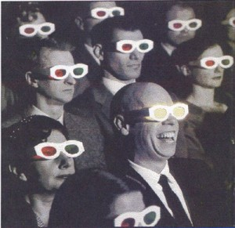

In the newly revised and updated MACS100: Introduction to Popular TV & Movies, you will learn how to view the media more thoughtfully, carefully, and critically – so that by the end of the semester movies and television will still be entertaining, but no longer mere entertainment. You will become a critical consumer of the media by developing four interrelated approaches of media analysis, examining: theories of “the popular” and "ideology"; media forms and genres; representations of race, class, gender and sexuality; and the industries and economies of film and television.

By the end of the semester, you will be able to answer questions like: What does it mean to call Empire “popular” and what might its impact be? How can I better understand the ways in which I consume media and why I binge-watch Orange is the New Black? And is it still TV if I watch it on the Internet? How do I make sense of the representation of race and gender in a movie like The Help? Does watching Toddlers and Tiaras mean I love child pageants? Is watching The Daily Show akin to watching the news? Who owns a movie like The Avengers and why does it get made? If I find myself living in a horror movie, when will I die? And you thought, even though this course fulfills 2 General Education requirements (“Humanities & the Arts” and “Cultural Studies: Western/Comparative Cultures”), that you might not be able to fit it into your schedule this semester? Your life might just depend on it.

But you won’t just become a more critical consumer of the media, but also a more skilled producer of it as well. Have you wanted to try your hand at shooting video? With your new knowledge of media forms as well as an introduction to some of the video production technologies available to you through the university, you will write, direct, and edit your own video with a group of classmates.

Dr. Amanda Ciafone is Assistant Professor of Media & Cinema Studies in The College of Media. After working for CBS Television, she returned to get her doctorate at Yale University and study the history of media and culture industries in the U.S. and the globalization of American culture in the twentieth century. She loves teaching and writing about television and movies almost as much as she loves watching them.

