Summer 2015 Course Announcement:
Introduction to Philosophy through

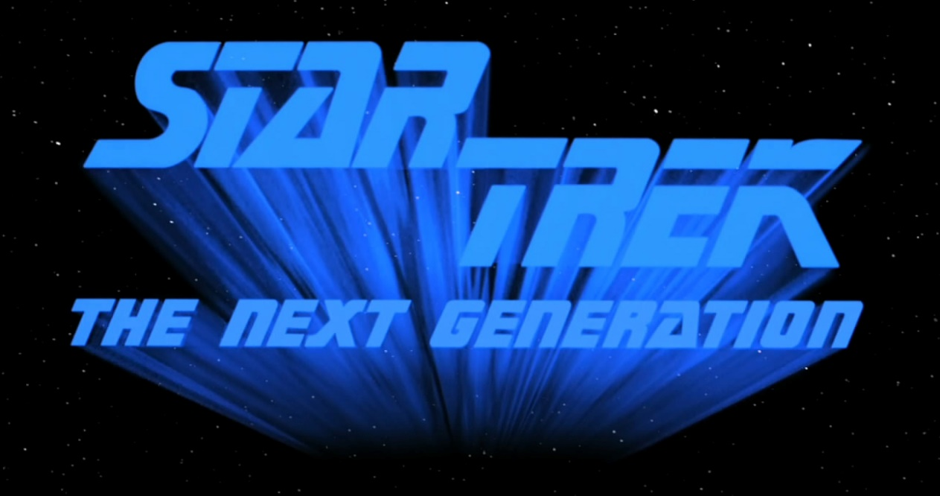
- Explore the universe of philosophy using case studies from Star Trek!
  - We will learn about ethics using the Prime Directive as a case study
  - We will learn about minds and artificial intelligence using the character Data as a case study
  - Other topics include time travel, fatalism, personal identity, and skepticism
- There is no need to be familiar with Star Trek, we will watch the needed episodes in class!
- Assignments will focus on developing your reading comprehension skills and writing skills
- Meets MWF 1-2:50pm from 15-Jun-15 to 06-Aug-15
- In UIUC Course Explorer under Summer 2015 as PHIL 101 B (CRN: 30225)
- Register today to ensure the course does not get cancelled

