What is a microbiome disturbance?
PART 1
The picture on the projector was taken with a scanning electron microscope and is computer colored. It is an image from the human gut. The artist writes “In this sample, numerous intestinal bacteria can be detected. Additionally, a plant fiber has passed the intestinal tract unharmed and spans across the frame (center). On the right hand side (half-cut) the relatively large and spherical shaped cyste of a Giardia parasite (brown) is visible. Apart from this unusual parasitic supplement, the documented bacterial fauna looks fairly diverse and well-sorted…” (Oeggerli, 2013)
Reference: Oeggerli, M. (Photographer). (2013). Intestinal Bacteria [Web Photo]. Retrieved from http://ngm.nationalgeographic.com/2013/01/125-microbes/oeggerli-photography
Use the picture your teacher shows to answer the questions.
- Circle one italicized word or phrase to complete the sentence.

There are one or two, a few, or many types of microbes in the human gut.
- Explain why you chose the word or phrase in question #1.

- A type of microbe may have a mutualistic or a pathogenic relationship with its host. Describe the difference between the two.

- What type of relationship do you think most of the bacteria in the picture have with their host? Why?

- An antibiotic is a drug that disrupts certain processes in a microbe cell. For example, one type of antibiotic prevents microbes from ingesting thiamine, an important nutrient for their survival. Some microbes need to ingest thiamine from their surroundings but, other types of microbes make their own thiamine from other nutrients they ingest. How would each of these types of microbes be affected by the antibiotic?

- Draw and compare two models that illustrate: a) what a healthy gut’s microbial community looks like and b) what a gut’s microbial community might look like after administration of an antibiotic.

PART 2
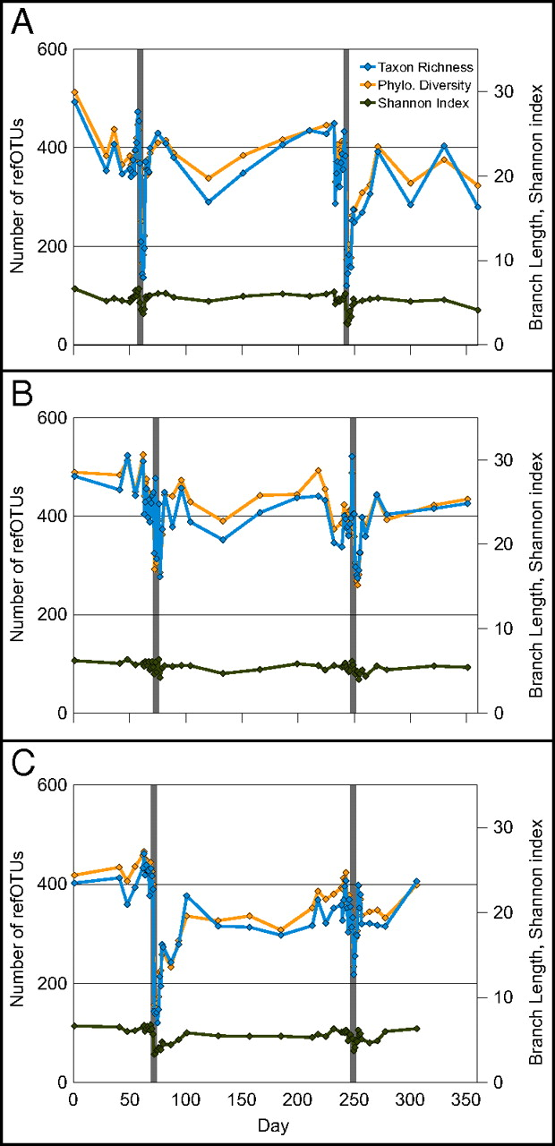
Three measures of biological diversity in samples from subjects A, B, and C.
These graphs come from a published scientific paper describing a study on the effects of antibiotics on healthy individuals. Specifically, they show the diversity of a healthy microbiome and the effects antibiotics can have on this microbial diversity. Each graph shows data from a single person. The gray bars represent times when the subject was given an antibiotic. The blue and yellow lines indicate measurements of the number and types of microbes (microbial diversity; y-axis) as compared to time (x-axis).
Use these graphs to answer questions 7-9.
Source: Dethlefsen, L. and Relman DA. (2011). Incomplete recovery and individualized responses of the human distal gut microbiota to repeated antibiotic perturbation. Proc Natl Acad Sci USA. 108(Suppl. 1): 4554-4561.

- Which day(s) were antibiotics administered?

- Describe the effect of the antibiotic on the microbial diversity immediately after administration.

- Did the ecosystem recover to its initial level of biological diversity after the individuals stopped taking the antibiotic? Explain what happened to the microbial diversity as shown by the graphs.

PART 3
When studying how ecosystems are affected by disturbances, there are a few ecological terms (listed below) that are very important. These terms are useful for analyzing information and for describing and explaining what is happening in the ecosystem. Work together to define the terms below. Use the graphs in Part 2 to provide examples of each term.
Diversity:

Disturbance:

Recovery:

Resilience:

