Case Investigation #: 972491

Investigators,

Thank you for assisting Dr. Rivera in developing his hypothesis regarding the effectiveness of fidaxomicin compared to vancomycin. To test this hypothesis, Dr. Rivera’s team members treated 44 patients with C. difficile infections (CDI) with vancomycin, and 44 patients with fidaxomicin. The patients were not told which drug they received, and the team members who administered the drug did not know which drug was given to each patient. This is referred to as a double-blind study. Only Dr. Rivera knew which drug was given to each set of patients.
Dr. Rivera and his team measured the amount of various bacterial species in the fecal samples of 10 patients from each treatment group in the clinical trial at CMW. They began collecting fecal samples at study entry (day 0), and then collected samples on days 4, 10, 14, 21, 28, and 42. The patients received antibiotic treatment for days 1-10 of the study.
In order to accurately calculate how much of a certain bacterial species was present in the stool sample, they measured the amount of DNA present in the sample. Each bacterial species has a unique DNA sequence that can be amplified and then quantified using the polymerase chain reaction (PCR) technique. To review this process, see the “PCR and DNA Sequencing” hospital resource.
Once the individual bacterial species’ DNA amount was calculated, Dr. Rivera and his team converted the amount of DNA found in each gram of fecal matter to colony forming units per gram of fecal matter (CFU/g). This unit is the standard unit for measuring the amount of microbes found in a gram of various types of samples (in this case a fecal sample).
Dr. Rivera would like your help in analyzing and interpreting the data he collected. The first graph (Figure 1) compares the counts of C.difficile before the patients received antibiotics, while they took antibiotics, and after they stopped taking antibiotics for both vancomycin and fidaxomicin.
Figures 2-5 show the counts of each of the commensal microbes that were measured in 10 patients of each treatment group (each point on the graph indicates the average of the 10). These commensal microbes are found in healthy individuals and it is hypothesized that they help digest food and protect against pathogenic microbes. Each of the Figures 2-5 also indicate the average count of these microbes as measured in 10 healthy individuals.
Figure 6 shows the number of patients out of the total 44 in each treatment group that experienced sustained cure or recurrence of CDI. Remember, high recurrence rates were one of the known problems with the vancomycin antibiotic.
Analyze and interpret the data shown in these graphs created by Dr. Rivera and his team. Help him draw conclusions on the effectiveness of fidaxomicin compared to vancomycin in treating the C.difficile infection.
Note: Because microbes grow in an exponential way (1 becomes 2, 2 become 4, 4 become 8…) the researchers graphed the CFUs on a log10 scale. This means that a mark at 6 really means that there were 10^6 CFUs or 1,000,000 CFUs. A mark at 5 means that there were 10^5 CFUs or 100,000 CFUs, that’s a big difference! Keep the scale in mind when you are interpreting the graphs.
Data presented is based on the following scientific publication: Louie T.J., Cannon K., Byrne B., Emery J., Ward L., Eyben M., Krulicki W. (2012). Fidaxomicin preserves the intestinal microbiome during and after treatment of Clostridium difficile infection (CDI) and reduces both toxin reexpression and recurrence of CDI. Clinical Infectious Diseases, 55(S2),S132-42.

Figure 1: Comparison of Clostridium difficile counts.
Antibiotics were administered days 1-10.
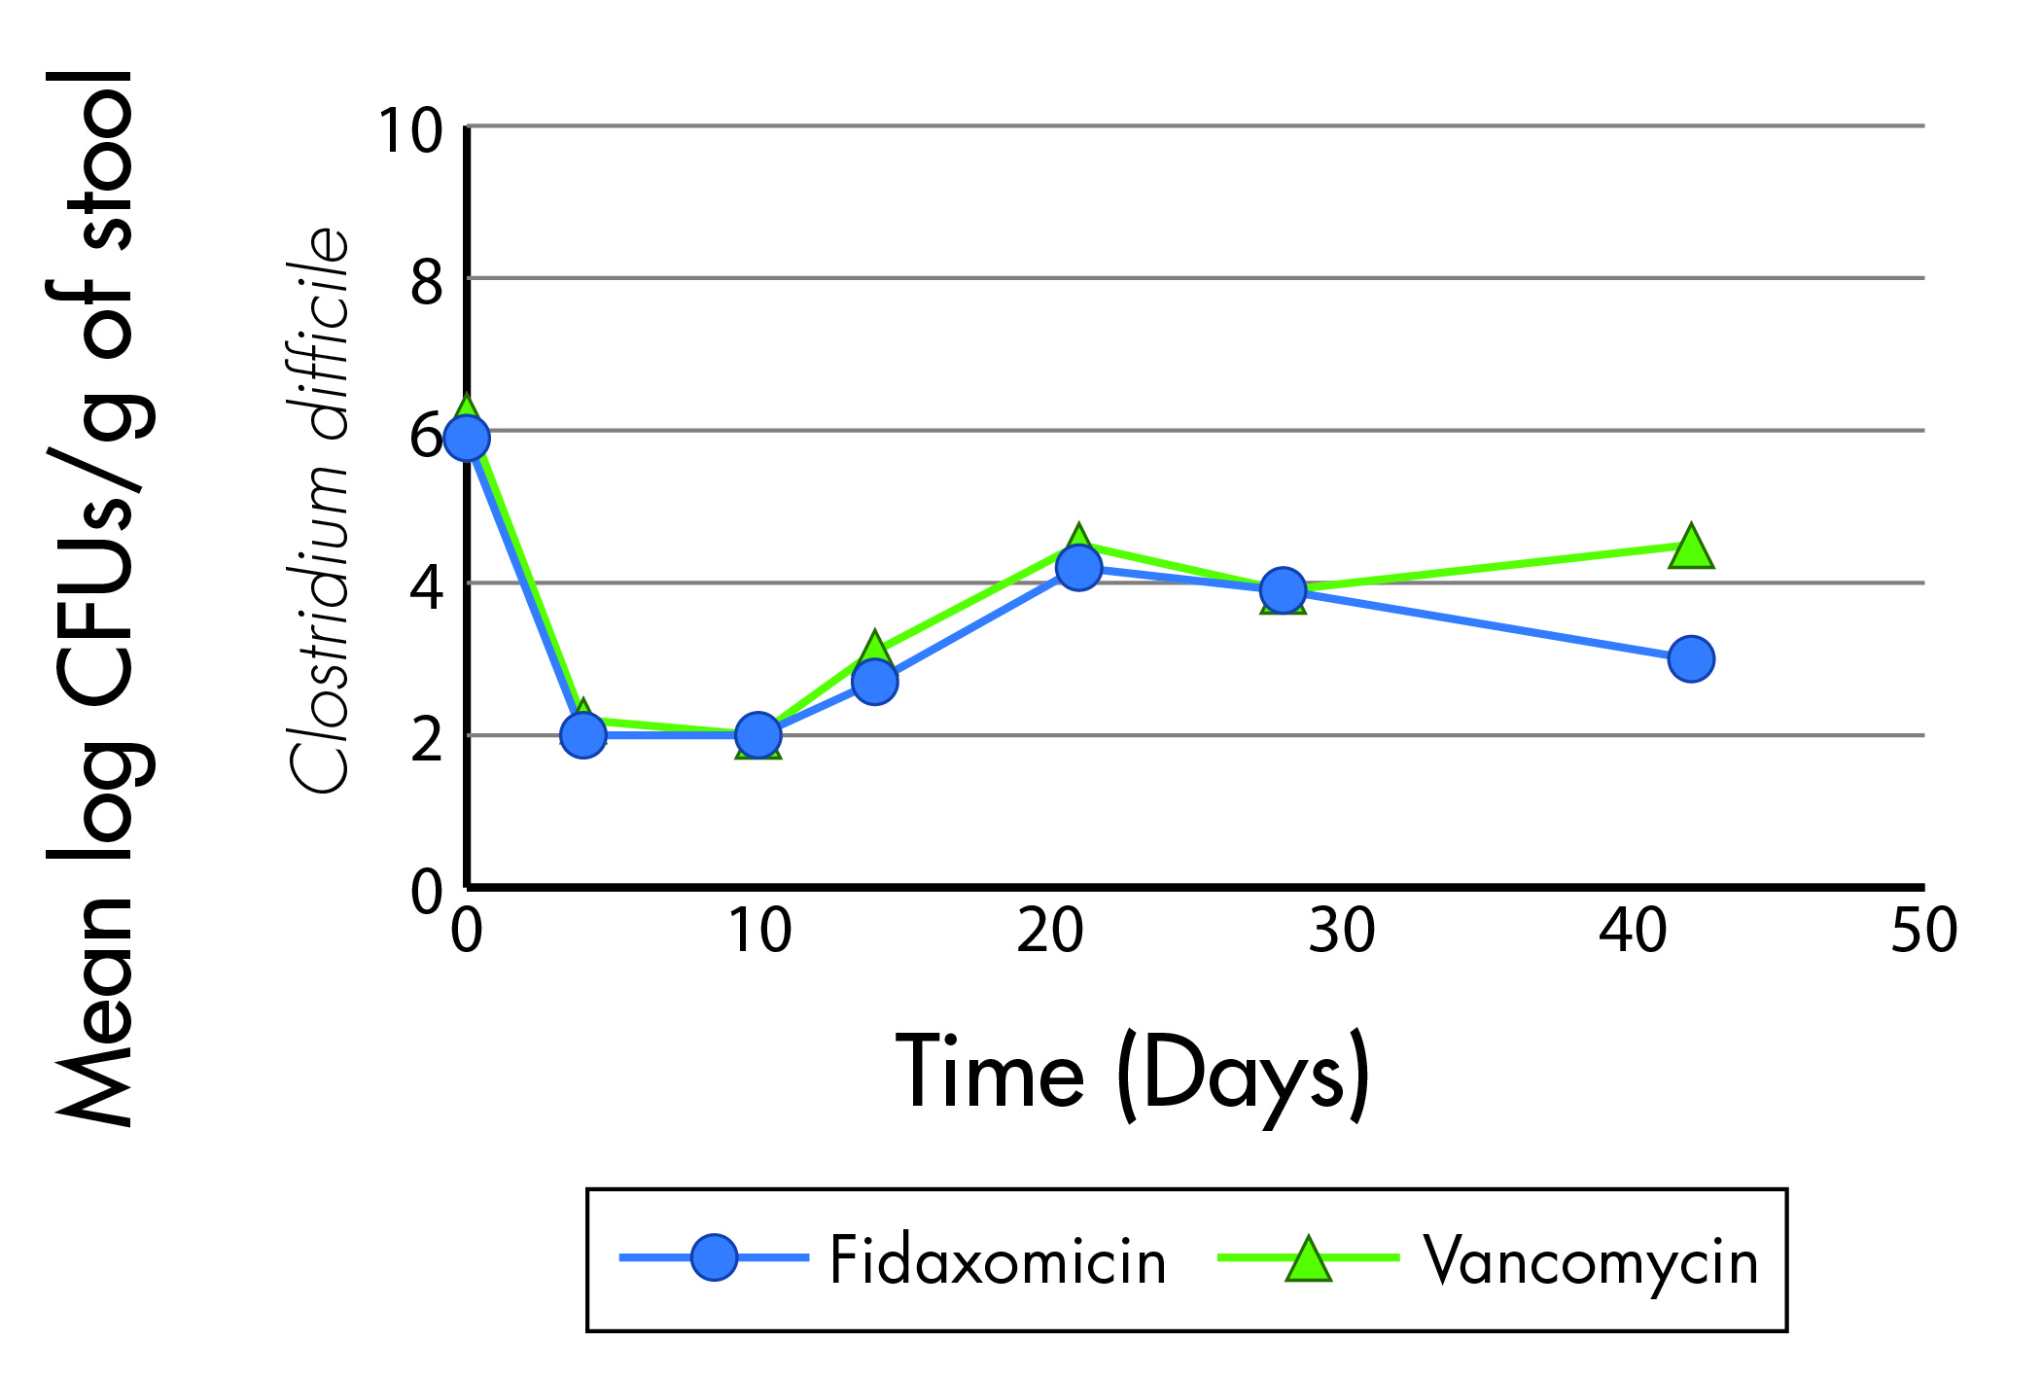
Data from: Louie et al. 2012

Figure 2: Comparison of Bacteroides counts. Antibiotics were administered days 1-10. | Figure 3: Comparison of Prevotella counts.  Antibiotics were administered days 1-10.
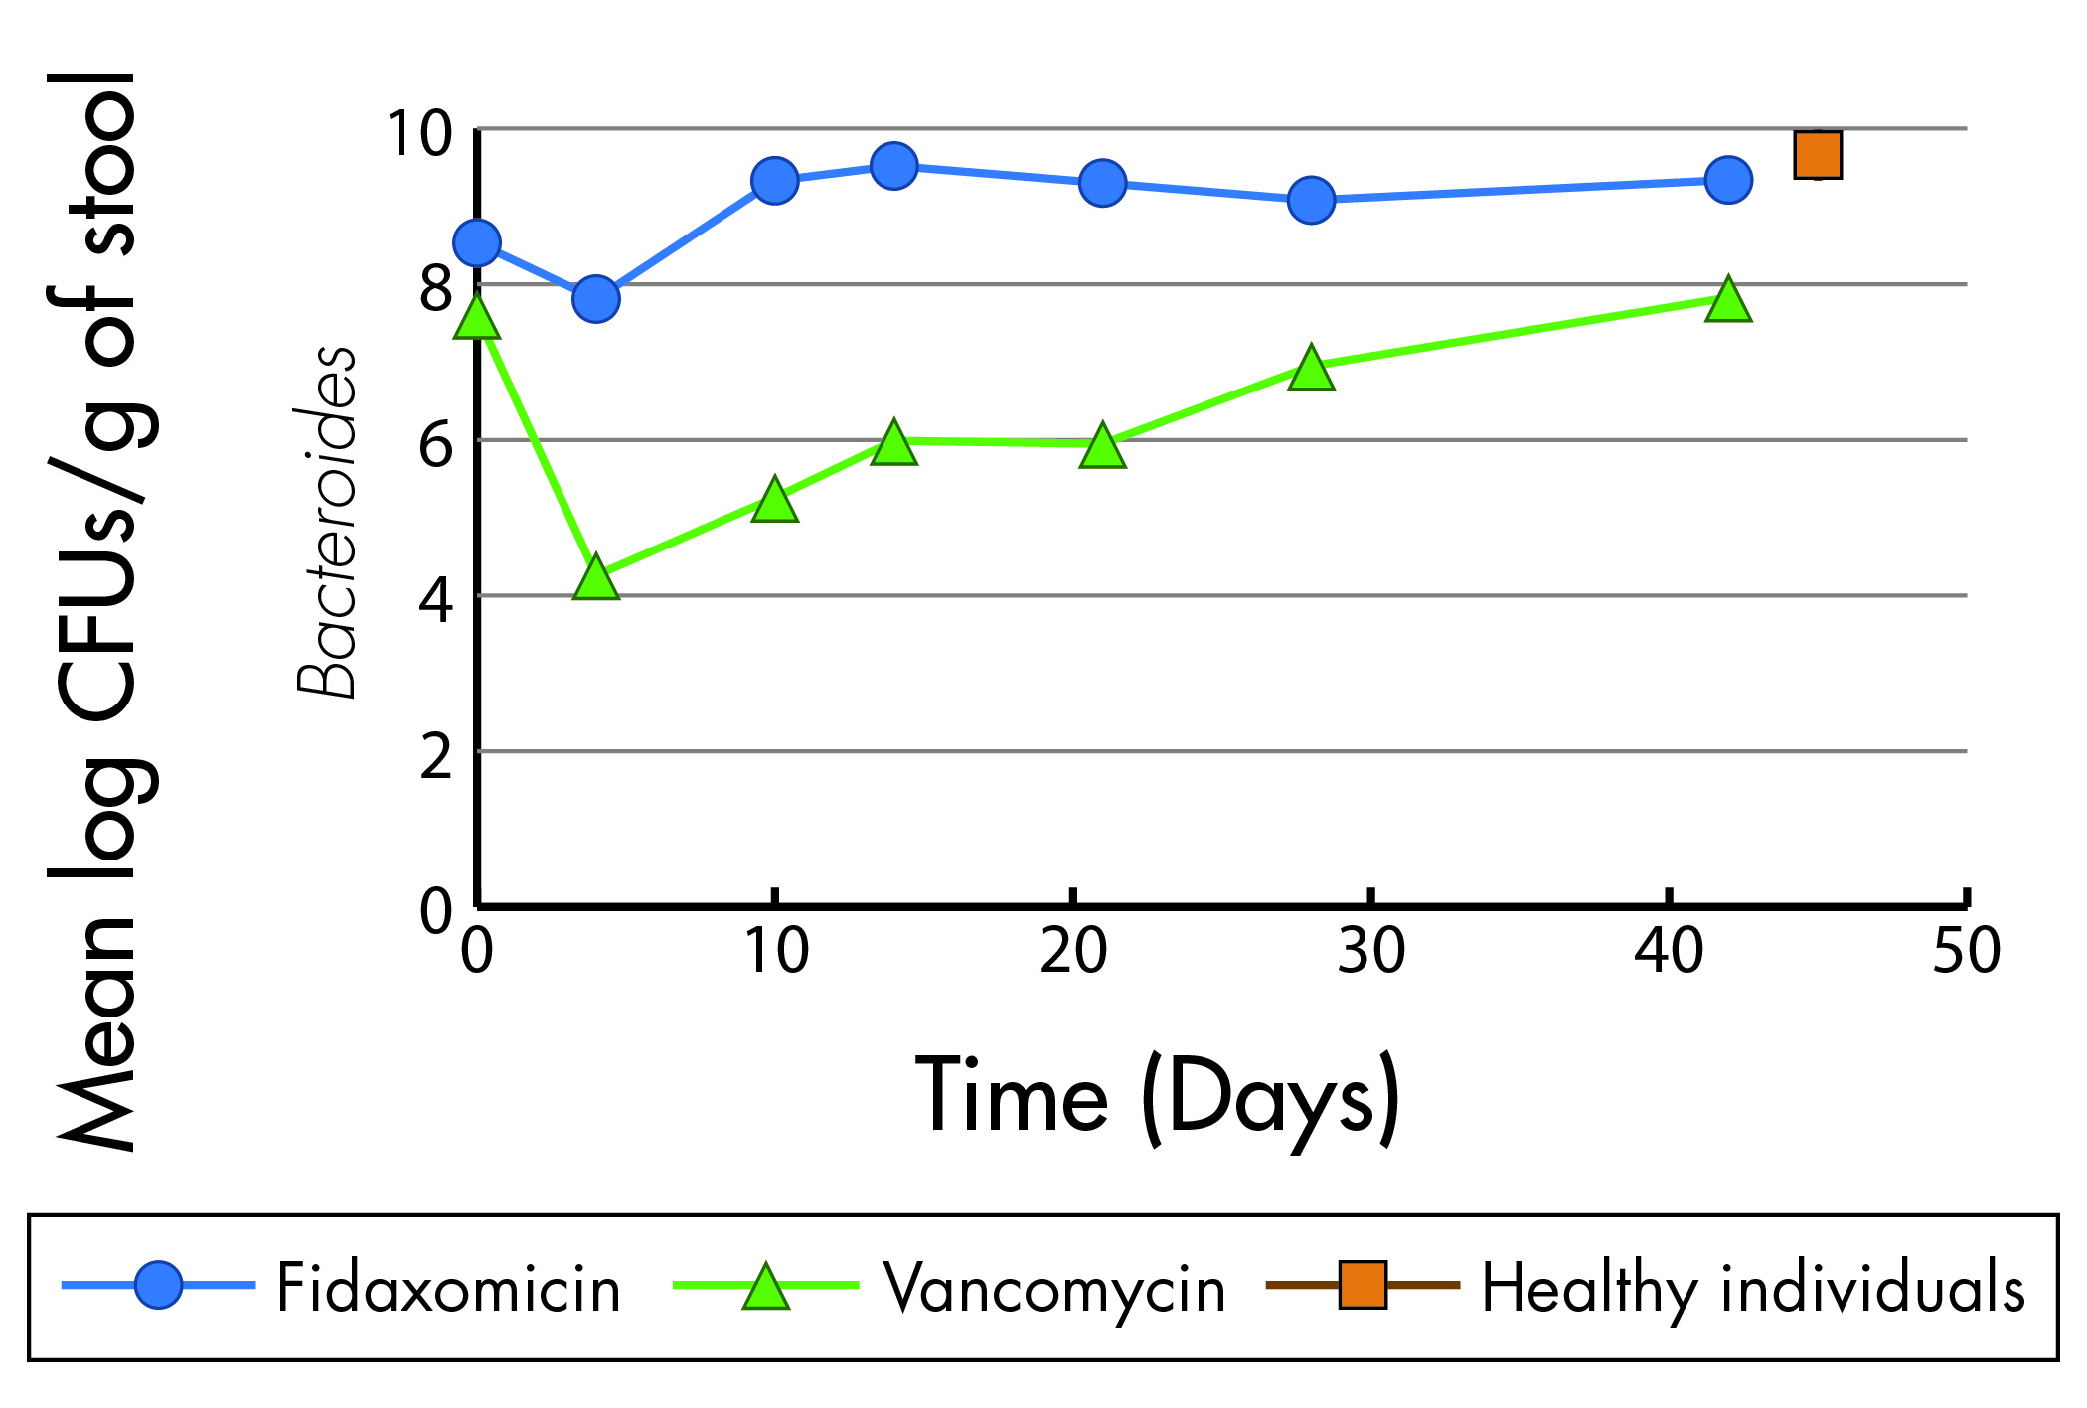 | 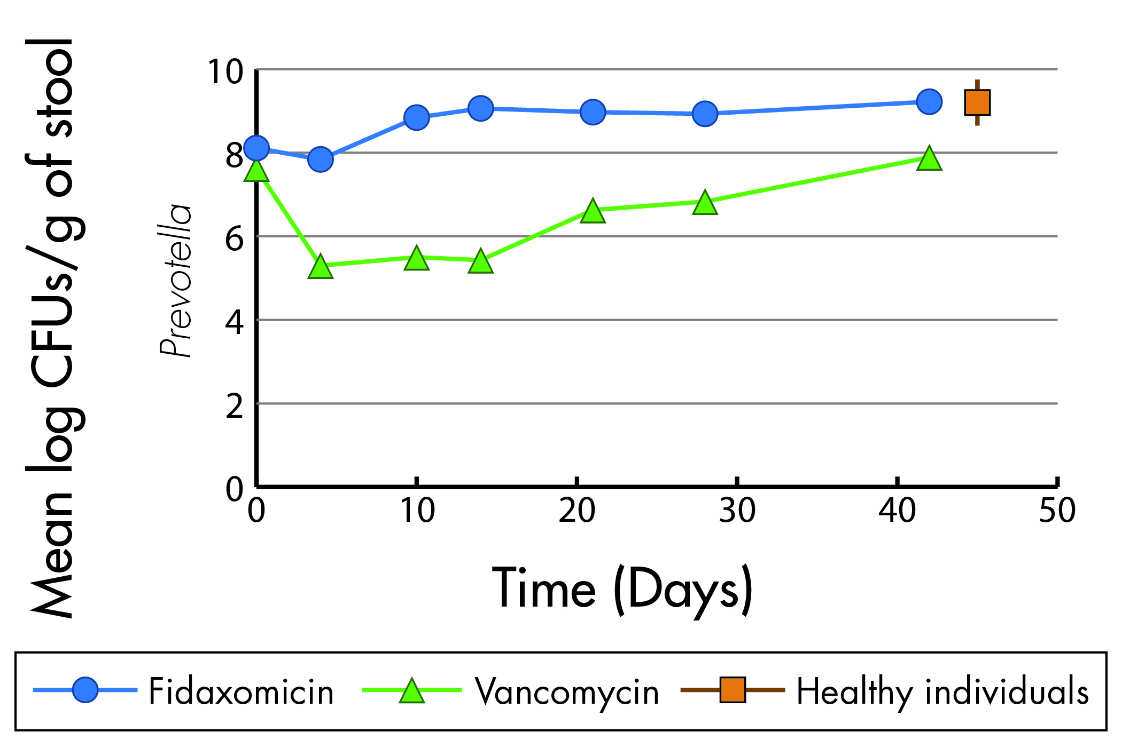  Data from: Louie et al. 2012

Figure 4: Comparison of Clostridium Coccoides counts. Antibiotics were administered days 1-10. | Figure 5: Comparison of Enterococcaceae counts Antibiotics were administered days 1-10.
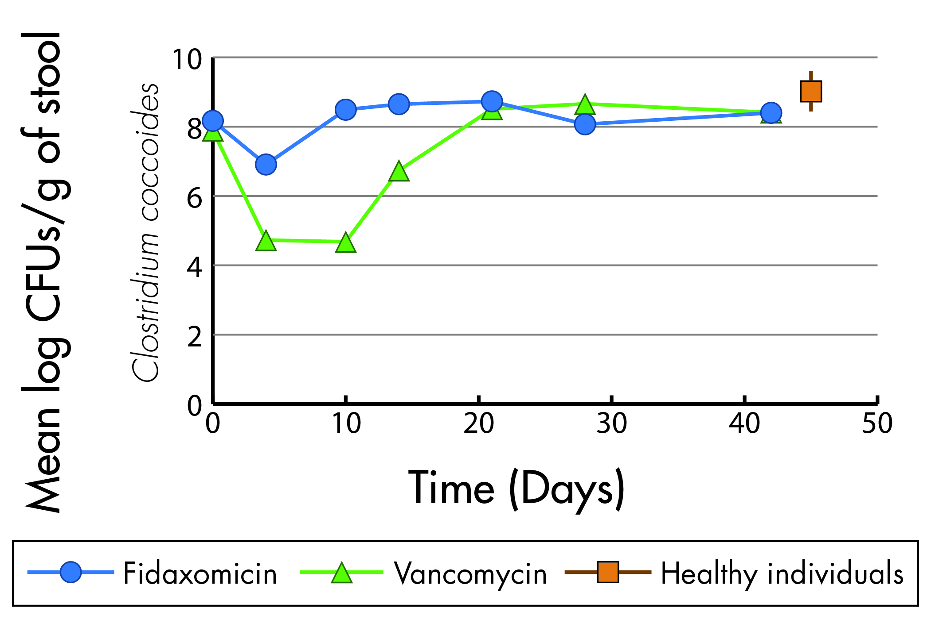 | 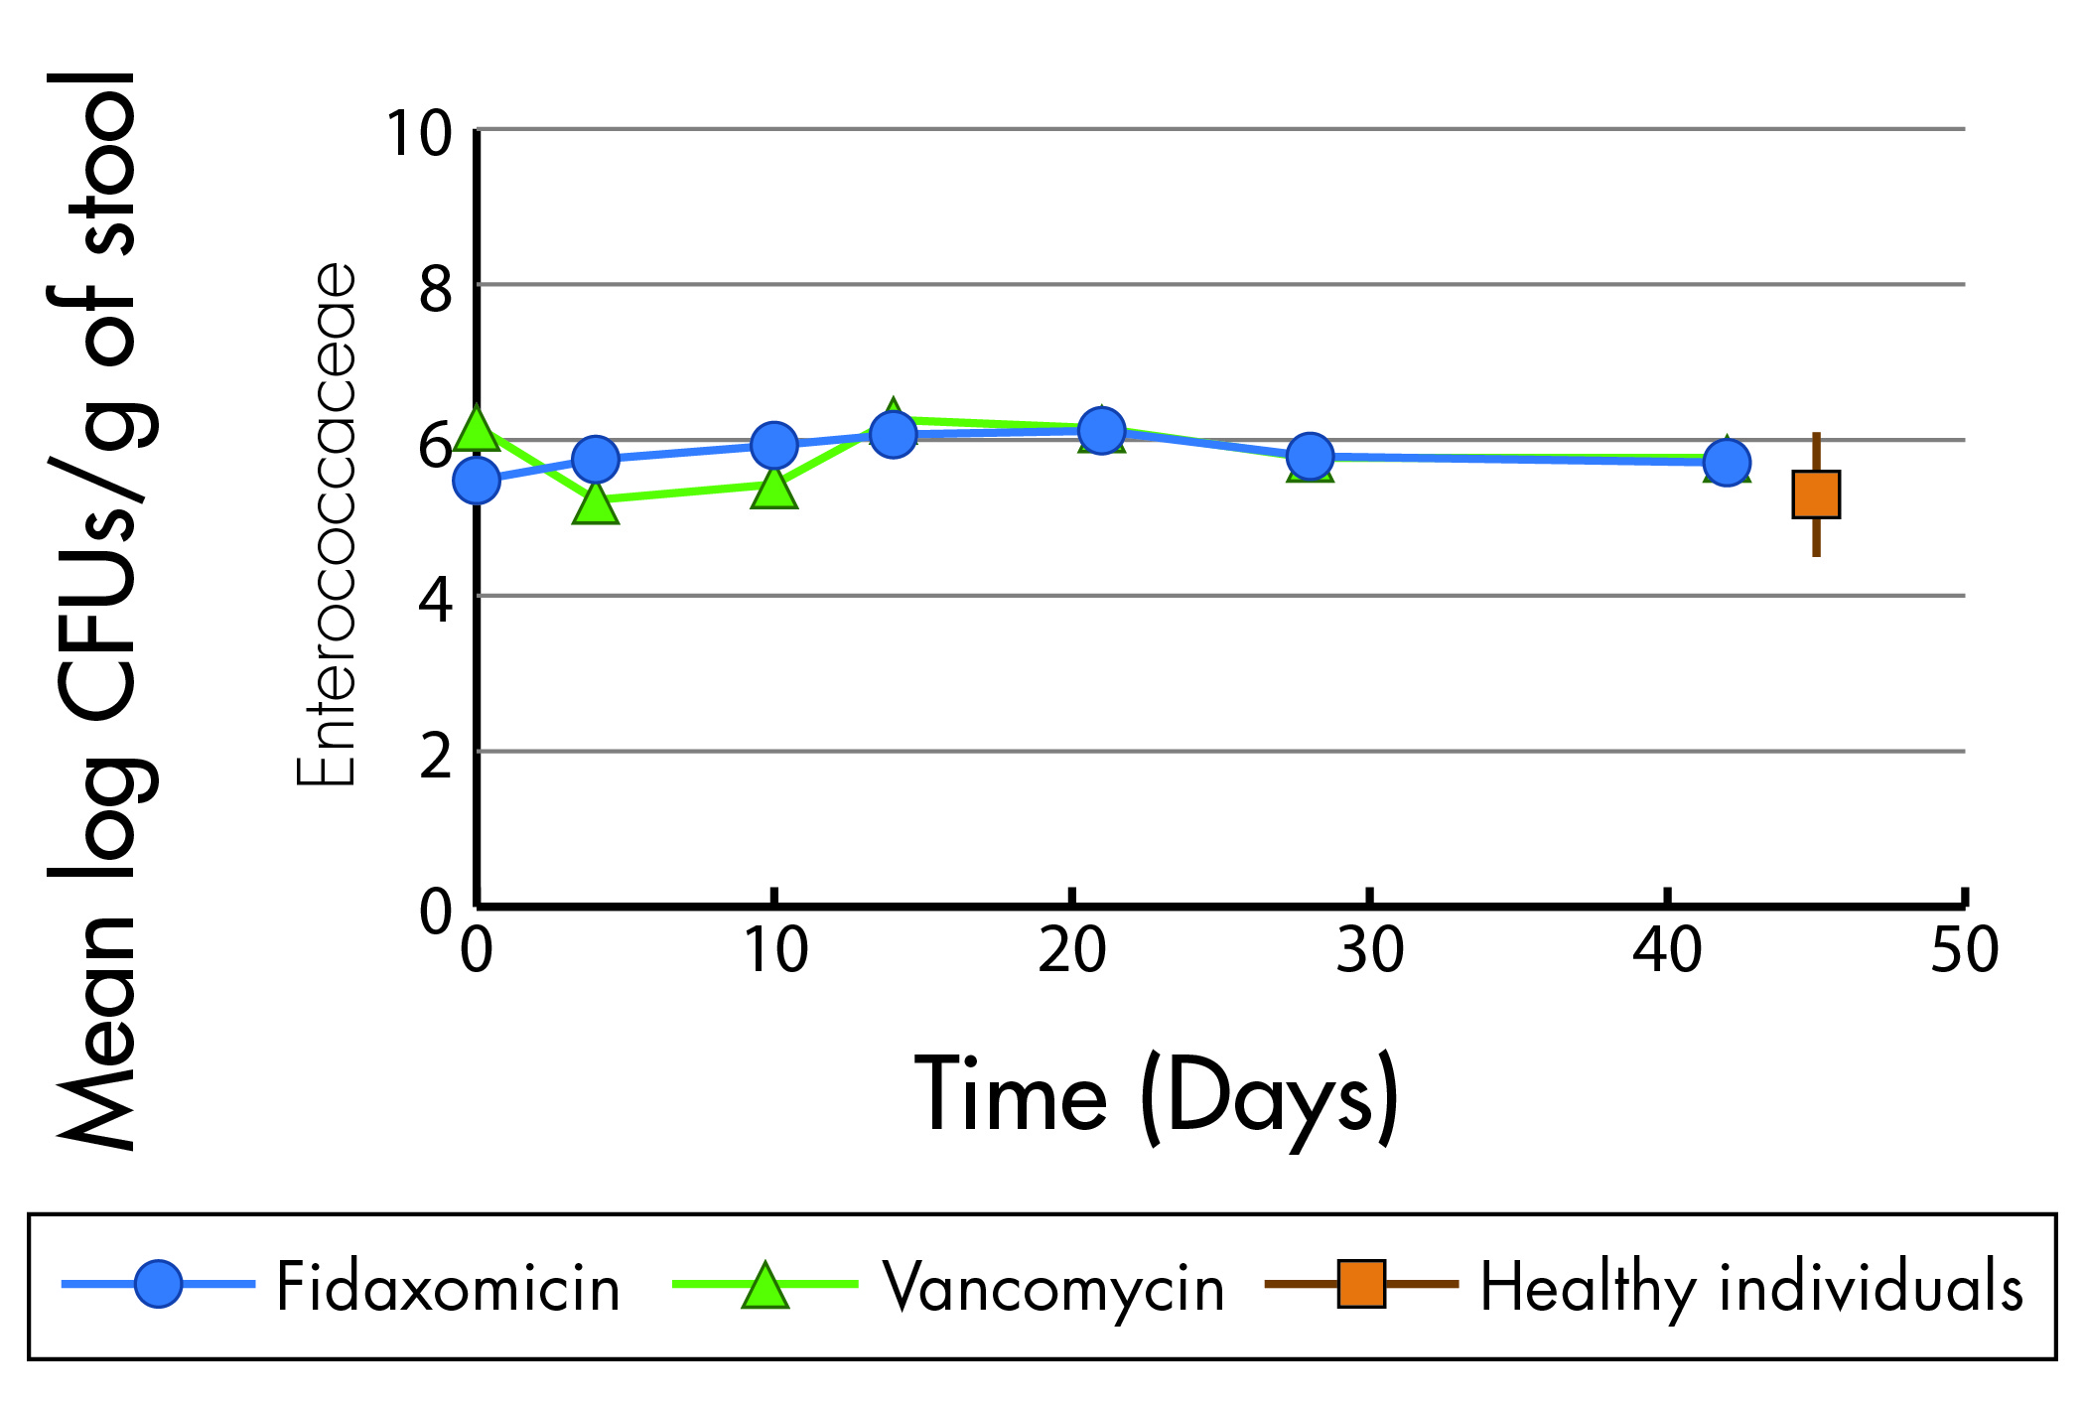  Data from: Louie et al. 2012

Figure 6: Comparison of recurrence of CDI and sustained cure rates
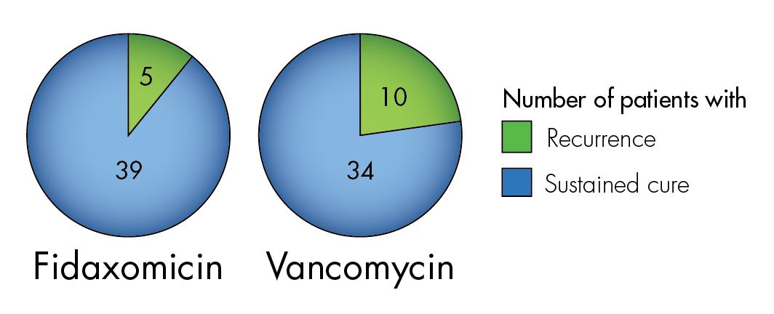
Data from: Louie et al. 2012

