Group 6: Using microbes as treatment of bacterial infection

“Poop Transplants” May Combat Bacterial Infections
Article adapted from: Rowan, K. (2012). “Poop Transplants” may combat bacterial infections. Live Science.
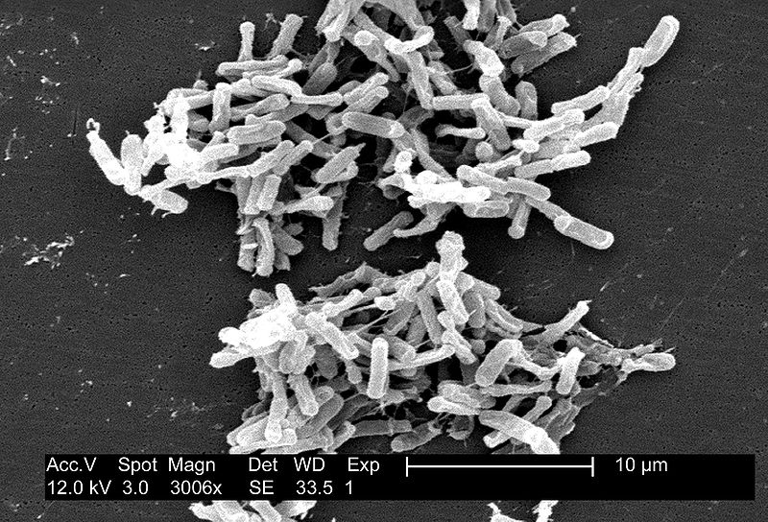
"Poop transplants" are an effective way to treat people with one type of intestinal bacteria infection, a new study shows.
Figure: Clostridium difficile
Credit: CDC/ Lois S. Wiggs. (2004)
Researchers transplanted fecal matter from healthy people into the colons of people infected with the notoriously hard-to-treat Clostridium difficile (C. diff) bacteria (, which causes severe, watery diarrhea. The researchers found that 46 out of 49 patients got better within a week of the treatment.
The transplant works because stool from healthy people, when mixed with warm water and delivered via a tube into patients' colons, helps re-establish the normal balance of bacteria in the intestine. C. diff infections generally occur when a person’s normal microbiome becomes disrupted, from either antibiotic treatment or a condition that leaves patients with a compromised immune system. With the transplant, the large influx of healthy bacteria can outcompete the C. diff for resources, essentially causing the C. diff to die off due to a lack of resources.
"C. diff is a serious infection — people die from this. With this treatment, the cure rate is close to 100 percent," said study researcher Dr. Mayur Ramesh, an infectious disease physician at Henry Ford Hospital in Detroit.
Among the 46 patients for whom the transplant was successful, four (or 8%) experienced a recurrence of their infection during the follow-up period. By contrast, studies have shown that infections recur in 25 to 30 percent of patients who receive the standard treatment for C. diff, which is a course of antibiotics, Ramesh said.
As of three months after the fecal transplant, the patients had developed no complications or side effects as a result of the treatment, the researchers reported at an infectious diseases research meeting.
C. diff infections are linked to 14,000 deaths in the U.S. yearly, according to the Centers for Disease Control and Prevention. People at highest risk for the infection are older adults and those who take antibiotics. It's believed that antibiotics may disrupt the normal balance of bacteria species in the intestine, giving C. diff bacteria a chance to thrive.
Patients with C. diff infections are typically treated with the antibiotics metronidazole or vancomycin; however, these drugs don't work for everyone, the researchers said. In severe cases, patients may need surgery to remove the infected parts of their intestines.
In the study, researchers looked at patients whose average age was 65 and who were treated with fecal matter transplants over a two-year period at the study’s hospital. In most cases, the donor was the spouse or child of a patient, but in some cases, siblings, parents, or unrelated people donated fecal matter.
The patients were not much bothered by the possible ick factor of the treatment, Ramesh told MyHealthNewsDaily. "These patients, they suffer so much from their symptoms," he said. "When I tell them about this treatment, they say, 'wow, that makes sense, go ahead and do it.'" No patients declined the treatment, he said.
Other studies have found a similarly high percentage of C. diff patients can be treated successfully with fecal transplants. However, the new research differed from previous studies because about a third of the patients had severe C. diff infections. "These are the patients who may die, or need to have a section of their colon removed," Ramesh said. Other studies have focused on patients with recurring, but not severe infections, he said.
Four patients in the study died, including three whose C. diff infection had been successfully treated with the transplant. The deaths were unrelated to C. diff, the researchers said; all had cancer before starting the treatment.
While this study and others suggest that fecal matter transplants are effective, randomized controlled trials are considered the "gold standard" of evidence in medicine.
One such trial was recently approved to begin in the U.S. In that study, patients will be randomized into two groups: in one, patients will receive fecal matter from healthy donors, while in the control group, patients’ own fecal matter will be transplanted back into them, according to an article published in September in the journal Clinical Infectious Diseases.
Pass it on: Fecal matter transplants may be an effective way to treat C. diff infections.

References
Article adapted from:
Rowan, K. (2012). “Poop Transplants” may combat bacterial infections. Live Science. Retrieved from http://www.livescience.com/36701-poop-transplants-bacterial-cdiff-infections.html
Image from:
CDC/ Lois S. Wiggs. (2004). Retrieved from http://commons.wikimedia.org/wiki/File:Clostridium_difficile_01.jpg

Expert Group Student Sheet
Station 6: Using microbes as treatment for bacterial infection
1. What is a fecal transplant?

1b. How do the microbes from the fecal transplant eliminate the C. diff infection?

1c. In the human gut ecosystem, how do native microbes protect humans from infections by microbes such as C. diff?

2. What was the rate of recurrence of the C. diff infection in patients who received the fecal transplant compared to those who received the standard antibiotic treatment?

2b. What could be potential negative consequences of a fecal transplant?

3. What are the next steps (according to the article) to investigate whether or not the fecal transplant is a more effective option than standard antibiotic treatment?

