Group 5: Microbes and the blood-brain barrier
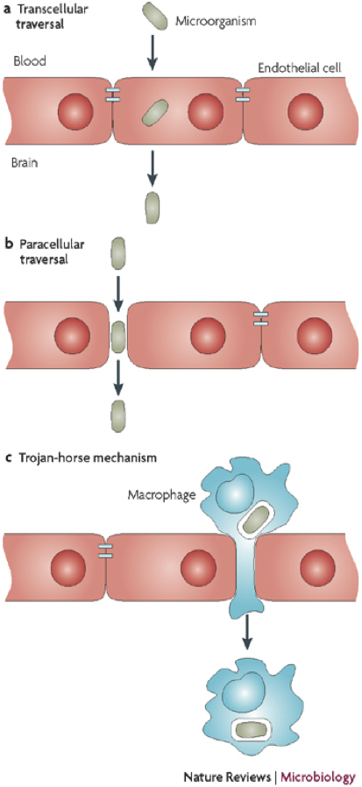
What happens to the health of our bodies if our microbes are not kept “in check”? Sometimes we can get sick if certain microbes that are part of our microbiome begin to grow excessively. This is the case with yeast infections. Candida albicans is present in our gastrointestinal tract but can cause infections in other parts of the body if the human environment changes, i.e. taking certain medications or a compromised immune system. This overpopulation of yeast disrupts the natural balance of the human microbiome.
Figure 1: Three different mechanisms of microbes crossing from the blood to the brain.
Image from: Kim, 2008, p. 627
Other times, microbes enter parts of our bodies where they are not welcome. For example, Listeria monocytogenes is a pathogenic (disease causing) microbe that can enter the body through contaminated food and cause food poisoning by colonizing in the gut. Generally, our immune systems can fight off Listeria when it enters the gut, and symptoms of food poisoning last 24-48 hours.

Listeria can also enter the central nervous system (CNS) causing meningitis (meninges= membranes that envelop the CNS, -itis= infection). The CNS is a generally microbe-free environment, and microbial infections can be extremely dangerous.

Infections of the central nervous system, which includes the brain and spinal cord, are rare but can happen if the microbes cross the endothelial cells that line the blood vessels that separate the blood from the brain. Generally, the microbes first enter the blood stream and when the microbe count is high, they can begin to attach to and/or damage endothelial cells, which allows them to enter the CNS. Figure 1 shows the three different ways that microbes can enter the CNS. In the transcellular traversal (a), microbes bind to the endothelial cells via proteins on their surface to enter the cells and then exit on the other side of the cell, thus crossing from the blood side to the CNS side. Next, the paracellular traversal (b) occurs when the microbes damage the tight junctions between two endothelial cells in order to pass in between the cells and go from the blood to the CNS. Finally, the microbes can hitch a ride on a macrophage (c), an immune cell that has “eaten” the microbe. The macrophage can move easily between the blood and brain, so when the microbe senses that it is on the CNS side, it will leave the macrophage to grow in the CNS.

The ability for Listeria to cross from the blood into the brain, and cause a more serious infection for the human host, is similar to the invasive species phenomenon observed in various ecosystems. Invasive species are those that have been introduced into an ecosystem (either by accident or by chance as a result of another event) that they do not normally inhabit. In the case of Listeria infection, once Listeria has crossed the blood-brain barrier, it can quickly take up residence in the (generally) microbe-free environment of the CNS because it has little to no competition of resources. The immune system then has to work to eliminate the microbes that have invaded, and hopefully restore the CNS ecosystem to its pre-invasion state.

References:
Kim, K.S. (2008). Mechanisms of microbial traversal of the blood-brain barrier. Nature Reviews: Microbiology.
6:625-634.

Expert Group Student Sheet
Group 5: Microbes and the blood-brain barrier
1. According to the reading, how can microbes, such as Candida albicans, that are part of a healthy human microbiome cause illness?

1b. Describe another example of the overpopulation of a certain species and its impact on an ecosystem.

2. What are the three types of ways that microbes can enter the CNS?

2b. What condition must be met in order for microbes to cross the blood-brain barrier?

3. How is Listeria an invasive species?

3b. Describe another organism that is an invasive species and its impact on an ecosystem.

