**Group 4: Intestinal microbiota development in infants**

With an increase in the awareness of the human microbiome and its implications for human health, researchers have been studying how our microbiome becomes established, that is, what factors lead to the diversity of human microbiomes in adults? To answer this question, Palmer and her colleagues set out to characterize the differences between 14 babies’ microbiomes and whether or not certain factors, such as method of delivery and diet, affected the development of the microbiome. Ecological succession occurs when the intestinal microbiome starts to develop. Succession is the process of colonizing a “blank slate” environment, and one notable example occurs in forests affected by fire, where the organic matter is destroyed and new organisms colonize the soil.

The data below show how Palmer and her colleagues analyzed the differences and similarities between the microbiomes of infants. The same 14 babies were used throughout the study.

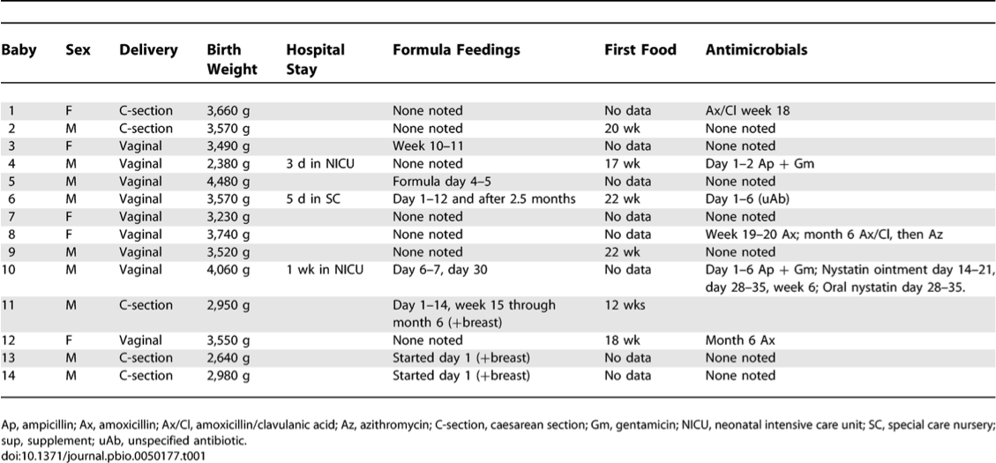

**Table 1: Characteristics of the infants used in the study**

Taken from Palmer, 2007, p. 1557



**Figure 1: The amount of total bacteria per gram of fecal sample was measured for each baby during the first 200 days of life. The grey bars represent antibacterial treatment while the pink bars represent antifungal treatment.**

Taken from Palmer, 2007, p.1560

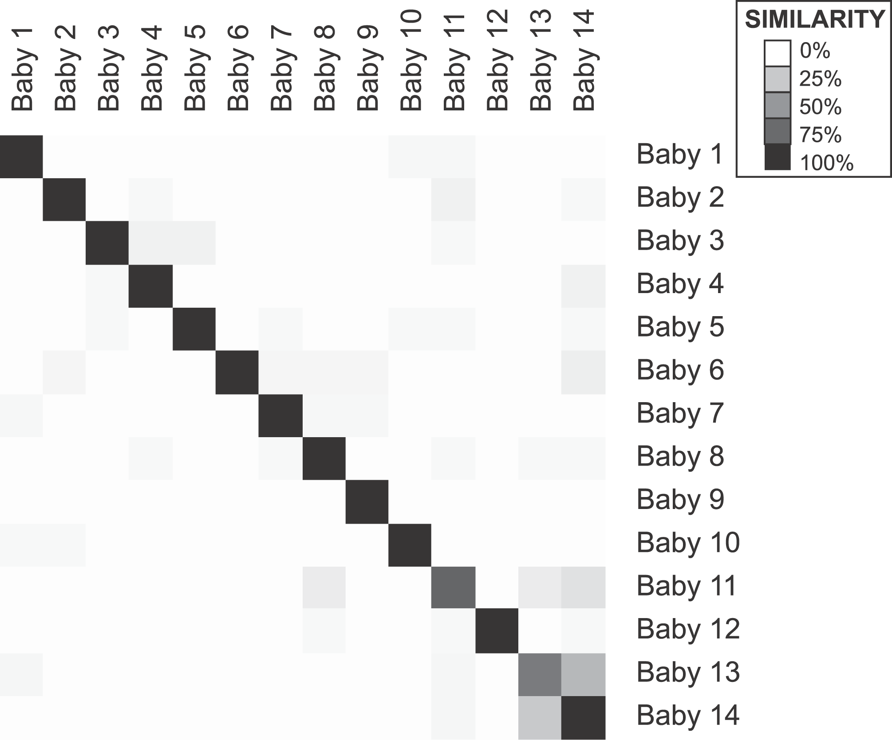

Taken from Palmer, 2007, p.1564

**Figure 2: Each of the 14 babies was compared to one another in intestinal microbiota similarity. This similarity calculation is based on the types of microbes found in each of the baby’s fecal samples.**

**References:**

Palmer, C., Bik, E.M., DiGiulio, D.B., Relman, D.A., and Brown, P.O. (2007). Development of the human

infant intestinal microbiota. *PLoS Biology, 5*(7), 1556-1573.

**Expert Group Student Sheet**

**Group 4:** **Intestinal microbiota development in infants**

1. How is infant microbial development an example of ecological **succession**?

1b. Give another example of succession that is not provided in the reading.

2. According to Table 1, how are babies 9 and 12 similar? How are they different? How do you think these differences may have affected their microbiomes?

2b. According to Figure 1, how do the microbial populations of babies 9 and 12 differ?

3. According to Table 1, how are babies 1 and 2 similar? How are they different? How do you think these differences may have affected their microbiomes?

3b. According to Figure 1, how do the microbial populations of babies 1 and 2 differ?

4. According to Table 1, how are babies 2 and 7 similar? How are they different? How do you think these differences may have affected their microbiomes?

4b. According to Figure 1, how do the microbial populations of babies 2 and 7 differ?

5. What is significant about the microbial populations of babies 4 and 6? Provide a likely explanation for what caused the patterns of microbial populations in both babies?

6. Locate the two most similar babies in Figure 2. Why might these two babies have a high amount of microbiota similarity?

7. Based on the data, what factors lead to the development of the human intestinal microbiome?