Group 3: Microbes educate immune cells
Scientists frequently use model organisms, or organisms with certain desirable characteristics, to study various biological phenomena. In one study by Atarashi and his colleagues, the team used mice to study how native microbes, specifically Clostridium, contribute to the education of regulatory T cells. Regulatory T cells are responsible for identifying which cells of the human body are "self" and "foreign", and are also in charge of regulating when the immune system should “turn off” after an invading pathogen has been eliminated. Regulatory T cells also prevent autoimmune diseases that have become increasingly prevalent in industrialized societies, such as allergies, asthma, and psoriasis.

Previous research showed that microbes of the colon help stimulate regulatory T cells and help them to discern which types of microbes are helpful and which ones are harmful. In the Atarashi study, the team inoculated (introduced a substance into the body of) 2-week old mice, which were grown in a laboratory setting that did not allow the colonization of Clostridium, with a controlled amount of Clostridium. This way, they could monitor how much Clostridium the mice were exposed to. The research team wanted to investigate whether Clostridium could not only stimulate the production of regulatory T cells but also whether or not this stimulation affected the autoimmune response of Clostridium inoculated mice. The results of their studies on the effects of Clostridium inoculation on the amount of regulatory T cells and various disease states, such as colitis and ovalbumin allergy, are found in Figures A, B, and C.

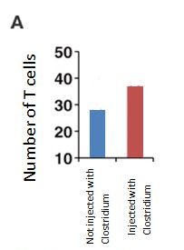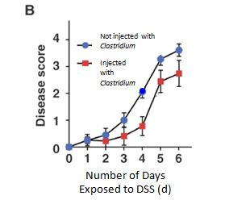
Taken and adapted from Atarashi, 2011, p. 340.

Taken and adapted from Atarashi, 2011, p. 340.
Disease Score
Number of Days Exposed to DSS (d)
Figure B: Both groups of mice were treated with 2% dextran sodium sulfate (DSS) to simulate colitis, a model of human irritable bowel syndrome. Over the course of 6 days, the mice in each group (n=7) were measured for their disease score, which was determined by the severity of body weight loss, stool consistency, and bleeding.
Not injected with Clostridium
Injected with Clostridium
Number of T Cells
Figure A: The number of T cells in mice 1) not inoculated with Clostridium and 2) orally inoculated with Clostridium.

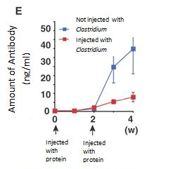
Taken and adapted from Atarashi, 2011, p. 340.

Injected
with
protein
Injected
with
protein
Amount of Antibody (ng/mL)
Figure C: Both groups of mice were injected with ovalbumin, a protein that induces an allergic reaction, at week 0 and week 2. The amount of antibody in the blood serum of both groups of mice was recorded to measure their allergic response over a period of 4 weeks.
C

References:
Atarashi, K., Tanoue, T., Shima, T., Imaoka, A., Kuwahara, T., Momose, Y.,…Honda, K. (2011). Induction of colonic regulatory T cells by indigenous Clostridium species. Science, 331, 337-341.

Vignali, D.A., Collison, L.W., & Workman, C.J. (2008). How regulatory T cells work. Nat Rev Immunol, 8(7), 523-32.

Expert Group Student Sheet
Group 3: Microbes educate immune cells
1. What role do regulatory T cells play in defending our bodies against foreign microbes?

2. In Figure A, how do the number of regulatory T cells in mice not injected with Clostridium compare to the number of regulatory T cells in mice that have been injected with Clostridium?

2b. What does this imply about Clostridium’s effect on regulatory T cells?

3. In Figure B, how do the disease scores differ between each group of mice?

3b. What does this data tell us about the effects of Clostridium inoculation on the severity of colitis?

4. In Figure C, how does the amount of antibody differ between the two groups of mice?

4b. What does this difference imply regarding the allergic response to ovalbumin in each group of mice?

5. What type of niche, or ecological role, does Clostridium play in the human gut? Would you say they are beneficial or detrimental to the human body in this example?

5b. In the example described in the reading, how are Clostridium and the human gut in a mutualistic relationship (i.e., how are both organisms benefitting from the relationship)?

