Group 1: Microbes that affect our body weight
If microbes work in our gut to decompose our food and provide us nutrients, is it possible that they could be providing “too much” of a good thing? Ruchi Mathur and her colleagues have recently published a study illustrating that the number of certain types of microbes in overweight people are different from those people of a normal body weight. They focused on two microbes that are abundant in the gut: the archaea M. smithii and the bacteria Bacteroidetes. M. smithii is an anaerobic (not requiring oxygen) microbe that uses hydrogen and produces methane. It obtains hydrogen from Bacteroidetes, which produces hydrogen as an end product of metabolism. M. smithii removes the excess hydrogen from Bacteroidetes’ environment. This hydrogen removal promotes the population of Bacteroidetes in the gut to increase which leads to an increase in hydrogen production. Hydrogen helps M. smithii break down the complex sugars we consume and turns them into short chain fatty acids (SCFAs), which we can then use as a source of energy (extra calories). Bacteroidetes also provides the human gut with vitamins and nutrients, while the human gut provides nutrients (in the form of food that we consume) and a place to live for both Bacteroidetes and M. smithii. Thus, the bacteria, archaea, and human host all rely on each other in mutualistic relationships to survive and thrive in the gut ecosystem. The following diagram summarizes the relationships between these three organisms.

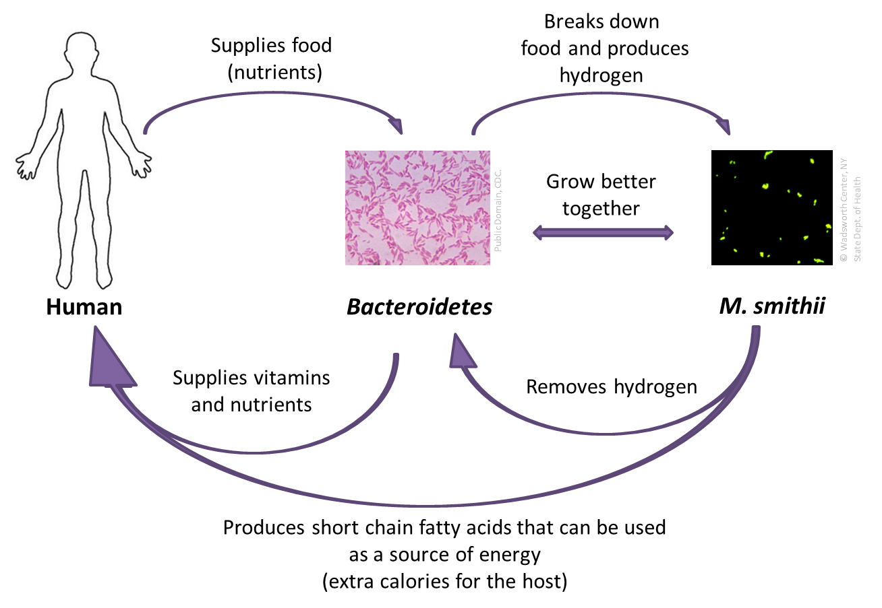

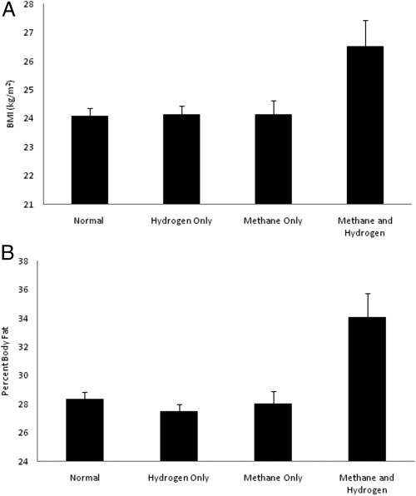
Figure taken from Mathur et al., 2013, p. E700

In this study, Mathur and her colleagues analyzed the methane and hydrogen content of various subjects’ breath. Graphs A and B represent the results of Mathur’s study. For both graphs, there were four groups of subjects: 1) Normal, 2) Hydrogen Only, 3) Methane Only, 4) Methane and Hydrogen. Subjects in the “normal” group had a normal amount of hydrogen, 20 ppm (parts per million) or less, and a normal amount of methane, 3 ppm or less. (“Normal” levels were based on previous research.) If subjects had greater amounts than the normal amount of hydrogen (≥20 ppm) detected but had less than the normal amount of methane (≤3 ppm), they were considered hydrogen positive (represented by the “Hydrogen Only” bar), while ≥3 ppm of methane detected but ≤20 ppm of hydrogen was considered methane positive (represented by the “Methane Only” bar). If subjects had greater than the normal amounts of both gases (≥20 ppm of hydrogen and ≥3 ppm), they were considered hydrogen and methane positive (represented by the “Methane and Hydrogen” bar).

References:
Buck, S. S. and Gordon, J.I. (2006). A humanized gnotobiotic mouse model of host-archael-bacterial
mutualism. PNAS. 103(26): 10011-10016.
Mathur, R., Amichai, M., Chua, K.S., Mirocha, J., Barlow, G.M., and Pimentel, M. (2013). Methane and
hydrogen positivity on breath test is associated with greater body mass index and body fat. J Clin
Endocrinol Metab. 98(4): E698-E702.
Expert Group Student Sheet
Group 1: Microbes that affect our body weight
1. According to the article, how do M. smithii, Bacteroides, and the human gut work together to form mutualistic relationships?

2. What type of information is provided in graphs A and B?

3. According to the National Institutes of Health, a healthy body mass index (BMI) is 18.5-24.9. In graph A, what do you notice about the amounts of hydrogen and methane in subjects with healthy BMIs compared to subjects who were overweight?

4. According to the American Council of Exercise, overweight people have, on average, greater than 30% body fat. In graph B, what do you notice about the amounts of hydrogen and methane in subjects with healthy body fat percentage compared to subjects who were overweight?

5. Based on graphs A and B, what is the relationship between body weight and the amount of methane and hydrogen content in one’s gut?

5b. Due to the known mutualistic relationships between M. smithii, Bacteroides, and the human gut, why might overweight study subjects have a different methane and hydrogen profile compared to healthy weight study subjects?

6. What niches, or specific ecological roles, have M. smithii and Bacteroides established in the human gut ecosystem?

