Forensic Microbiology

A woman walks through a chain-linked fence topped with barbed wire and travels down a dusty road into a small clearing. She stops. For a moment, she doesn’t even notice that scattered around the towering pine trees and among the tall weeds are bodies. There are five dead bodies total, all in different stages of decay. Some are decomposed to the point of only bones and dust and others still have flesh. This is not a scene out of CSI. This woman is a researcher on a body farm, a place where scientists leave cadavers to study how they decompose.

Fingerprints, bloodstains, hair, and DNA are all forms of evidence that investigators have traditionally used to piece together the story of a crime scene. But, have you ever stopped and thought about the microscopic witnesses that are always present at the crime scene? A corpse is far from dead—it contains trillions and trillions of living microorganisms that can tell a story!

Investigation 1
Our skin is covered in tons and tons of microorganisms, which are collectively called the skin microbiome. Much like regular fingerprints, our skin microbiome leaves behind a bacterial “fingerprint” on everything we touch. We can study these bacterial fingerprints left by people and find out which types of bacteria each fingerprint contains.
Researches at Rob Knight’s lab in Colorado investigated whether the bacterial community of a person’s keyboard matches the bacterial community on that person’s fingers. Keyboards were swabbed from three personal computers 1-2 hours after last having been touched, and then the fingertips of the keyboard owners were also swabbed. Bacteria were extracted from each of the swabs and the DNA was extracted from the bacteria. To characterize the differences between the bacteria present in each swab, researchers sequenced a gene that all bacteria have: the 16S ribosomal DNA. The figure below shows the results from their investigation.
At first glance, the graph below may appear hard to read, but the concept behind it is simple. Shapes of the same color come from the same individual. For example looking at the key on the right of the graph, shaded black circles represent bacterial samples taken from individual 1’s keyboard, and unshaded black circles represent bacterial samples taken from individual 1’s fingertips. The x and y scales of the graph measure “relatedness”. Two shapes that are close to each other on the graph represent bacterial samples that have a more similar 16S ribosomal DNA sequence to two shapes that are farther apart.

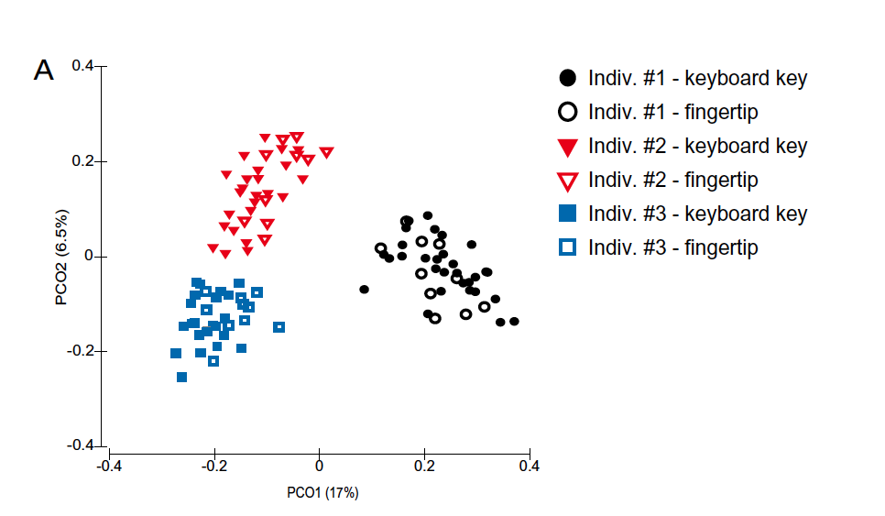
Taken from Fierer et al., 2010
Questions:
- On the graph above, do the following:
  - Circle any one of the triangles that represents a bacterial fingertip samples from individual #2.
  - Place a circle around any one of the triangles that represent a bacterial keyboard sample that came from individual #2.
  - Place a box around a different triangle that represents a fingertip sample from individual #2.
  - Place a box around one of the triangles that represents a keyboard sample from individual #1.

- Based on your markings from question 1, are the fingertip #2/keyboard #2 shapes you circled closer to each other, or are the fingertip #2/keyboard #1 shapes that you boxed closer to each other? Why would these two shapes be closer to each other?

- Based on the graph, does this suggest that the bacterial communities found on the fingertips of these three individuals are unique to each individual? Why or why not?

- If a person touches an object, it leaves behind an impression in the form of a physical fingerprint. The fingerprint left on that object can be matched to the fingerprint on a person to link a suspect to a crime scene. No two people have the same fingerprints. Physical fingerprints are a useful forensic tool.
Based on the results from the graph, explain why a bacterial fingerprint would NOT be a useful forensic tool to link a single suspect to a crime scene where many other people were present. (HINT: Think about how the graph above would look like if we crowded data from 50 more individuals on the graph above! Or if you sampled a keyboard that was used by hundreds of users!) Are bacterial communities found on the fingertips of individuals in a large population unique to each individual?

Investigation 2
A group of researchers at the University of Colorado performed an investigation into what may become a new powerful tool in homicide investigation: a body’s “microbial clock”. During the 48-day study, researchers tracked the microbial changes on the heads, torsos, body cavities and grave soil of 40 mice at eight different points of time and during the forensically recognized stages of decomposition. These stages include the Fresh stage (before decomposition begins), Active Decay (bloating and rupture), and Advanced Decay. They found that the microbial community of dead mice changes drastically over a 48 day period, and that their data could be used to estimate the time of death of a mouse within 3 days accuracy.
To characterize the differences between the bacteria present at each stage of decomposition, researchers once again sequenced a gene that all bacteria share: the 16S ribosomal DNA. Below is a figure showing the different types of bacteria present in samples taken after mice died based on their 16S ribosomal DNA sequence. Each color represents a different group of bacteria and the x-axis shows the number of days after death each sample was collected from the mouse.
Taken and adapted from Metcalf et al., 2013

Note that the figure shows a percentage bar graph. The amount of color for each group represents the percentage of bacteria present in each sample. For example, on the “Skin of belly” graph, on day 0 there is a low percentage of alphabroteobacteria and a high percentage of gammaproteobacteria present in the sample.
Questions:
- A sample is taken from the abdominal cavity of a dead mouse and the 16S ribosomal DNA of the bacteria present is sequenced and analyzed. The results show that the sample has a very low percentage of gammaproteobacteria and a high percentage of firmicutes. Three days later, a second sample was analyzed from the same mouse and the percentage of gammaproteobacteria had increased dramatically. There are now more gammaproteobacteria present than than firmicutes. How many days had the mouse been dead when the first sample was taken?

- Which of the graphs do you think would be the poorest choice to use when trying to determine how many days a mouse has been dead: Abdominal cavity, Soil, Skin of head, or Skin of belly? Why?

- You sample the abdomen, soil, head, and belly of a dead mouse and construct the table below. Based on your data (the table below), about how many days ago did the mouse die?
 | Relative abundance (percentage)
Sample origin | Firmicutes | Gammaproteobacteria | Alphaproteobacteria
Abdominal cavity | 22% | 40% | 0%
Soil | 4% | 6% | 23%
Skin of head | 3% | 67% | 5%
Skin of belly | 7% | 80% | 6%

This reading was developed by Quincy Elery, an MCB 300 Honors student at the University of Illinois, Urbana-Champaign.

References:
Fierer N, Lauber CL, Zhou N, McDonald D, Costello EK, and Knight R. (2010). Forensic identification using skin bacterial communities. Proc Natl Acad Sci USA, 107:6477-6481.
Heimesaat MM, Boelke S, Fischer A, Haag L-M, Loddenkemper C et al. (2012). Comprehensive Postmortem Analyses of Intestinal Microbiota Changes and Bacterial Translocation in Human Flora Associated Mice. PLOS ONE 7: e40758. doi:10.1371/journal.pone.0040758.
Metcalf JL, Parfrey LW, Gonzalez A et al. (2013). A microbial clock provides an accurate estimate of the postmortem interval in a mouse model system. eLife, 2, e01104.
Parkinson RA, Dias K-R, Horswell J, Greenwood P, Banning N et al. (2009). Microbial Community Analysis of Human Decomposition on Soil. In: K Ritz L. and Dawson D. Miller. Criminal and Environmental Soil Forensics. Springer Science. pp. 379-394.

