Bacteriophage Therapy
When we hear the term “virus”, what pops in your head? Negative imagery of sickness, death, and disease may readily come to mind, but did you know that scientists are now actually harnessing the power of viruses to combat bacterial infections? In this reading, we will first learn about a specific type of virus called a bacteriophage. We will then take a look at how scientists are using these phages to fight against pathogenic bacteria that cause disease in humans.

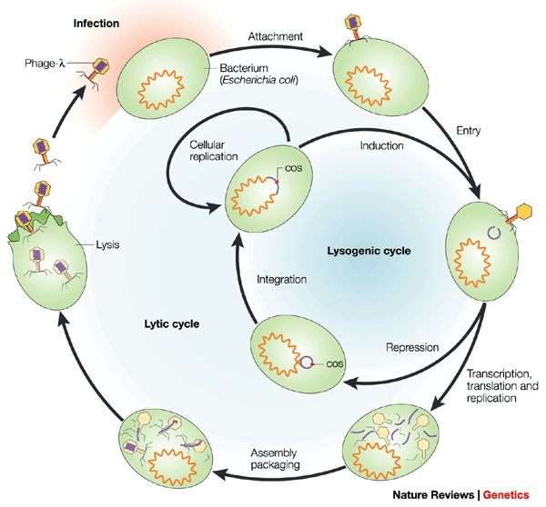
A virus is an infectious particle made of protein surrounding genetic information in the form of DNA or RNA. Viruses depend upon a host for survival and reproduction, as they cannot replicate on their own. A virus that exclusively infects bacteria is known as a bacteriophage, or phage for short. The life cycle of a bacteriophage can be seen in the diagram to the left. Starting at the top of the diagram, the bacteriophage will first attach to a bacterial cell and inject all of its genetic information, or genome, into the bacterial cell. The virus will “hijack” the cell’s replication and transcription machinery in order to replicate and transcribe its own genome.
Taken from Campbell, 2003

The viral genome acts as a blueprint to synthesize the necessary pieces to produce and assemble more phages inside the bacterium. The newly assembled phages then lyse the cell, causing the cellular contents to spill out along with all the newly synthesized phages into the surroundings, where they can go and infect neighboring cells. This type of phage life cycle is called the lytic cycle. In certain instances after the virus infects the cell they enter what is called the lysogenic cycle. During the lysogenic cycle, the viral genome integrates into the bacterial genome. This viral genome is now a part of the bacterial genome and so when the bacteria divide the viral genome also divides and all the bacterial progeny also have the virus. This will continue until other signals are given to the virus that will make it go into the lytic cycle.

It may sound dangerous, but scientists are beginning to use phages in what is called “phage therapy”. Antibiotics are widely known for their role in treating disease caused by microorganisms, but many bacteria have developed resistance to these drugs, rendering some of them ineffective. Why is it that we don’t see widespread usage of phage therapy? If we go back to the time of the Soviet Union, it turns out the Russians were doing cutting edge research on phage therapy and even used phages on their soldiers to combat diseases such as dysentery. Around the same time in the West, penicillin antibiotics were discovered and research on phage therapy was more or less abandoned. The scientific barrier due to the Cold War isolated both sides from the others’ research; the Russians were insulated from the discovery of antibiotics and continued phage research. Likewise, the United States set aside phage therapy in favor of antibiotic research. It is only now, due to bacterial resistance to antibiotics, that the world has once again begun to take interest in phage therapy as a means to combat bacterial infection.

So how does phage therapy work exactly? As we just learned, phages can lyse bacteria, so scientists have isolated lytic phages that can specifically target certain bacteria and kill them. We will take a look at an experiment done on mice infected with the bacterium Pseudomonas aeruginosa. P. aeruginosa is a common bacterium that under certain circumstances can cause infections that can be fatal. Scientists have isolated a phage that specifically targets and kills P. aeruginosa. In the following experiment, scientists tested three different treatments. In the first treatment, mice were infected with P. aeruginosa. In the second treatment, mice were treated with phage. Finally in the third treatment, they infected mice with P. aeruginosa first and then administered the phage. The results of the experiments are shown in Table 1 below.

TABLE 1.
Protection studies: efficacy of phage therapy on P. aeruginosa infection
Treatment | # of survivors/total # of mice (% survival)
 | Expt 1 |  | Expt 2 |  | Expt 3 |  | Combined expt  Taken and adapted from McVay et al., 2007.
P. aeruginosa infection only | 0/6 (0%) |  | 1/6 (16.7%) |  | 2/6 (33.3%) |  | 3/18 (17%)
Phage only | 6/6 (100%) |  | 6/6 (100%) |  | 6/6 (100%) |  | 18/18 (100%)
P. aeruginosa infection + Phage | 6/6 (100%) |  | 6/6 (100%) |  | 5/5 (100%) |  | 17/17 (100%)

What are some of the advantages and disadvantages to phage therapy? One advantage to antibiotics is that phages can evolve right along with the bacteria. If the bacteria evolve resistances to phages, the phages will evolve to overcome that resistance. However, it is this same ability to evolve that brings up questions of safety. The original phage administered might be safe to use on a human body but who is to know what this phage will evolve into? Antibiotics are currently a safer method because they do not evolve and their effects are predictable. The specificity of phages also allows them to only target the “bad” bacteria. Barring unforeseen events, the phages will not kill any of the useful or “good” bacteria that are in our bodies. Antibiotics often indiscriminately kill bacteria and can eliminate the good bacteria along with the bad. There are currently no phage therapies authorized for human use in the United States but a lot of research is going into the technique. Phages used for combating food poisoning bacteria are already in use in the food industry. In conclusion, phage therapy is a promising and exciting new treatment under development that may one day help us in our issues combating bacterial infection.

This reading was developed by Joshua Chang, an MCB 300 Honors student at the University of Illinois, Urbana-Champaign.
References:
Campbell, A. (2003). The future of bacteriophage biology. Nat Rev Genet 4:471–477.
Kantor, A. (July 2006). U.S. Needs to open eyes to 'phage therapy’. USA TODAY. Retrieved August 19, 2014, from: http://usatoday30.usatoday.com/tech/columnist/andrewkantor/2006-07-06-phage-therapy_x.htm
McVay, C., Velasquez, S. M. & Fralick, J. A. (2007). Phage therapy of Pseudomonas aeruginosa infection in a mouse burn wound model. Antimicrob Agents Chemother: 51.
Siringan, P., Connerton, P.L., Cummings, N.J. & Connerton, I.F. (2014). Alternative bacteriophage life cycles: The carrier state of Campylobacter Jejuni. Open Biology : 130200.
Wikipedia contributors (July 2014). Bacteriophage. Wikipedia, The Free Encyclopedia. Retrieved August 19, 2014, from http://en.wikipedia.org/w/index.php?title=Bacteriophage&oldid=618512288
Expert Questions:

1. Diagram the lytic and lysogenic cycles. Which cycle is most relevant for phage therapy purposes?

2. Why is phage therapy beginning to increase in popularity again? What was the reason that it was abandoned in the West?

3. Why is the specificity of the phage so important?

4. Based on the data presented in Table1, what is the purpose of each treatment and what does each treatment prove? Does the experiment show that phage therapy has potential to combat bacterial infection?

5. List 3 advantages and 3 disadvantages to phage therapy. Try to come up with some of your own reasons!

