The Rise of Antibiotic Resistant Acinetobacter in Hospital Acquired Infections
Background: Acinetobacter is a genus of 27 different species of bacteria that can thrive in a wide variety of habitats from moist soil to dry surfaces in a hospital room to human skin. These bacteria are typically rod shaped, and are classified as Gram Negative, meaning they have a thin layer of peptidoglycan between their inner and outer cell membranes. Many species of Actinobacter are quite resilient, as some are even able to grow on benzene, an organic component of crude oil that is highly carcinogenic to humans.
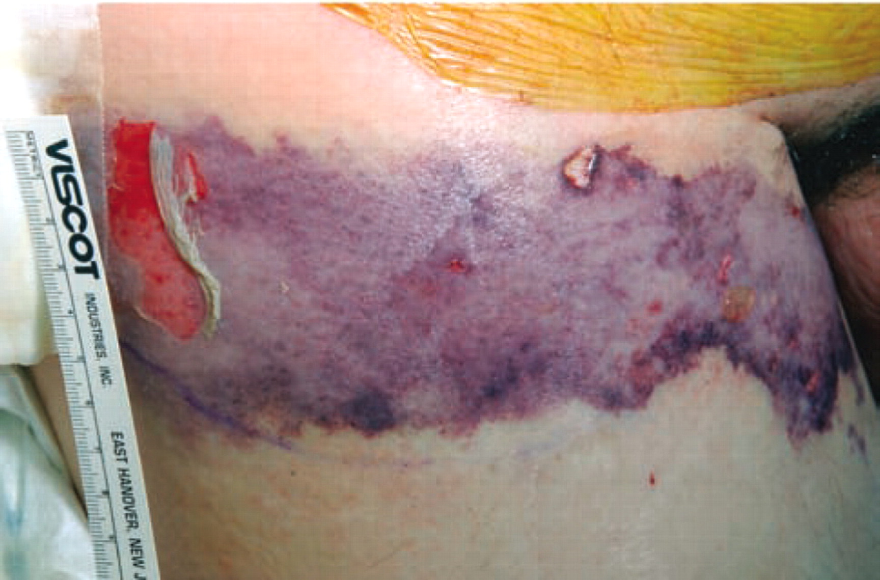
Clinical Significance: Microorganisms that cause infection and disease are known as pathogenic organisms, or pathogens. Members of the genus Acinetobacter are not always pathogenic; one study showed Acinetobacter species thriving on the skin and in the mucous membranes of 43% of non-hospitalized people sampled. However many species of this genus are known to be opportunistic pathogens, meaning they can cause life-threatening infections in individuals with compromised immune systems, typically causing pneumonia. One species, Acinetobacter baumannii, is the fifth most common pathogen implicated in nosocomial (hospital acquired) infections worldwide. Several factors contribute to the ability of A. baumannii to wreak havoc in hospitals:
Image shows A. baumannii infection in a patient’s leg following a gunshot wound.

Taken from Sebeny et al. 2008

- Groups of A. baumanni can create biofilms, sticky films of polysaccharides secreted by the bacteria that surround them and act as a physical barrier to disinfectants and antibiotics.
- A. baumannii is able to survive totally dry surfaces, allowing them to persist on hospital surfaces until able to reinfect a susceptible patient.
- The species is extremely adept at rapidly acquiring antibiotic resistance (an ability that will be discussed later), making treatment of infections all the more difficult.
Mechanism of Resistance: There are a wide variety of mechanisms by which bacteria can resist destruction by antibiotics. These drugs typically target an aspect of bacterial physiology not present in humans, but there are four main methods by which bacteria may escape the lethal effects of antibiotics:
- The bacteria may evolve a new version of a trait that will escape targeting by a specific drug. For example, if a specific antibiotic usually binds to and inactivates bacterial ribosomes, a vital tool for synthesizing proteins, a resistant bacterium may have evolved functional ribosomes that do not possess the site targeted by the drug.
- Biochemical pathways can be adapted to create products that either destroy or inactivate the drug when it enters the cell.
- Cells can prevent the drug from reaching lethal levels by either blocking their entry, or evolving efflux pumps, proteins that shuttle the drug out of the cell before it can do any real damage, somewhat like dumping water out a boat with a bucket before it can sink.
- If a drug would typically block a vital biochemical pathway that most bacteria need to perform to survive, bacteria resistant to this drug may have evolved an alternative pathway that is unaffected by the antibiotic, allowing them to survive and grow unhindered.
As recently as the 1970s, A.baumannii was sensitive to all known antibiotics. What then, has allowed it to play such a major role in hospital acquired infections just 40 years later? For one, the ability of A.baumannii to resist antibiotic treatment has since increased dramatically. Samples of A.baumannii that are resistant to all antibiotics have been reported as early as 2008. Many of these multi-drug resistant strains of A. baumannii are resistant to an entire category of antibiotics, known as beta-lactam antibiotics. This category includes common antibiotics like penicillin and ampicillin, which function by blocking cell wall synthesis in bacteria, causing them to burst when they try to divide. These drugs are named for their “beta lactam” ring in their chemical structures. However, beta-lactam resistant bacteria can produce enzymes called beta-lactamases that destroy these rings and disable the drug before it can do a lethal level of damage, allowing the bacteria to continue infecting patients treated with these beta-lactam antibiotics. This change in the antibiotic’s chemical structure is depicted below:
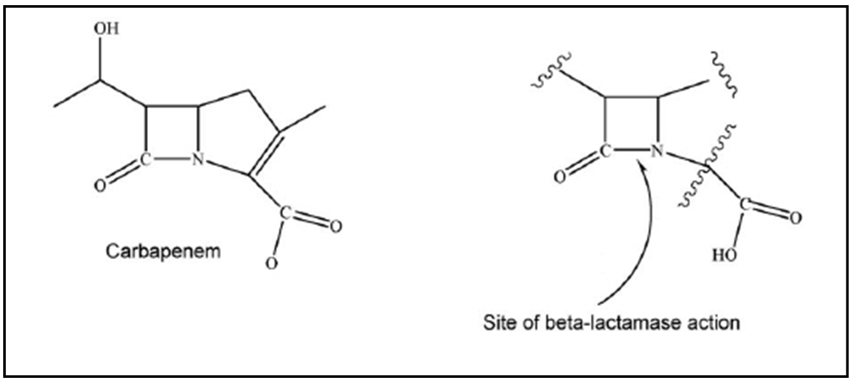
Adapted from UIC College of Pharmacy.

Where does resistance come from?: To use the previous example, beta-lactamases can only be produced if the bacterium possesses a gene in its DNA that codes for the information necessary to produce these beta-lactamase enzymes. The gene that allows these bacteria to produce beta-lactamases can exist on a small DNA molecule separate from the rest of the bacteria’s DNA called a plasmid. These plasmids can be taken up from the environment or swapped between bacteria, allowing pathogens to build resistance by mixing and matching genes with completely different species of bacteria. In a hospital environment, with plenty of exposure to different pathogens, each potentially carrying their own genes coding for resistance to different antibiotics, plasmids can be swapped readily. A baumannii is notorious for being able to pick up any surrounding DNA in the environment, allowing them to gain antibiotic resistance coding genes extremely quickly. This trait evolved due to long-term coexistence in the soil with other microbes that naturally produced their own antibiotics, leading to natural selection favoring strains of A. baumannii that could quickly pick up antibiotic resistance coding genes from their surroundings!
Resistance Worldwide: A. baumannii has been identified as the cause of 1-2% of all nosocomial pneumonia infections worldwide. According to the CDC’s Annual Threat Report, antibiotic resistant organisms in the entire genus Acinetobacter account for just .365% of infections and 2.17% of deaths caused by antibiotic resistant pathogens annually in the US. However, some studies of hospitals in less developed Asian and Middle Eastern countries such as Iran, Taiwan, and India show higher rates of these nosocomial infections due to multi-drug resistant (MDR) Acinetobacter. Do these organisms show differences in rates of resistance across different parts of the globe? The graph below shows the percentage of Acinetobacter that were found to be resistant to antibiotics in samples taken from hospitals in three countries.
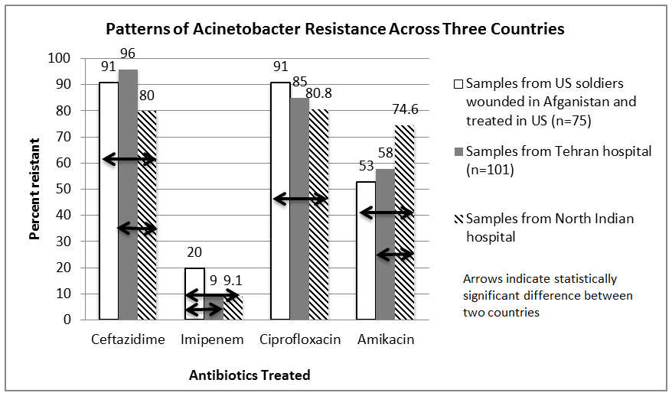
Data from Hujer et al. 2006, Kumar et al. 2013 and Maleki et al. 2014

The rise of MDR bacteria is only made worse by human misuse and overprescription of antibiotics across the world. In countries like India and China, common antibiotics are available for purchase over the counter, and across the world physicians prescribe antibiotics for illnesses not even caused by bacteria, like the common cold. By overusing common antibiotics like tetracycline, humans drastically increase selection for antibiotic resistant bacteria, and accelerate their growth and spread. While promising alternatives are in development, such as administering viruses that only kill the pathogenic bacteria in the body, antibiotics remain extremely vital to healthcare practices across the globe. New antibiotics are not created at a sufficient rate, and once the remaining “last resort” antibiotics are no longer effective, previously common, treatable infections could become much more lethal.
This reading was developed by Jesse Black, an MCB 300 Honors student at the University of Illinois, Urbana-Champaign.

References:
Behzadnia S, Davoudi A, Rezai MS, Ahangarkani F. (2014) Nosocomial infections in pediatric population and antibiotic resistance of the causative organisms in north of Iran. Iran Red Crescent Med J. 16(2):e14562.
Hujer KM, Hujer AM, Hulten EA, et al. (2006) Analysis of antibiotic resistance genes in multidrug-resistant Acinetobacter sp. isolates from military and civilian patients treated at the Walter Reed Army Medical Center. Antimicrob Agents Chemother. 50(12):4114-23.
Hsueh PR, Teng LJ, Chen CY, et al. (2002) Pandrug-resistant Acinetobacter baumannii causing nosocomial infections in a university hospital, Taiwan. Emerging Infect Dis.;8(8):827-32.
Kumar SG, Adithan C, Harish BN, Sujatha S, Roy G, Malini A.( 2013) Antimicrobial resistance in India: A review. J Nat Sci Biol Med.;4(2):286-291.
Maleki MH, Sekawi Z, Soroush S, et al.(2014) Phenotypic and genotypic characteristics of tetracycline resistant Acinetobacter baumannii isolates from nosocomial infections at Tehran hospitals. Iran J Basic Med Sci, 17(1):21-6.
Roca I, Espinal P, Vila-farrés X, Vila J. (2012) The Acinetobacter baumannii Oxymoron: Commensal Hospital Dweller Turned Pan-Drug-Resistant Menace. Front Microbiol, 3:148.
Sebeny PJ, Riddle MS, Petersen K (2008) Acinetobacter baumannii Skin and Soft-Tissue Infection Associated with War Trauma. Clin Infect Dis 47:444–449
"Threat Report 2013." Centers for Disease Control and Prevention. Centers for Disease Control and Prevention, 1 Jan. 2013. Web. 7 Aug. 2014.

UIC College of Pharmacy. "Drug Information Center." University of Illinois at Chicago, n.d. Web. 07 Aug. 2014.

Winstanley C, Taylor SC, Williams PA. (1987) pWW174: a large plasmid from Acinetobacter calcoaceticus encoding benzene catabolism by the beta-ketoadipate pathway. Mol Microbiol., 1(2):219-27.

Expert Questions:
- Why is A. baumannii able to pick up antibiotic resistance more quickly than other species of bacteria?

- Why might populations of A. baumannii in hospitals in developing countries show different rates of antibiotic resistance than those found in the US or Canada? Do you think the problem of resistance would be better or worse in these developing countries?

- What does it mean to be an opportunistic pathogen?

- Can you think of any way to target and destroy specific bacteria in the human body that does not involve antibiotics?

- A specimen of A. baumannii picks up a plasmid that allows it to be resistant to high concentrations of the antibiotic chloramphenicol. This antibiotic typically blocks the ability of bacteria to produce proteins by binding to a specific site on the ribosome. Can you think of a mechanism by which this plasmid could allow A. baumannii to be resistant to this drug?

- Draw a picture of this mechanism of resistance.

