A Brief Microbial Field Guide

Although individual microbial cells are not visible with the naked eye, microbial populations can display visible field marks that can be used to observe and identify them on a macro level. This brief field guide lists just some of the types of microbes that are more commonly found in most water and sediment environments and the field marks that distinguish them.

Sulfide oxidizers:
Sulfide oxidizers are a group of bacteria that eat hydrogen sulfide and breathe oxygen. They live near black sediments rich in hydrogen sulfide. A field mark of sulfide oxidizers is the white scum and fuzz they often produce. They require oxygen and therefore, will not be too deep in the sediment, but may be hidden below the green photosynthetic bacteria and algae. The ideal location for these microbes is where the layers of oxygen rich sediment and anaerobic, hydrogen-sulfide rich sediment meet, such as marine estuaries.

Cyanobacteria:
Cyanobacteria are green photosynthetic bacteria that can be found in nearly all environments with light and water including freshwater, marine, and terrestrial habitats. Cyanobacteria are often in competition with the eukaryotic green algae (who are often a brighter emerald-green color), and the two are often heavily mixed. In freshwater habitats cyanobacteria are often army-green, but can also appear as brown/black patches, gooey reddish-orange floating masses, yellow-brown films floating on the water or attached to vegetation.

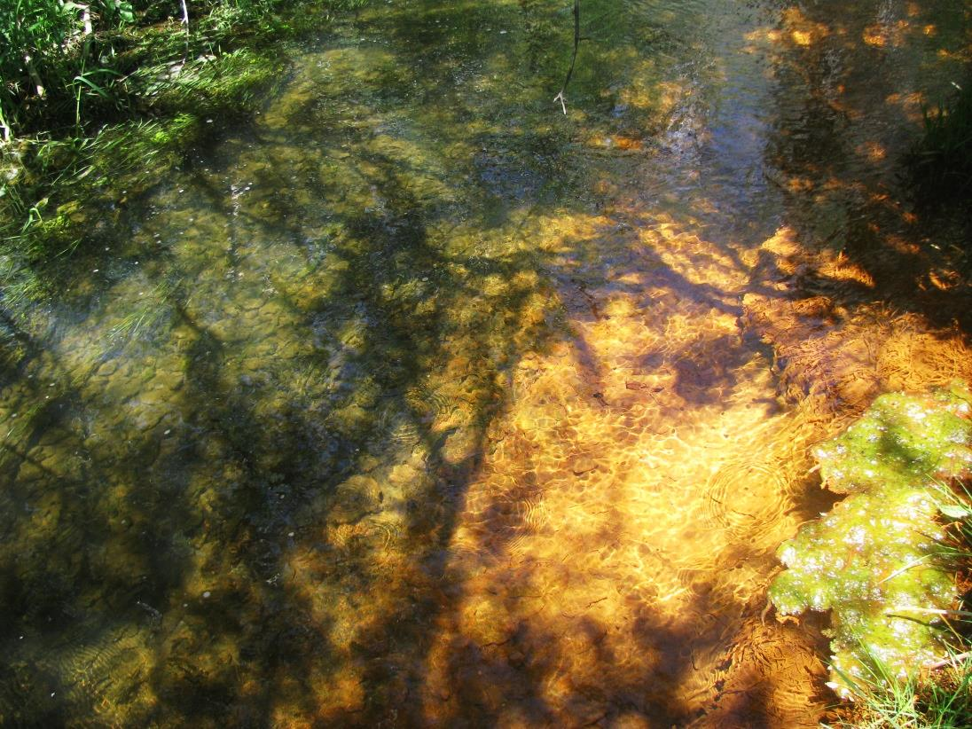
Cyanobacteria and Iron-Oxidizers
Photo by James Henriksen

Green Sulfurs:
Green sulfurs can be seen in anoxic environments that receive light (photic zones) and have high sulfur and low oxygen levels. They can be seen as a thin layer of green beneath the purple bacteria and above a black sediment rich in sulfide.

Halophiles:
Halophiles, as the name suggests, is a group of archaea that thrive in environments with high salt concentrations. They are often aerobic. They can be seen as pink, red, or orange coloring on salt crystals that form in evaporated saline water, salt lakes, salterns, salt crusts, or commercial salt sites.

Iron-oxidizers:
These microbes produce a rust red color, a field mark that appears most often over black sediments. The color is a sign of iron reducers solubilizing solid iron from minerals in the anoxic parts of the sediment.

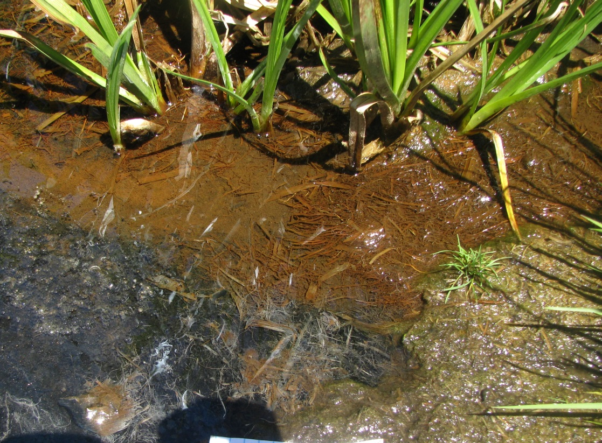
Photo by James Henriksen

Cyanobacteria, Iron-Oxidizers, Sulfur-oxidizers

Methanogens:
Methanogens are archaea that take in hydrogen, acetate, or a few one-carbon compounds and carbon dioxide and produce the gas methane. They can be found in anoxic environments such as below the surface of stagnant, swampy water. If the sediment is stirred and bubbles of gas come up to the surface, this is a sign of the methane produced by methanogens. The gas does not necessarily smell like sulfur and can be flammable. Sediment rich in methanogens is often a deep black color.

Purple Nonsulfurs:
The purple nonsulfurs can be found in anaerobic environments in the photic zone (the layer of the sediment that sunlight can reach) where they can carry out photosynthesis. Some representatives of this group are very metabolically flexible. These bacteria can be found in marine, fresh, hypersaline, or thermal waters, and are common in temporary puddles in hardwood forests.

Purple Sulfurs:
Purple sulfurs use hydrogen sulfide, light and carbon dioxide to make sugars. Therefore, they thrive in environments that are within the photic zone and are rich in sulfide compounds. These bacteria can be found as a purple-pink layer beneath the green cyanobacteria and in contact with sediments that are sulfide-rich, anaerobic, and black in color.
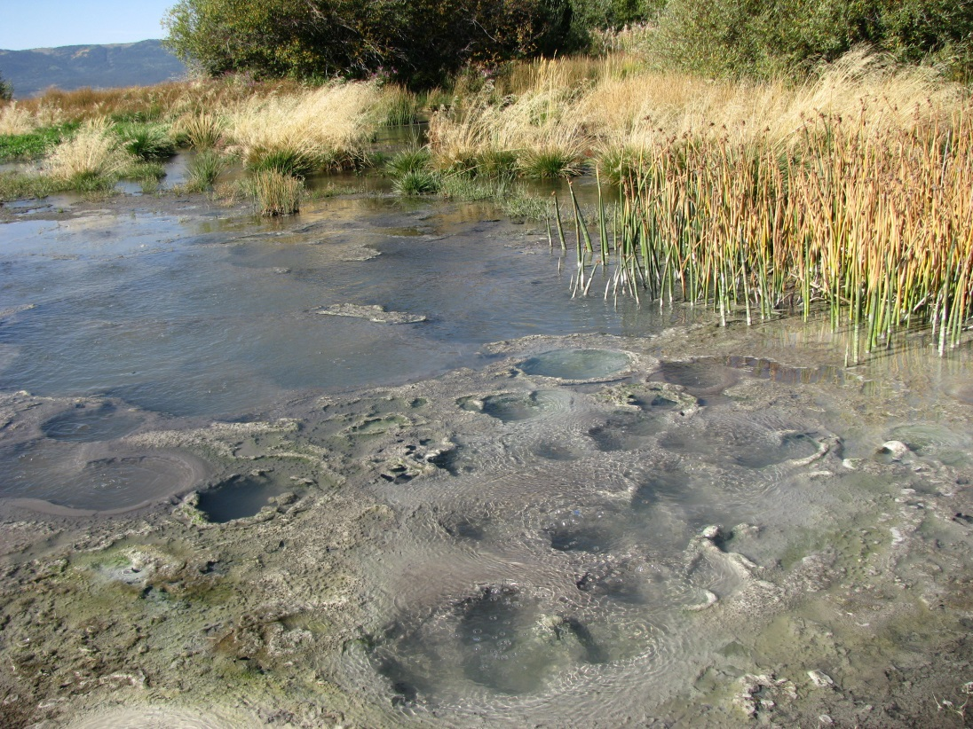
Photo by James Henriksen

Purple Sulfurs

Sulfate reducers:
Sulfate reducers eat hydrogen and sugars and breathe sulfate. They produce hydrogen sulfide which is the stinky smell in rotten eggs. They form a black layer of sediment below the photic zone especially in marine environments where sulfate from seawater is plentiful.

Fermenters:
Fermenters grow without oxygen to produce hydrogen, CO₂, and alcohols like ethanol. They are found in the most anaerobic environments including deep in sediment and human guts. Fermenters make the bubbles of CO₂ in bread, cheese and beer.

Biofilm formers:
Organisms that eat sugars, carbohydrates, and amino acids and breathe oxygen are called aerobic heterotrophs. Many microbes that are aerobic heterotrophs grow in thick gooey layers called biofilms. Biofilms can cause a big problem industrially and in medicine on medical devices because they form a protective layer around a microbial community and prevent antimicrobials from killing them.

Bioluminescence:
Like fireflies, bioluminescent bacteria like Vibrio fischeri can make molecules that are bioluminesce (or glow) when they react with oxygen in the environment. If you have ever swum in the warm ocean at night, the spectacular bioluminescent display comes from bioluminescent microbes.

Note: The information in the field guide portion of the protocol was drawn heavily from the book “A Field Guide to Bacteria” by Betsey Dexter Dyer (2003).

