Name: ____________________________
Putting Microbial Scale in Context
Part 1: Let’s Measure!
For this activity, you will receive four different rulers: one meter (m) ruler, one centimeter (cm) ruler, one millimeter (mm) and one micrometer (µm) ruler. Use these rulers to help you answer the following questions.
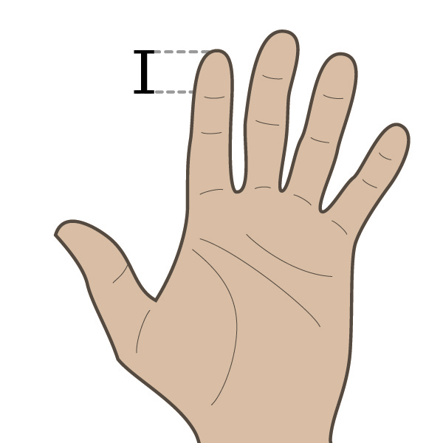
- The tip of your index finger
How long is the tip of your finger in:
- meters (m) __________
- centimeters (cm) __________
- millimeters (mm) __________
- micrometers (µm) __________

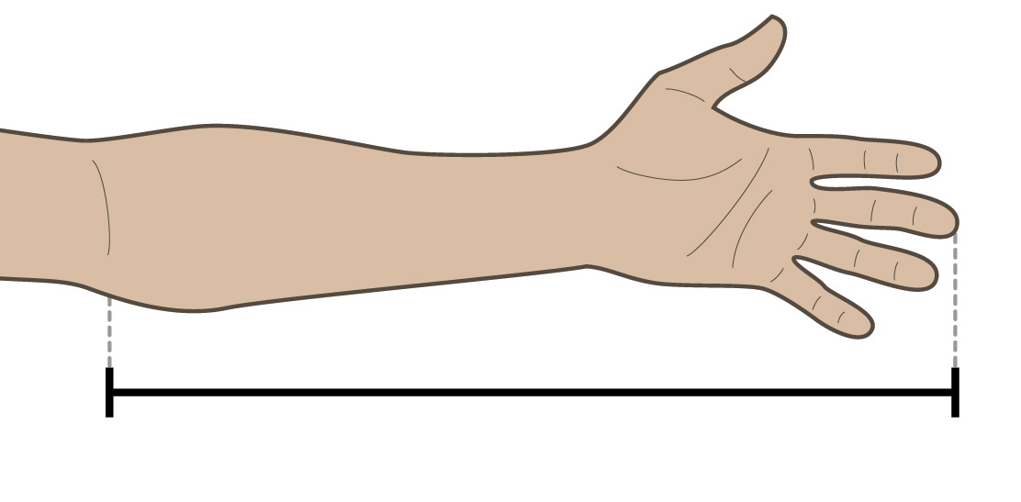
- The distance between your elbow and the tip of your middle finger. Interesting fact: The Egyptian cubit was one of the most popular units of measurement in the ancient world and was the distance between the elbow and the tip of the outstretched fingers.
How long is the length from your elbow to the tip of you middle finger in:
- meters (m) __________
- centimeters (cm) __________
- millimeters (mm) __________
- micrometers (µm) __________

- What do you notice about the relationship between meters, centimeters, millimeters and micrometers?

- Which of these units is the largest unit? Which is the smallest unit?

- Complete the unit conversion line below to help convert from one metric unit to another. The meter is already indicated by “m”. Fill each of the blanks with one of the of following units: mm, cm, and µm
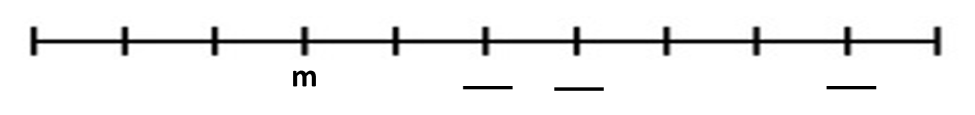

- Using what you know about meters, centimeters, millimeters, and micrometers, construct the conversion table below.

Conversion Table
m | cm | mm | µm
1 | __________ | __________ | __________
__________ | 1 | __________ | __________
__________ | __________ | 1 | __________
__________ | __________ | __________ | 1

Part 2: Using Units
For the list of objects below, indicate what unit of measurement (meter, centimeter, millimeter or micrometer) should be used to measure each of the objects. Write m for meter, cm for centimeter, mm for millimeter and µm for micrometer.

- Length of a football field __________
- Diameter of a pin head __________
- Microbes __________
- Thickness of a penny __________
- Length of your index finger __________
- Thickness of a strand of hair __________
- Diameter of a penny __________
- Height of a door __________
- Thickness of a coat of paint __________
- Length of a car __________
Additional Calculations
- If a microbe is 1µm (like many of them are) how many would fit across the tip of your finger if they were lined up? Hint: Use Part 1 of the worksheet to help you find this answer.

- If the average length of a grain of salt (also of a period) were 0.5mm, how long would this be in micrometers? Hint: Use your conversion tables to help you find this answer.

- If a period that measures 0.5mm is magnified 5,000 times:
  - How big would the period be?

  - How much would this measurement be in m, cm and µm?
__________ m
__________ cm
__________ µm

