Verses from a Campanian Tomb?
Vergil and Silius Italicus’ Punica
8.10.25 – 11.10.25
Villa Vergiliana
Via Cuma 320
80070 Bacoli (NA), Italia

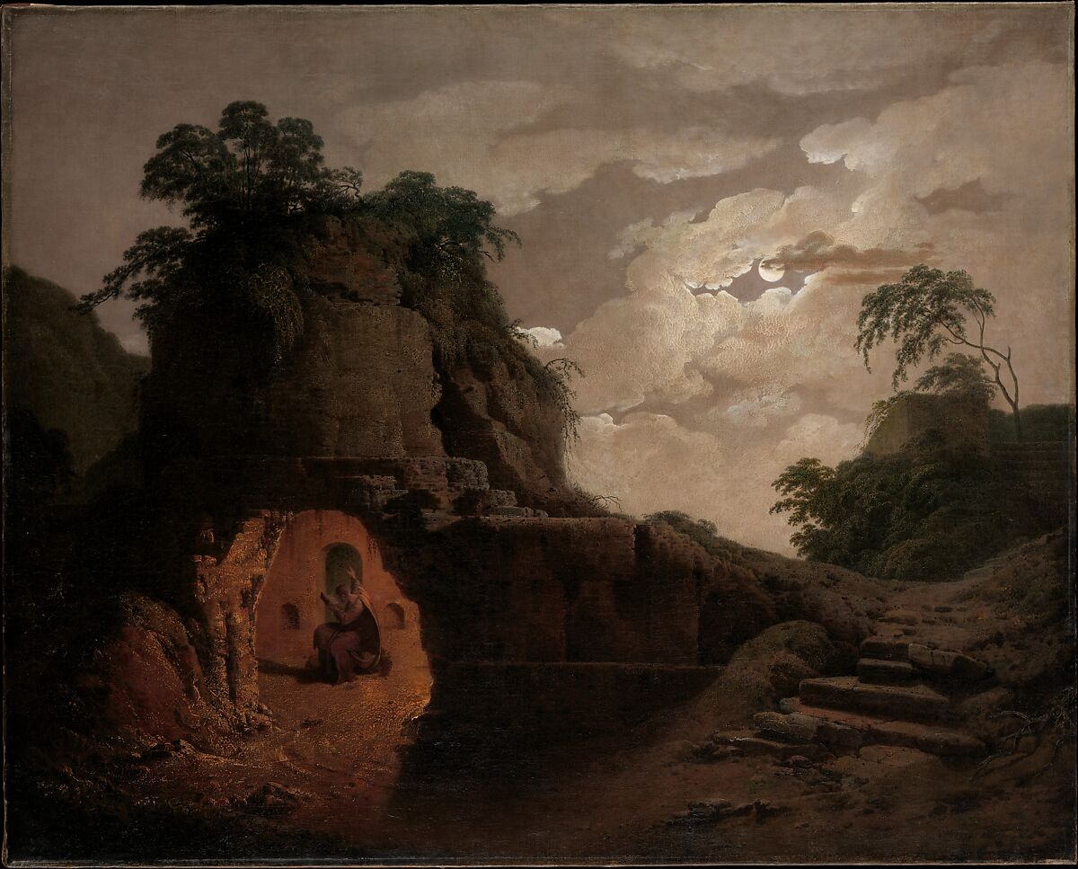
Joseph Wright of Derby (1779), Virgil’s Tomb, with the figure of Silius Italicus

Organized by:
Antony Augoustakis (University of Illinois, Urbana-Champaign)
Clayton Schroer (Emory University)
Under the Auspices of the Vergilian Society
Wednesday, October 8
Afternoon Arrivals
Dinner at 8 PM
Thursday, October 9
Greetings and Welcome
Panel 1: 9 – 10:30
Narratives and Narration
Vergilian Storms, Gods and Narrative Arrangement in Punica 12
Sanne van den Berg, University of Amsterdam (Netherlands)
A Tale of Scipio: A Miniature Aeneid in Punica 15
Lorenzo Severin, University of St. Andrews (UK)
Vergil as Intertextual Linchpin in Silius’ Siege of Saguntum
Ben Broadbent, University of Michigan (USA)
10:30 – 11:00: Coffee
Panel 2: 11:00 – 12:00
“Remember, Roman:” Exemplarity and the Literature of the Past
In the Footsteps of Odysseus: Homeric and Virgilian vestigia in Silian and Flavian Campania
Claire Stocks, University of Amsterdam (Netherlands)
M. Claudius Marcellus in Silius Italicus and Vergil
John Jacobs, Montclair Kimberley Academy (USA)
12:30 – 1:30: Lunch
Panel 3: 2:00 – 3:30
Expectations and Reality
Vergil’s Ascanius, Silius’ Scipio, and the temerarii pueri of the Punica
Theodore Antoniadis, Aristotle University of Thessaloniki (Greece)
Trickery and the Enemy: The Depiction of Greeks in the Aeneid and Carthaginians in the Punica
Arshy Azizi, University of Chicago (USA)
Love, Duty, and Tragedy: Vergilian Influence in the Syphax episode of Punica 17

Angeliki Roumpou, Academy of Athens (Greece)
4:00 – 6:00: Outing to Cuma
7:00: Drinks and Dinner
Friday, October 10
Panel 1: 9:00 – 10:30
Look Who’s Talking
Silius’ Virgil / Silius’ Martial / Martial’s Silius: Literary Inheritance in the Tales of Tagus and Mopsus
Jean-Michel Hulls, Dulwich College (UK)
Virgilian Reflexions in Teuthras’ Episode
Carmela Laudani, Università della Calabria (Italy)
Virrius and Vergilian Fama
Mélissande Tomcik, University of Montreal (Canada)
10:30 – 11:00: Coffee
Panel 2: 11:00 – 12:30
A Hospitable Reception? Dido and Circe
The Temples of Dido and the Senate in the Punica (Sil. 1.81-103; 1.609-629), and Latinus’ Temple in the Aeneid (Verg. Aen. 7.170-191)
Clara Nüsslein, Julius-Maximilians-University Würzburg (Germany)
Echoes of Circe; Mythology and History in Vergil and Silius Italicus’ Punica
Marsha McCoy, Southern Methodist University (USA)
Rome and Carthage: An Intertextual Reading of the Opening Scenes of the Punica
Pieter van den Broek, University of Amsterdam (Netherlands) and Jörn Soerink, Universiteit Leiden (Netherlands)
1:00 – 2:00: Lunch
2:00 – 6:00: Excursion to Baiae
7:00: Restaurant Dinner
At Tenuta Giordano

Saturday, October 11
Panel 1: 9:00 -10:30
Philologies Old and New
Vergil’s “Altars” (Aen. 1.109) and the Republican Epic Tradition in Punica 3.647-714
Brian Walters, University of Illinois at Urbana-Champaign (USA)
Pedagogical or Performative? Towards a Postcolonial Introduction to Vergil and Silius Italicus
Clayton Schroer, Emory University (USA)
Fanaticism and/or Philological Attitude: Silius Italicus as Witness of Vergil’s Indirect Tradition
Marco Fucecchi, University of Udine (Italy)
10:30 – 11:00: Coffee
Panel 1: 11:00 – 12:00
Highlighting Heroism
Heroism and Heartlessness: Regulating the Emotions from Virgil to Silius
Susannah Wright, Rice University (USA)
Sparsa ad pugnam proludit harena: Vergilian Self-Allusions in the Punica
Luigi Maria Guerci, Sapienza Università di Roma (Italy)
12:00 – 12:30: Closing Remarks and Bon Voyage

