**Applying for a Judge Role**

***Volunteer Step-By-Step Help Sheet***

* **Step 1**: *Create a VIMS Account*
  + 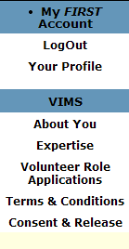Navigate to the Volunteer Information Matching System (VIMS) landing page: <https://my.usfirst.org/FIRSTPortal/Login/VIMS_login.aspx>
  + For instructions on how to create a VIMS Account, please see our Step-by-Step Guide (Found on the landing page of VIMS)
* **Step 2**: *Find & Apply to a FIRST Event*
  + Click on “Volunteer Role Applications” in the left hand navigation bar.
  + Click on “Apply for an Event”
  + Select a *FIRST* LEGO League
  + Select “State/Province”
  + Click “Find Event”
  + Select the appropriate event
  + Select a role
  + Click Submit
* **Step 3**: *Screening*
  + 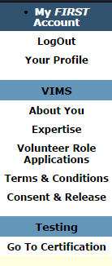Applying to an event will trigger screening. You may defer screening to another time; you must complete the screening process in order to be assigned in the role you have selected for *FIRST* event. If you defer screening, you will be prompted to initiate screening the next time you login to VIMS.
  + See Step 7 in the Step-by-Step Guide
* **Step 4**: *When Assigned* 
  + An email will be sent when a volunteer assignment has been made.
  + Log back into VIMS.
* **Step 5**: *Be your AMAZING SELF!*
  + **Thank you for volunteering! We are so excited to have you join us and can’t wait to see you at our event!**