**SUMMER1 2015**

***Introduction to Japanese Culture***

**EALC 250 日本文化入門**

**MTWRF 9AM-11:20AM**

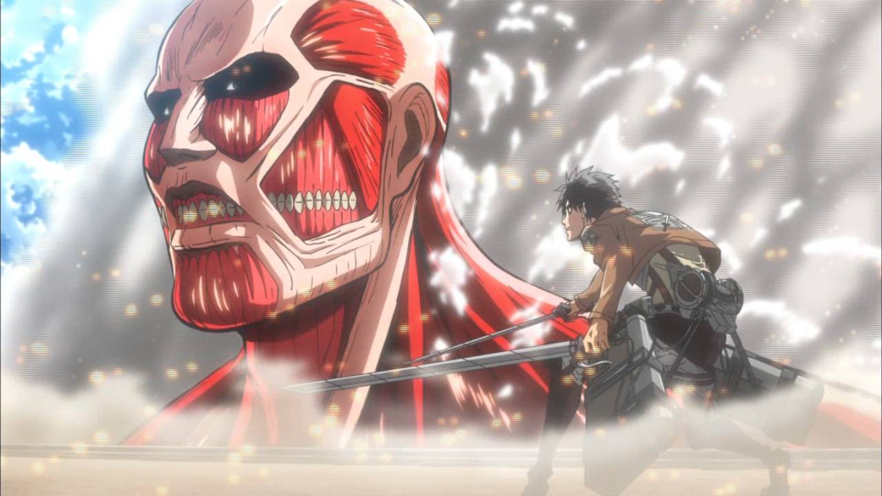 [](http://miku.sega.jp/f/en) C:\Users\onosaka\AppData\Local\Microsoft\Windows\Temporary Internet Files\Content.IE5\7RQF79XI\MC900350612[1].wmfC:\Users\onosaka\AppData\Local\Microsoft\Windows\Temporary Internet Files\Content.IE5\7YG6476B\MC900445124[1].wmfC:\Users\onosaka\AppData\Local\Microsoft\Windows\Temporary Internet Files\Content.IE5\1FE4UBTO\MC900441832[1].wmf

**This course satisfies the General Education Criteria for *BOTH***

1. **Non-Western Cultures**
2. **Social Sciences**