Go Celtic this summer!

English 261 X (summer session II):

Irish Myth and Legend
in the Middle Ages
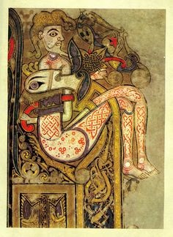
In this course we’ll read the Celtic myths and legends of medieval Ireland: tales of gods and goddesses, Druids and Druidesses, heroes and heroines, and of other world voyages, of strange births and tragic deaths, magical transformations, courtships and cattle-raids.

We’ll also learn about aspects of the history, art, and culture of medieval Ireland.

