Tutorial on Bioinformatic Tools and Approaches to Identify Neuropeptides from the Genome.

A. Hummon and S. L. Rodriguez-Zas
Department of Animal Sciences, University of Illinois
June 2005

Introduction
Neuropeptides are messenger molecules produced by neurons and secreted extracellularly to interact with other neurons. Once secreted, the neuropeptides interact with G-protein coupled receptors on other neurons beginning a signaling cascade. Neuropeptides are cleaved from longer protein sequences called prohormones. The cleavage occurs prior to secretion by enzymes present in the vesicles. A schematic of the cellular organelles involved in prohormone processing is shown in Figure 1.

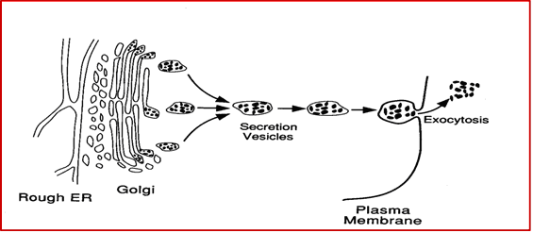

Figure 1 Cellular organelles involved in prohormone processing. The prohormones are synthesized in the rough ER and translocated into the Golgi. Processing begins in the Golgi with cleavage by the enzyme furin. The prohormones are then packaged into vesicles with a complement of processing enzymes. As the vesicle moves toward the cell membrane, additional prohormone convertases cleave the prohormone, producing the neuropeptides. The neuropeptides are released via exocytosis as the vesicle docks with the cell membrane. Figure adapted from Groskreutz et al. Cell Biology and Biotechnology. Springer-Verlag: New York, 1993.

Neuropeptides are cleaved from longer protein sequences called prohormones. A sample prohormone sequence from Drosophila melanogaster is shown below (Figure 2). Some of the neuropeptides have been detected by mass spectrometry and are underlined in the sequence.

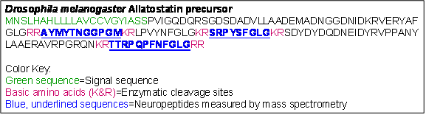

Figure 1 Prohormone sequence of the Drosophila melanogaster allatostatin precursor. The peptides shown in blue and underlined were reported in Baggerman et al. J Biol Chem. 2002, 277(43):40368-74.

Methodology

A successful approach to identify prohormones and associated neuropeptides relies in the integration of genome information available in public databases, bioinformatics tools to detect prohormone sequence signals and molecular biology experiments. Next we describe a series of steps that can be pursued in the annotation of prohormones and neuropeptides in the honey bee genome. These steps can also be applied to other proteins and peptides in species at different stages of their genome sequencing projects.

1) Homology Search
To annotate neuropeptides in a newly-sequenced genome, first the genes need to be located in the genome sequence. One of the best ways to locate genes is to perform homology searches using annotated sequences from other species. Here the allatostatin gene from the honey bee, Apis mellifera, will be located by a homology search with the Drosophila precursor shown in Figure 2.

Basic Local Alignment Search Tool (BLAST) is a well-known search tool for rapid sequence comparison and is used for homology searching. Neuropeptides, protein precursors and gene sequences from other species are used as query sequences in these searches.

When using another neuropeptide precursor as a BLAST query, use a tBLASTn search (protein query against a 6-frame translation of a nucleotide database). An e value of 1 is a good threshold and BLOSUM62 works well as a substitution matrix. Searching with the shorter neuropeptide sequences can also work well. In this case, use PAM30 as the substitution matrix. Alternatively, a nucleotide sequence can be used as the query, then using a BLASTn search.

To perform a BLAST search for the Apis allatostatin gene with the Drosophila sequence, first load the NCBI BLAST site (http://www.ncbi.nlm.nih.gov/BLAST/) (Figure 3).

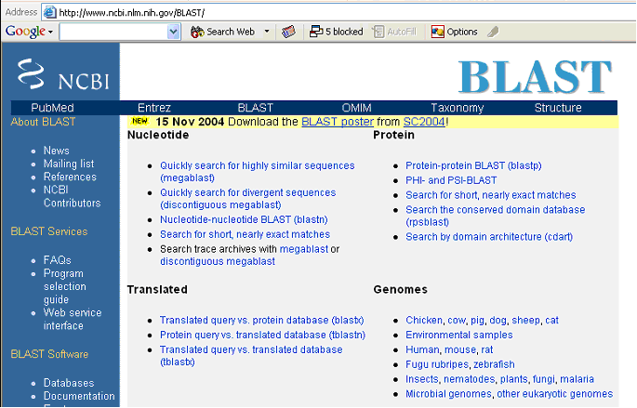
Figure 3 The NCBI BLAST site

A sample tBLASTn query with the Drosophila allatostatin prohormone is shown in Figure 4. The species is set to Apis, the type of search is tBLASTn and the Expect value is set at 10.
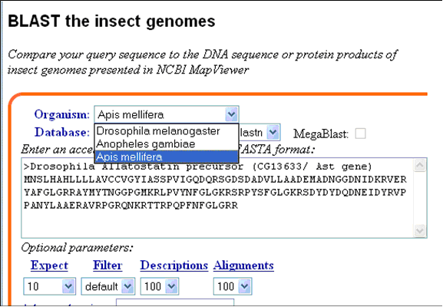
Figure 2 NCBI BLAST page. The honey bee genome is accessed under the section “Genomes” by clicking on “Insects”.

The results with the lowest e value from this BLAST search are shown below in Figure 5.
The BLAST result shown in Figure 5 contains two occurrences of the peptide sequence FGLG, which is the unmodified C-terminal of many allatostatin peptides. For this reason, the sequence will be examined for gene features.

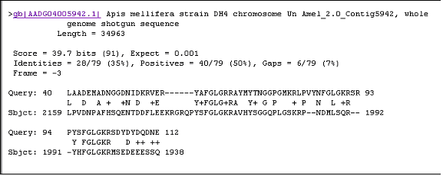
Figure 5 BLAST result with the lowest e value after searching the honey bee genome with Drosophila allatostatin homolog.
To obtain the sequence, click on the accession number (gb|AADG04005942.1|). Select the section of the Apis sequence that corresponds to the BLAST hit, as indicated by the subject or “Sbjct” line in the BLAST result. In this example, the sequence surrounding 2159 to 1938 should be copied (copying an extra ~2000 bp in either direction). Since location of the BLAST corresponds to decreasing locations within the sequence, the homologous match is located on the reverse complement of the genome. Therefore, all annotation needs to use predictions for the reverse complement. Alternatively, one can copy the sequence and then generate the reverse complement. There are several websites that are useful for manipulating sequences. One such site is: http://pga.mgh.harvard.edu/web_apps/dna_utilities.html.

Gene Feature Finding

a) Intron/exon boundary predictor
Once the sequence is obtained, it can be examined for gene features, like intron/exon boundaries. One online intron/exon boundary predictor that works well for insect sequences is found through the Berekeley Drosophila Genome Project page (http://www.fruitfly.org/seq_tools/splice.html).
The webpage to enter a sequence is shown in Figure 6
Results from the intron/exon boundary search shown in Figure 6 are shown in Figure 7.

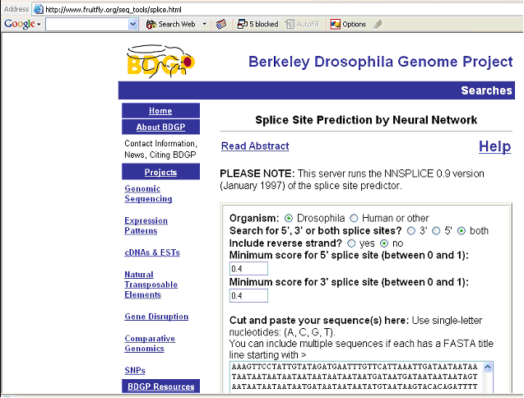
Figure 6 Entry page for the Berkeley Drosophila Genome Project splice site predictor. Note that the default organism is not Drosophila, but human.

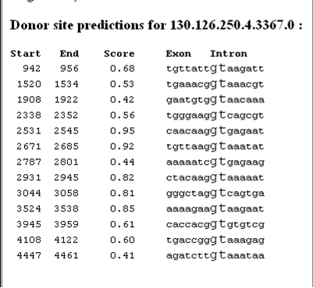
Figure 7 Results from BDGP splice site predictor, donor sites shown, acceptor site predictions not shown.

b) Splicing Prediction (Splice Predictor Online)
Another splice site predictor that works well on honey bee sequences is the Splice Predictor Online (http://bioinformatics.iastate.edu/cgi-bin/sp.cgi). For this predictor, the closest organism to the honey bee is Drosophila. The same honey bee sequence analyzed by the BDGP splice predictor is submitted to the Splice Predictor Online, as shown in Figure 8.

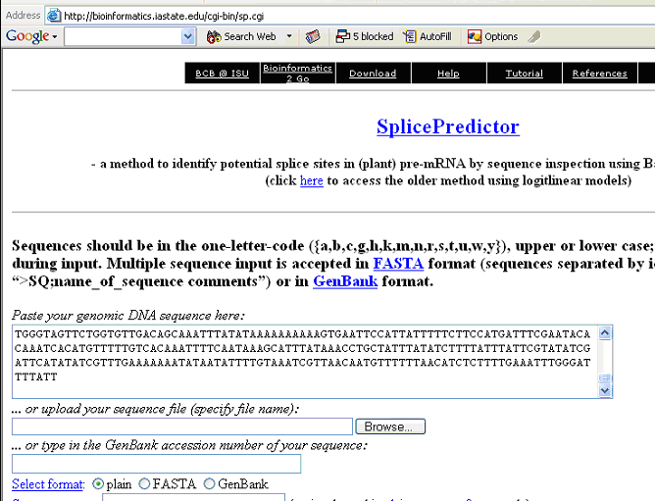
Figure 8 Input site for the Splice Predictor Online website.

The results from this submission to the Splice Predictor Online are shown in Figure 9.

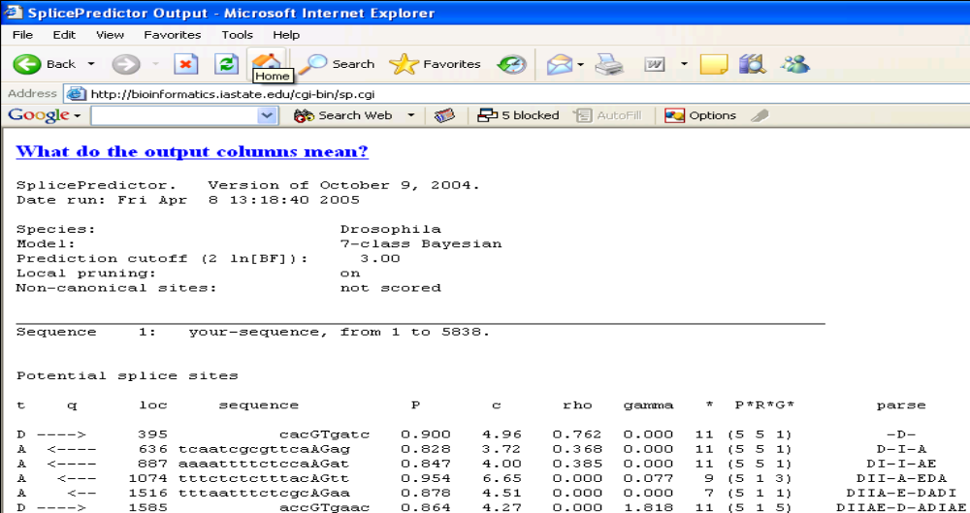
Figure 9 Results from submission of honey bee sequence to Splice Predictor Online. Unlike the BDGP splice predictor, the donor and acceptor sites are listed together.
c) Splicing Prediction (NetGene)r

A third and final splice site predictor that works well with honey bee sequences is the Net Gene 2 predictor (http://www.cbs.dtu.dk/services/NetGene2/). The same sequence is shown being submitted to the Net Gene 2 server is shown in Figure 10.
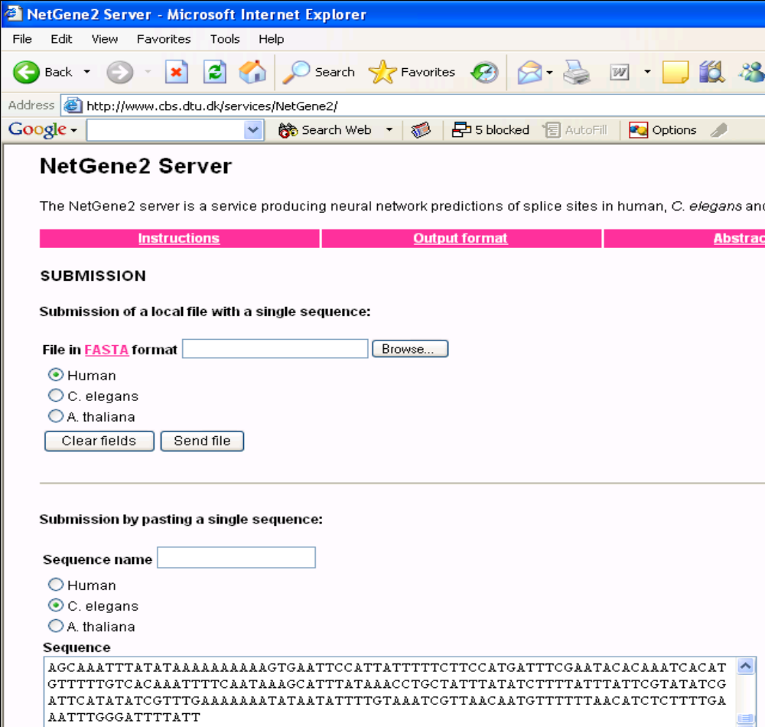
Figure 10 Submission of honey bee sequence to Net Gene2 Splice site predictor. C. elegans is selected as closest organism.

The results from this submission are shown in Figure 11. The donor sites for both the forward and complement strands are shown. The acceptor predictions are not shown.

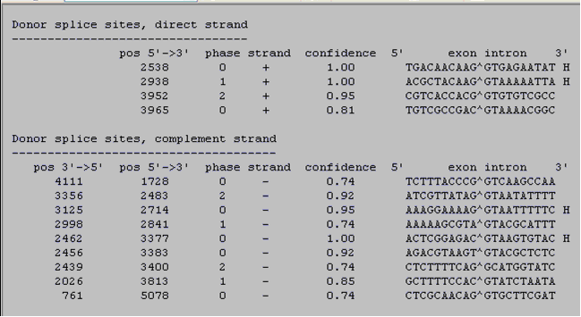
Figure 11 Results from submission of honey bee sequence to NetGene2 server. The donor sites are shown.

Once all three splice site predictions are acquired, they can be compared to determine which sites are conserved in all predictions. Using these sites, the introns and exons can be predicted around the regions of the BLAST hit that contain the FGLG peptide sequence.

Alternatively, the gene structure can also be predicted with a gene predictor and then the splice site predictions can be used to confirm the prediction.

d) Gene Prediction (FGENESH)
To predict gene structure, the HMM-based gene structure predictor (FGENESH at www.softberry.com) is useful. After pasting the nucleotide sequence, select the most similar organism to assist in gene prediction. For example, when annotation honey bee genes, mosquito (Anopheles) or fruit fly (Drosophila) work best.

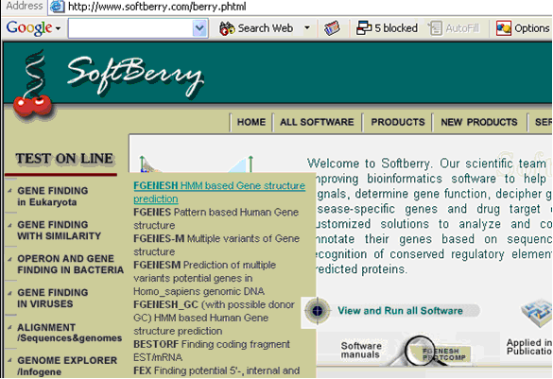
Figure 12 The Softberry site showing the link to FGENESH, for gene structure prediction.

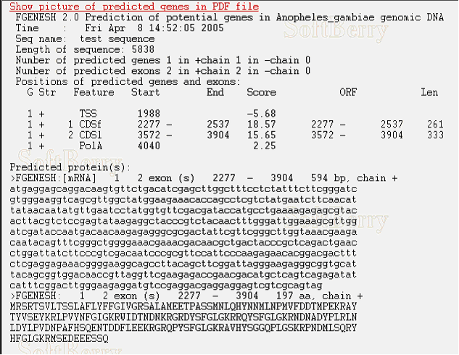
The results from submitting the honey bee sequence to the FGENESH site are shown in Figure 13. In this case, the species selected for comparison was Anopheles.
In this case, the predicted protein contains the repeated FGLG sequence, indicating that this is the honey bee allatostatin protein. Additionally, the exon/intron boundaries predicted by FGENESH match those predicted by the three splice predictors.

e) Identification of the Signal Peptide (SignalP)
As a final check, all neuropeptide precursors have a signal sequence (shown in green in Figure 2). The signal sequence indicates to the cell that the protein, or processed pieces of it, will be secreted extracellularly. Proteins can be examined to confirm if they are signaling molecules at the SignalP server website (http://www.cbs.dtu.dk/services/SignalP/).

The potential honey bee allatostatin prohormone predicted by FGENESH is submitted to the Signal P 3 server shown in Figure 14.

The results from Signal P are shown in Figure 15.
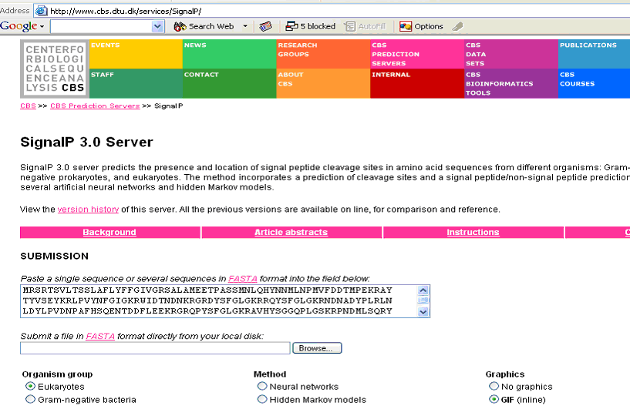
Figure 14 Input of potential honey bee allatostatin prohormone to Signal P server.

As indicated by the graph in Figure 15 and the most likely cleavage site, the protein does have a signal sequence. Given the signal sequence and the FGLG peptide sequence, it confirms that this is the honey bee allatostatin prohormone. The gene is discovered and annotated!

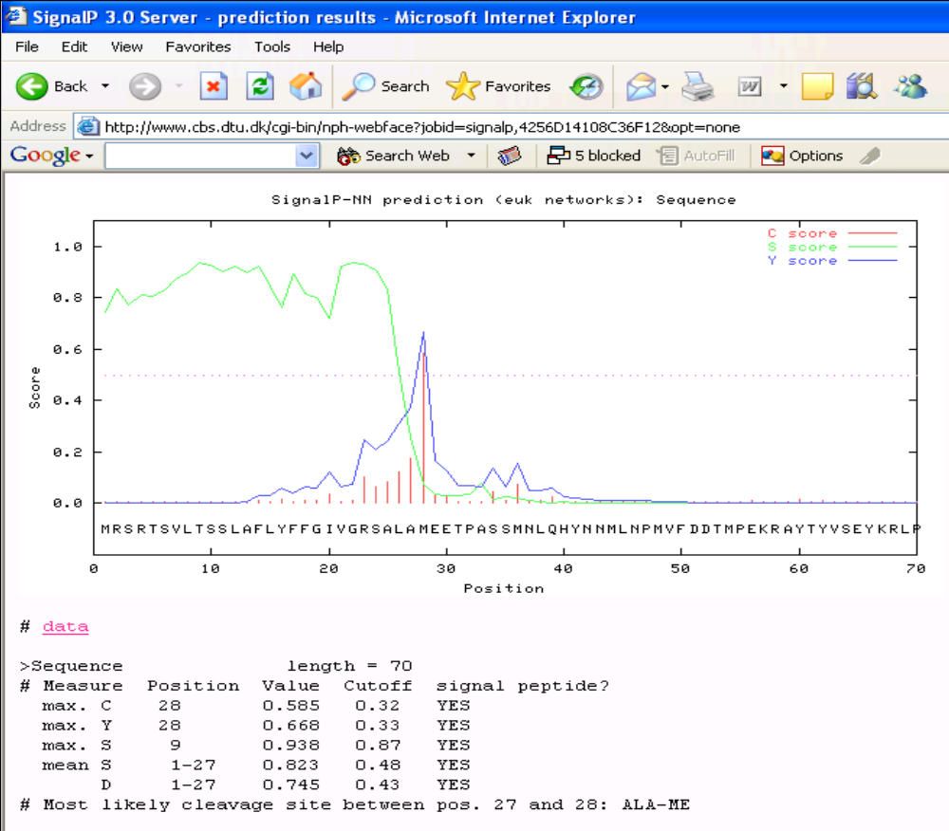Figure 15 Results from Signal P server for potential honey bee allatostatin prohormone

Prediction of Cleavage and Mass Spectrometry Verification

Once the prohormone sequence is determined, the sequence can be analyzed for possible cleavage sites (Hummon et al. J Proteome Res. 2003, 2(6):650-6; Hummon et al. Science 2006 (Accepted)) Once the peptides are predicted, they are confirmed with mass spectrometric analysis of samples.

In the case of this protein, the predicted peptides are AYTYVSEY, LPVYNFGIamide, WIDTNDN, GRDYSFGLamide, RQYSFGLamide, GRQPYSFGLamide, AVHYSGGQPLGS, and PNDMLSQRYHFGLamide (C-terminal amides arise from post-translational conversion of glycines). Most of these peptides have been confirmed by mass spectrometry, further confirming the prediction of this gene.

