Convention Itinerary

Thursday, February 26
Dress: Casual
4:00 p.m. | O’Hare Airport, Chicago | Peoria Charter  Bus Departs from O’Hare Airport  (Conference attendees should board bus parked at the appointed spot at O’Hare Airport.)
4:00 p.m. – 7:30 p.m. | At individual Hotels | Check-In  (All hotels will have a PTS Illinois representative present)
7:30 p.m. – 9:00 p.m. | Green Street/Downtown Champaign | Dinner  With PTS Illinois Members

Friday, February 27
Dress: Business Casual
8:00 a.m. – 9:00 a.m. | At individual hotels | Continental Breakfast  (Provided by hotel)
9:00 a.m. – 9:30 a.m. |  | Travel  From Hotels to Hawthorn
9:30 a.m. – 12:00 p.m. | Hawthorn | Pi Tau Sigma Convention Introduction  -Student Advocacy and U of I Introductions and Welcome  (Gavin Hamilton)  -Best Practices Think Tank  (Sam Zschack)  -Business Meeting Preface  (Laura Chemler and Cynthia Mitchell)
12:00 p.m. – 1:30 p.m. | Hawthorn | Lunch  Introduction of Speaker: Dr. Gloria Wiens,  University of Florida  Speaker: Dr. William King,  Chief Technology Officer,  Digital Manufacturing and Design Innovation Institute
1:00 p.m. | O’Hare Airport, Chicago | Peoria Charter  Bus Departs from O’Hare Airport  (Conference attendees should board bus parked at the appointed spot at O’Hare Airport.)
1:30 p.m. – 2:00 p.m. |  | Travel  From Hawthorn to Tours
2:00 p.m. – 4:00 p.m. | National Center for Supercomputing Applications  Research Park  Caterpillar | Tours  (all travel times included)
4:00 p.m. – 5:30 p.m. | iHotel – Illinois Room | Department Head Panel  Moderator: Dr. Antonios Kontsos,  Drexel University  Dr. Placid Ferreira, University of Illinois at Urbana-Champaign  Dr. Farzad Mashayek, University of Illinois at Chicago  Dr. Jaal Ghandhi, University of Wisconsin  Dr. Keith Bowman, Illinois Institute of Technology  Dr. Anil Bajaj, Purdue University
6:00 p.m. – 8:00 p.m. | iHotel – Illinois Room | Dinner  Welcome and Roll Call  Dr. Mun Choi, University of Connecticut  “Future of Mechanical Enginerring”  Mr. J. Robert Sims, President of ASME
8:00 p.m. – 10:00 p.m. | iHotel – Illinois Room | Business Meeting
9:30 p.m. – 12:30 a.m. |  | Travel  From iHotel to Union
10:00 p.m.+ | Illini Union | Social Event

Convention Itinerary (Cont’d)

Saturday, February 28
Dress: Business Professional
7:30 a.m. – 8:30 a.m. |  | Shuttle  From Hyatt to iHotel
8:00 a.m. – 9:00 a.m. | iHotel – Illinois Room | Breakfast  “History of Pi Tau Sigma”  Dr. Chris Wilson,  Tennessee Technology University
9:00 a.m. – 12:00 p.m. | iHotel – Illinois Room | Competition: Combine It  Moderator: Dr. Antonios Kontsos,  Drexel University
12:00 p.m. – 1:30 p.m. | iHotel – Illinois Room | Lunch  Introduction of Speaker: Dr. Chris Wilson, Tennessee Technology University  “Future of Making Things and Autodesk Fusion 360”  Mr. Dan Banach, Autodesk Inc.
1:30 p.m. – 2:30 p.m. | iHotel – Illinois Room | Initiations  Moderators:  Dr. Mun Choi, University of Connecticut  Dr. Alex Moutsoglou, South Dakota State University
2:30 p.m. – 3:30 p.m. | iHotel – Illinois Room | Career Panel  Moderator: Alex Moutsoglou
3:30 p.m. – 4:00 p.m. |  | Travel  From iHotel to Engineering Quad
4:00 p.m. – 4:30 p.m. | Engineering Quad | Group Picture
4:30 p.m. – 6:00 p.m. | Mechanical Enginnering Laboratory  -John Deere Pavilion | Career Fair  MechSE Lab Tours
6:00 p.m. – 6:30 p.m. |  | Travel from MEL to iHotel
6:30 p.m. – 8:30 p.m. | iHotel – Illinois Room | Dinner  Chapter Awards  National Officers  “Mechanical Engineering $ΠΤΣ$ Centennial: ‘Making’ for a Bright Tomorrow”  Mike Molnar
8:30 p.m.+ | Green Street | Social Event

Sunday, March 1
Dress: Business Casual
8:00 a.m. – 8:30 a.m. |  | Shuttle  From Hotels to iHotel
8:30 a.m. – 10:00 a.m. | iHotel – Illinois Room | Breakfast  Closing Remarks:  Dr. Alex Moutsoglou  Update on Next Year’s Convention  University of Southern California
10:00 a.m. -11:00 a.m. | iHotel/Hyatt | Checkout
11:00 a.m.-2:30 p.m. |  | Peoria Charter  Departs from Hotels

Competition
Combine It!

This year’s convention will feature an engineering competition, Combine It, where engineering meets creativity in an explosion of imagination. This challenge will put your entrepreneur, presentation, and innovation skills to the test. Attendees will be placed in random groups to tackle this challenge head on. Be ready to design, draw, present, and most importantly have fun! Separate prizes will be awarded for creativity, presentation, and innovation as voted on by YOU!

Contact Information

Pi Tau Sigma – Illinois Alpha
Gavin Hamilton, Convention Chair – ghamilt2@illinois.edu | Phone: (781) 534-8354
Samual Zschack, Chapter President – zschack2@illinois.edu

Accomodations

iHotel
1900 S First St. Champaign, IL 61820
Phone: (217) 819-5000

Hyatt Place Hotel
217 N. Neil St. Champaign, IL 61820
Phone: (217) 531-2800

Emergency Information

All police, fire, and medical emergencies – 911 (or 9-911 from campus telephone)
University police non-emergency – (217) 333-1216
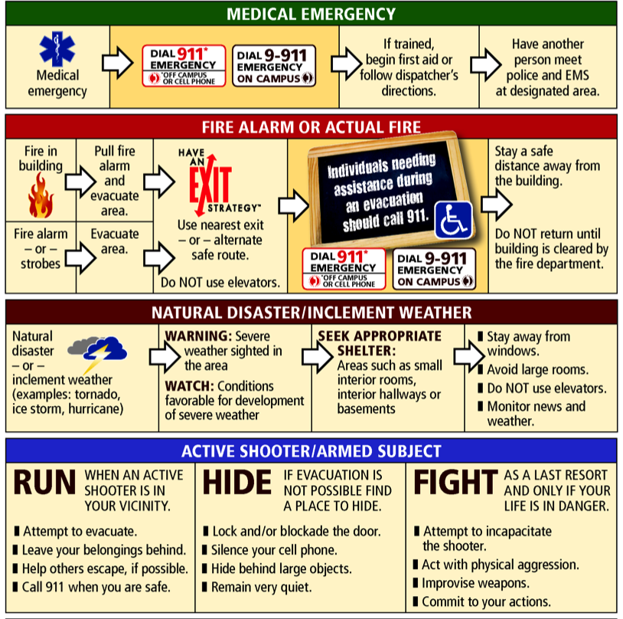

Sponsors
The Pi Tau Sigma – Alpha Chapter of the University of Illinois would like to thank our generous sponsors for making the 2015 National Convention possible:

Platinum

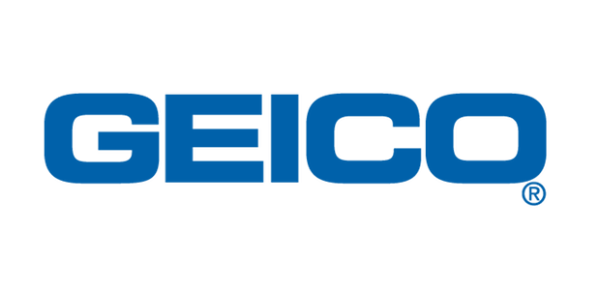
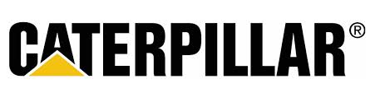
Gold
Silver

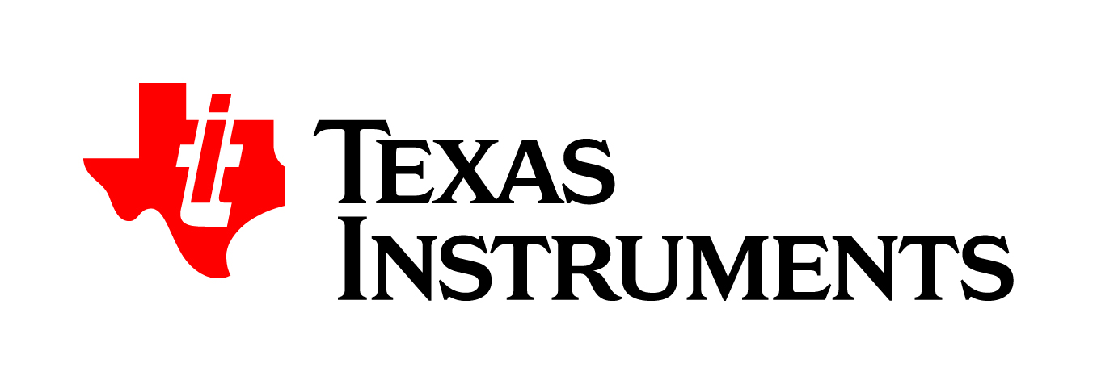
Bronze

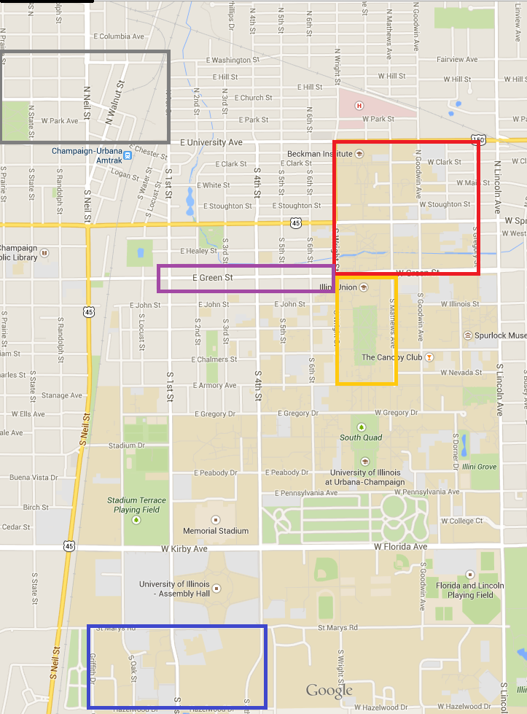
Map of UIUC
iHotel/Research Park
Main Quad
Engineering Quad
Green St
Downtown
Champaign

Downtown Champaign
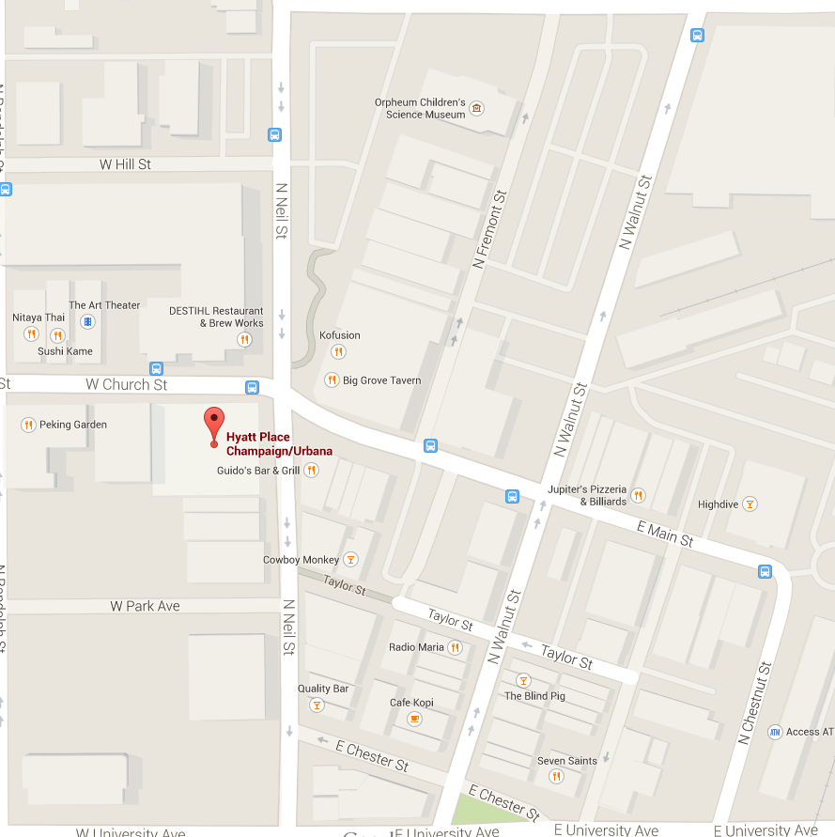
8
7
6
5
4
3
2
1

Accommodations
1. Hyatt Place Hotel

Restaurants
Each $ = ~$10
2. Destihl ($$$)
3. Peking Garden ($)
4. Farren’s Pub & Eatery ($$)
5. 301 Mongolia ($$$)
6. Kofusion ($$$)
7. Big Grove Tavern ($$)
8. Seven Saints ($$)

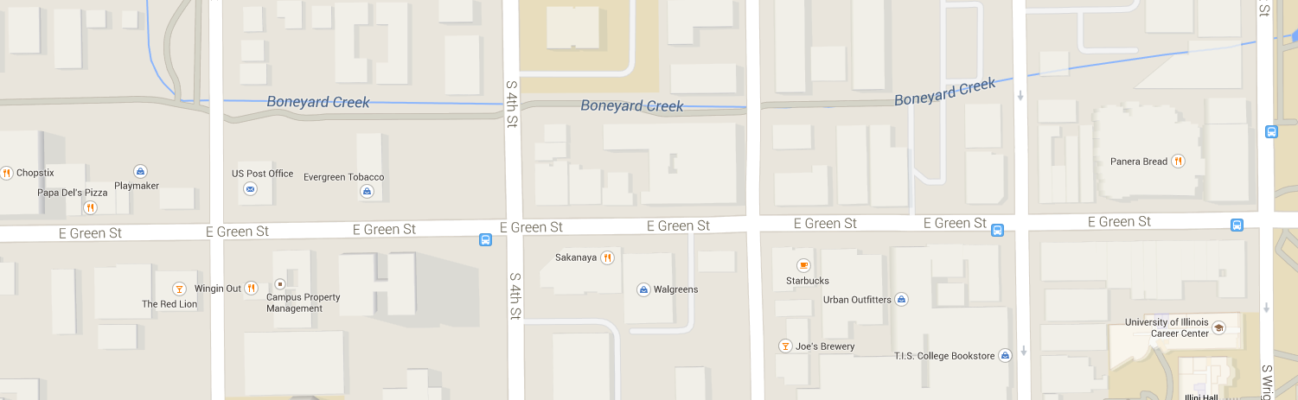
Green Street
16
15
14
13
12
9
10
11
8
7
6
5
4
3
2
1

Restaurants
Each $ = ~$10
1. Papa Del’s Pizza ($)
2. Lai Lai Wok ($)
3. Bombay Indian Grill ($)
4. Sakanaya ($)
5. Torticas ($)
6. Bankok Thai ($)
7. Empire Chinese ($)
8. Potbelly’s ($)
9. Chipotle ($)
10. Noodles & Company ($)
11. Flat Top Grill ($$)
12. Jimmy John’s ($)
13. McDonald’s ($)
14. Subway ($)
15. Mia Za’s ($)
16. Zorba’s ($)

Engineering Quad

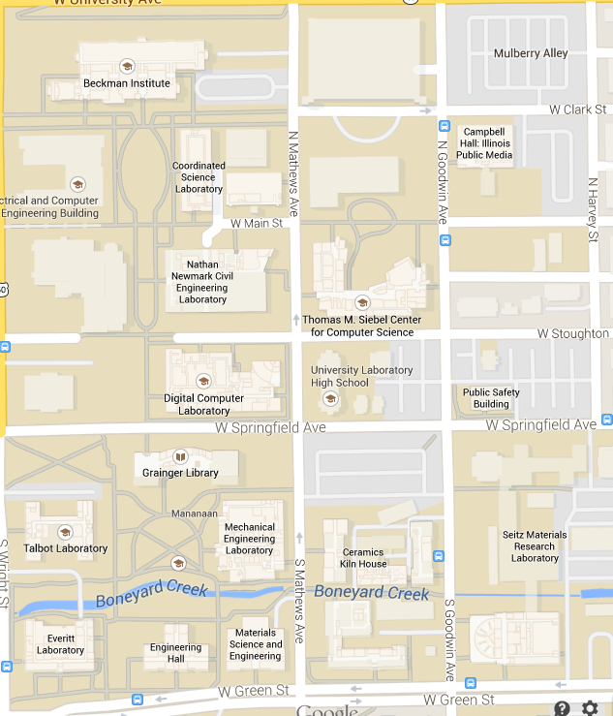

Main Quad
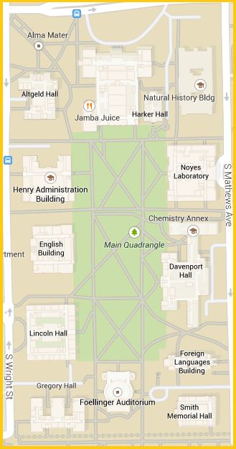

Convention Locations
1
1. Illini Union

iHotel/Research Park
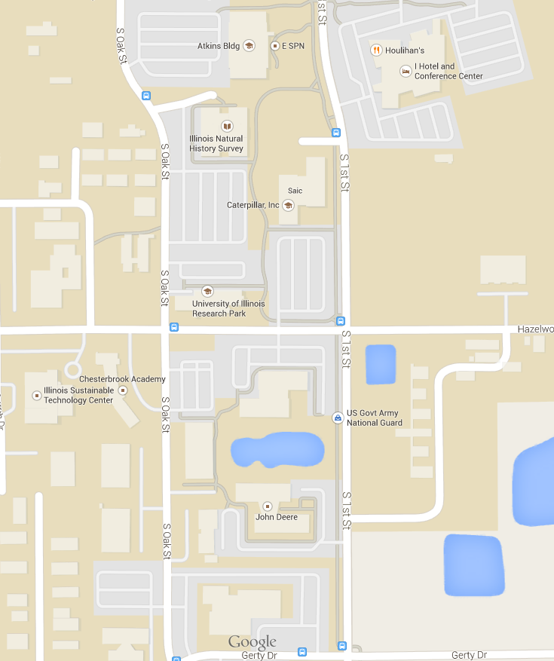
Convention Locations
1
1. iHotel
2. Research Park
2

Featured Speakers

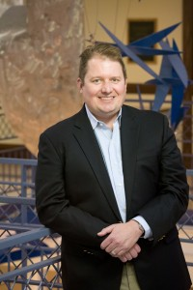
Prof. William P. King, Ph.D

William P. King, Ph.D. is the Chief Technology Officer at the Digital Manufacturing and Design Innovation Institute at UI LABS in Chicago, IL, where he directs a $200M portfolio of technology investments focused on the future of manufacturing. He is Professor in the Departments of Mechanical Science and Engineering, Materials Science and Engineering, and Electrical and Computer Engineering at the University of Illinois Urbana-Champaign, where he holds the Ralph A. Andersen Endowed Chair.

Dr. King received a Ph.D. from Stanford University and completed the Program for Leadership Development at Harvard Business School.

Dr. King has been founder, adviser, or director at a dozen early stage technology companies with a focus on nanotechnology, materials, and manufacturing. He is an accomplished leader of projects that cross the boundaries between science, technology, and business.

Dr. King has consulted for numerous companies on technology strategy, advanced manufacturing, and materials. Dr. King holds many patents and often consults on projects related to technology strategy and intellectual property.

Dr. King is the winner of numerous awards for science and technology accomplishments, including the PECASE award from the White House and the ASME Gustus-Larson Award for accomplishment in Mechanical Engineering. He was named by Technology Review Magazine as a person whose innovations will change the world.

Dr. King has published 200 journal articles and is a Fellow of ASME, AAAS, and APS.

Featured Speakers (Cont’d)

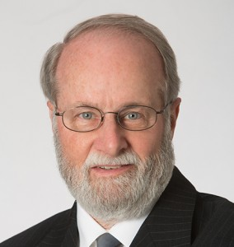
J. Robert Sims, ASME President
“Future of Mechanical Engineering”

J. Robert Sims is the 133rd president of the American Society of Mechanical Engineers serving the 2014-2015 term of office. Sims has been an active member of the Society for more than 33 years and is a recognized authority on risk-based technologies. He is a senior engineering fellow with Becht Engineering Co., Inc. where he provides consulting services in failure analysis of pressure equipment, pressure vessel and piping system design and analysis, mechanical integrity evaluation and Fitness-For-Service analysis, and the design of high pressure oil and gas well equipment.

Prior to joining Becht Engineering in 1998, Sims worked for more than thirty years with Exxon (now ExxonMobil), the last ten years as a pressure equipment specialist with worldwide responsibility for standards and improving equipment integrity. He has led multidisciplinary teams in performing risk analyses and has managed technology development in the area of flaw evaluation. Sims is a fellow of ASME and has served in a number of leadership roles, particularly in areas involving the Society’s codes, standards and certification processes. He served as senior vice president for ASME Standards and Certification (2005-2008), vice president for Pressure Technology Codes and Standards (1999-2002), chair of the Pressure Technology Post Construction Committee (1995-2001), and was a member of the ASME Board of Governors from 2010-2013. He is past vice chair and current member of the ASME/API Joint Fitness for Service Committee and is a member of a number of Standards and Certification committees and subcommittes.

Sims is the recipient of the Society’s Dedicated Service Award (1995), the J. Hall Taylor Codes and Standards Medal (2004) and the Melvin R. Green Codes and Standards Medal (2006). He has more than 30 publications and two patents to his credit and is a frequent speaker and chair at technical forums.

Sims earned his degree in mechanical engineering from Vanderbilt University and served two years as a commissioned officer in the United States Navy.

Featured Speakers (Cont’d)

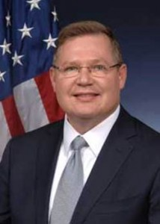
Mike Molnar, Director of NIST Advanced Manufacturing
“Mechanical Engineering $ΠΤΣ$ Centennial: ‘Making’ for a Bright Tomorrow”

Mike Molnar likes to be introduced simply as "a manufacturing guy from industry" with nearly 30 years of experience in advanced manufacturing. To help provide an industry focus in 2011 he was named the first Chief Manufacturing Officer of the National Institute of Standards and Technology. Today Mike leads the NIST Advanced Manufacturing Program Office for extramural manufacturing programs and also serves as the director of the interagency Advanced Manufacturing National Program Office. As called for by the Advanced Manufacturing Partnership initiative, the AMNPO's mission is to foster industry-led partnerships and to form a "whole of government" approach to strengthen competitiveness and innovation in U.S. manufacturing.

Mike's experience includes leadership roles in advanced manufacturing, metrology, manufacturing systems, quality, technology development, sustainability and industrial energy efficiency. His credentials include service as a Federal Fellow in the White House Office of Science and Technology Policy, and election as Fellow of both the American Society of Mechanical Engineers and the Society of Manufacturing Engineers. He is a licensed Professional Engineer, a Certified Manufacturing Engineer and a Certified Energy Manager. He received a Master of Business Administration from the University of Notre Dame, and both a Master of Science in Manufacturing Systems Engineering and a Bachelor of Science in Mechanical Engineering from the University of Wisconsin. He is an active member of professional societies, consortia and volunteer organizations.

Thermo Song
Tune: Battle Hymn of the Republic

Free energy and entropy were swirling in his brain,
With partial differentials and Greek letters in their train,
For Delta, Sigma, Gamma, Theta, Epsilon, and Pi,
Were driving him distracted as they danced before his eyes.

Chorus:
Glory, Glory, dear old Thermo,
Glory, Glory, dear old Thermo,
Glory, Glory, dear old Thermo,
It’ll get you by and by.

They asked him on the final if a mole of any gas,
In a vessel with a membrane through which hydrogen could pass,
Were compressed to half its volume what the entropy would be,
If two-thirds Delta Sigma equals one-half Delta P.
(Chorus)

He guessed that the entropy would have to equal four,
Unless the second law would bring it up a couple more,
But then it might be seven if the thermostat was good,
Or it might be almost zero if once rightly understood.
(Chorus)

The professor read his paper with a corrugated brow,
For he knew he’d have to grade it but he didn’t quite know how,
Till a sudden inspiration on his cerebellum smote,
And he seized his trusty fountain pen and this is what he wrote.
(Chorus)

Just as you guessed the entropy, I’ll have to guess your grade,
But the second law won’t raise it to the mark you might have made,
For it might have been 100 if your guesses had been good,
But I think it might be zero till their rightly understood.
(Chorus)

