How do microbes influence the presence of acne?
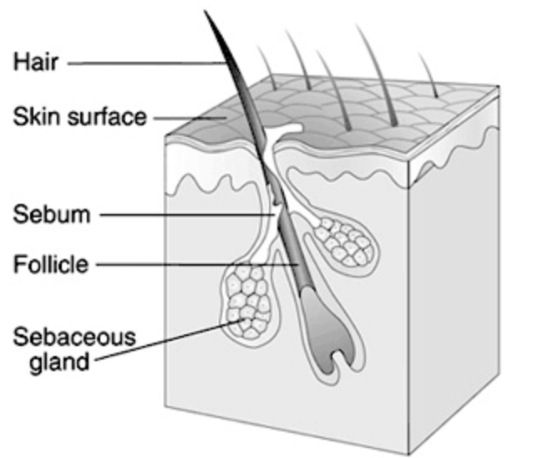
It is very likely that most teens will experience the burden of acne. Around 80% of people in America have struggled with acne, and it’s a persistent problem in dermatology. It’s so common that it is considered a normal part of becoming an adult. Acne can be difficult to treat; some people have tried countless medications, prescriptions, and over the counter drugs, and none of them have seemed to have lasting results.
Figure 1. Pore structure
Public Domain
Acne is an infection that occurs in the pores, which are small holes that cover most surfaces on the body. Inside pores, there are multiple sebaceous glands that produce an oily substance called sebum. The sebaceous glands are connected to the rest of the pore by tiny channels, or ducts. Sebum production increases during puberty because of changes in hormone levels. Sebaceous gland ducts can become blocked and infected with the bacteria Propionibacterium acnes.
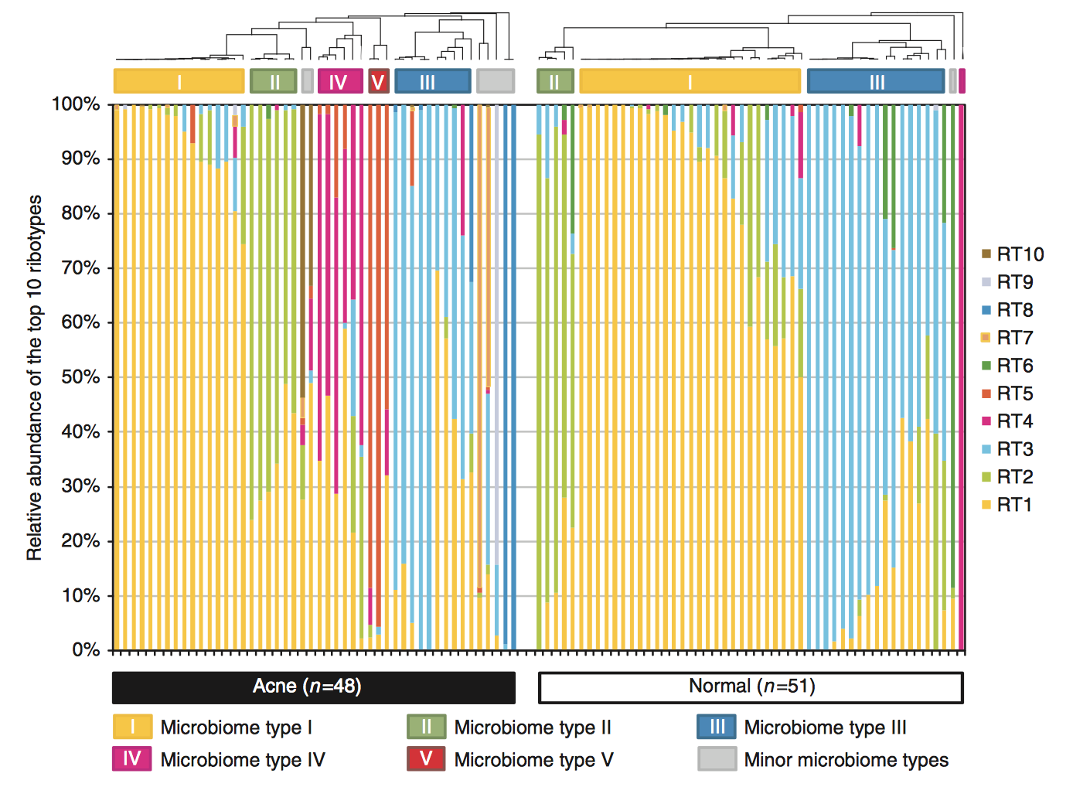
It is a widely accepted fact that bacteria can cause infection, but many people are unaware that bacteria and other microbes live harmlessly inside and outside our bodies. P. acnes is actually part of the normal microbial community that resides on the face. Commensalism is a relationship between two organisms in which one benefits and the other is unaffected. Here, the P. acnes benefits from this relationship because the human skin is its ideal environment. In a normal situation, the human remains unaffected by the presence of the bacteria.
Figure 2. (adapted from Fitz-Gibbon et al., 2013) Visual representation of the abundance of ribotypes of P. acnes. Each bar on the x-axis represents a different individual’s sample, with the left side being samples from acne patients, and the right side being samples from healthy individuals. The y-axis shows the fractions within the total sample of the various ribotypes present. Although P. acnes is present in all samples, certain ribotypes are highly associated with acne.
Acne occurs when the P. acnes on our skin acquires pathogenic capabilities, or the abilities to produce infection. Researchers did a study that sampled the microbial communities of 49 acne patients and 52 healthy individuals. They found that the amount of P. acnes present in the pores of acne patients and normal individuals were similar. However the strains of P. acnes noticeably contrasted between the two groups. Strains are groups of bacteria of the same species that have slight variations in DNA sequences. To characterize these differences, the researchers sequenced a gene that all bacteria have: the 16S ribosomal DNA. Researchers classified the different strains of P. acnes by ribotype, or the unique genomic fingerprint containing the 16S ribosomal DNA sequence. Figure 2 demonstrates the discovery that some strains are uniquely associated with acne patients and are characterized as pathogenic.
It can be tricky to get rid of these pathogenic strains. It has recently been suggested that P. acnes forms biofilms within pores. Biofilms are groups of microorganisms that collectively adhere to each other and attach to a surface. A common example of a biofilm is the plaque that forms on teeth. The cells in biofilms are protected by an extracellular matrix that can withstand harsher conditions and facilitate microbial communication.
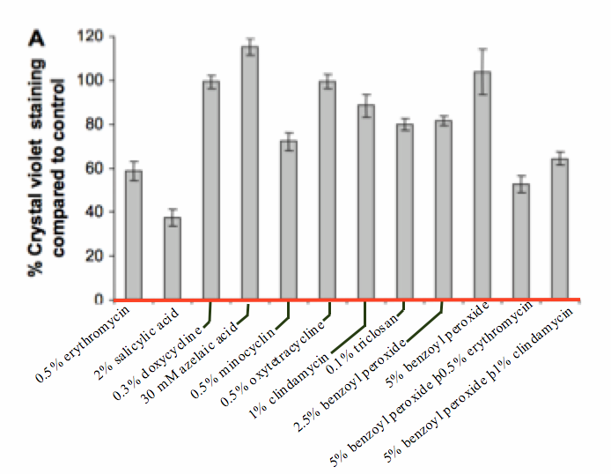
A major benefit to this environment is the improved ability to be resistant to antibiotics. The extracellular matrix and the dense outer layer of cells protect inner cells by preventing antibiotic agents from reaching them.
Figure 3. (adapted from Coenye et al., 2007) Percent of biofilm mass remaining after treatment with different antibiotics compared to the control, which received no antibiotic treatment. Biofilms play a key role in the persistence of acne and ineffectiveness of many treatments. The red line at the bottom zero marker represents the free cells that would be fully inhibited in the presence of every type of antibiotic.
Researchers conducted a study to measure the effectiveness of certain antibiotic medications at decreasing biofilm mass of P. acnes. Before conducting the experiment, it was determined that all of these antibiotics completely inhibit the growth of free cells that are not part of a biofilm. In the study, colonies of bacteria were allowed to grow and form biofilms for a 24-hour period before antimicrobials were added. Crystal violet staining was used to determine the amount of bacteria present. Crystal violet is a dye that makes bacterial cells easily visible under a microscope. Figure 3 demonstrates the varying effectiveness of each these medications.
There has been a great deal of research conducted on this pesky disease. Armed with knowledge about the variety within skin microbiomes and awareness of biofilms, researchers are making great strides of progress toward a more foolproof solution.

This reading was developed by Robin Rice, an MCB 300 Honors student at the University of Illinois, Urbana-Champaign.

References:
Article adapted from:
Coenye T, Peeters E, Nelis H. (2007) Biofilm formation by Propionibacterium acnes is associated with increased resistance to antimicrobial agents and increased production of putative virulence factors. Research in Microbiology.158, 386–392.

Fitz-Gibbon S, Tomida S, Chiu B, et al. (2013) Propionibacterium acnes strain populations in the human skin microbiome associated with Acne.” Journal of Investigative Dermatology. 133, 2152–2160.
Expert Questions:

- According to the information contained in the reading, which ribotypes are uniquely associated with acne patients?

  - In general, what can you conclude about the effectiveness of antibiotics?

  - Which antibiotic has the greatest effects?

  - Which antibiotic has the least effect?

- Figure 3 shows the amount of bacteria as a percent of crystal violet staining compared to the control. What is a possible explanation for why some antibiotics have a value over 100%?

- Considering all the information contained in this reading, propose a reason for why certain ribotypes seem to contribute more to acne formation.

- Propose a future study that would help determine the traits that contribute to the pathogenicity of the ribotypes associated with acne.

