**Road Race 2015:**

[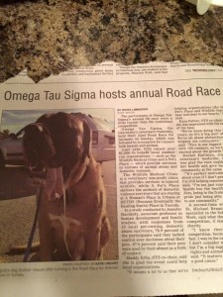](http://publish.illinois.edu/omegatausigma/files/2015/03/12065714_10154229097085663_6748126273605050132_n.jpg)[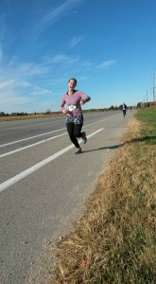](http://publish.illinois.edu/omegatausigma/files/2015/03/12042987_10153748557254365_3126076103859982596_n.jpg)[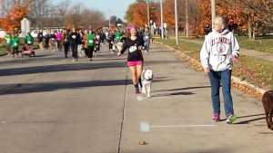](http://publish.illinois.edu/omegatausigma/files/2015/03/11987207_10208020943864066_8770931188174794943_n.jpg)[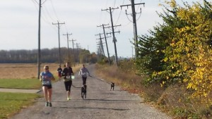](http://publish.illinois.edu/omegatausigma/files/2015/03/12190114_10208020943544058_7450348424935078089_n.jpg)[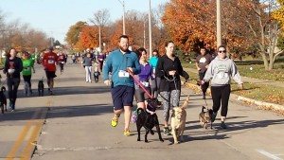](http://publish.illinois.edu/omegatausigma/files/2015/03/12065758_10208020944184074_8316766413260861013_n.jpg)[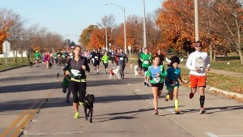](http://publish.illinois.edu/omegatausigma/files/2015/03/12049585_10208020944464081_3462446551622484899_n.jpg)[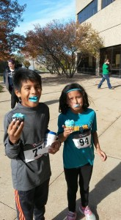](http://publish.illinois.edu/omegatausigma/files/2015/03/12189694_10153748767919365_8211369536189184679_n.jpg)[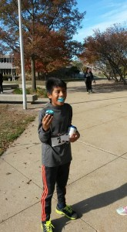](http://publish.illinois.edu/omegatausigma/files/2015/03/12111962_10153748767989365_8574229344222951705_n.jpg)[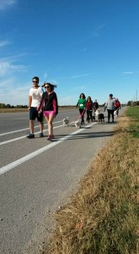](http://publish.illinois.edu/omegatausigma/files/2015/03/12063737_10153748768424365_5121345873177773068_n.jpg)[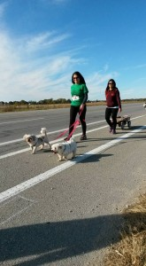](http://publish.illinois.edu/omegatausigma/files/2015/03/12047161_10153748768254365_7919087662082728757_n.jpg)[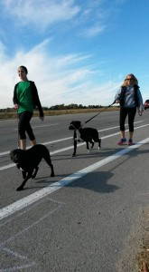](http://publish.illinois.edu/omegatausigma/files/2015/03/12039648_10153748768939365_822458813371433500_n.jpg)[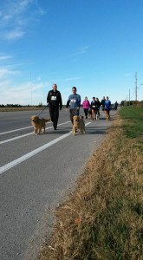](http://publish.illinois.edu/omegatausigma/files/2015/03/10986926_10153748769389365_8410346212295731324_n.jpg)[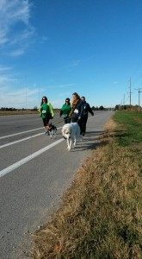](http://publish.illinois.edu/omegatausigma/files/2015/03/12187728_10153748769539365_700324831548978237_n.jpg)[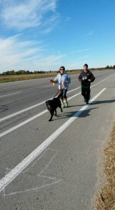](http://publish.illinois.edu/omegatausigma/files/2015/03/12065503_10153748769719365_1752410223970857351_n.jpg)[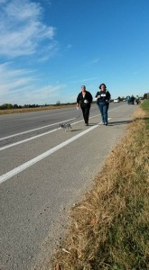](http://publish.illinois.edu/omegatausigma/files/2015/03/12096025_10153748769984365_4397348571657101049_n.jpg)[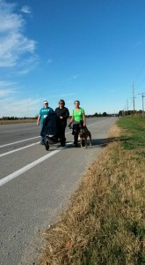](http://publish.illinois.edu/omegatausigma/files/2015/03/12189781_10153748769829365_4869681191906806746_n.jpg)[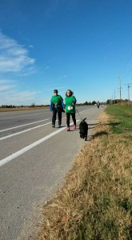](http://publish.illinois.edu/omegatausigma/files/2015/03/12122746_10153748770434365_1563248036436531432_n.jpg)[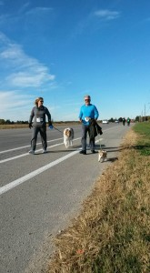](http://publish.illinois.edu/omegatausigma/files/2015/03/12049564_10153748770694365_7192627994263905963_n.jpg)