**OTS/Law School Tailgate 2015:**

[](http://publish.illinois.edu/omegatausigma/files/2015/03/12049675_10153160136198861_1451306919957224823_n.jpg) [](http://publish.illinois.edu/omegatausigma/files/2015/03/12074849_10153160137073861_2195549926108294819_n.jpg) [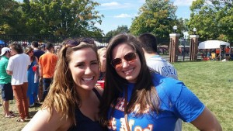](http://publish.illinois.edu/omegatausigma/files/2015/03/12038431_10153160137153861_3918770114611283003_n.jpg) [](http://publish.illinois.edu/omegatausigma/files/2015/03/12038511_10153160137208861_3806681097079008435_n.jpg) [](http://publish.illinois.edu/omegatausigma/files/2015/03/12043082_10153160137358861_1736293347025613527_n.jpg) [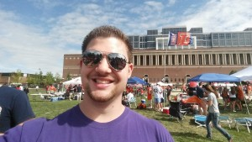](http://publish.illinois.edu/omegatausigma/files/2015/03/12042962_10153160137408861_6477526661055868339_n.jpg) [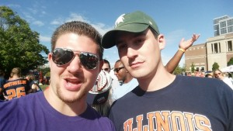](http://publish.illinois.edu/omegatausigma/files/2015/03/12049231_10153160137498861_1762756465223182483_n.jpg) [](http://publish.illinois.edu/omegatausigma/files/2015/03/12049424_10153160137748861_8924345519243393132_n.jpg)