**OTS Road Race 2019:**

[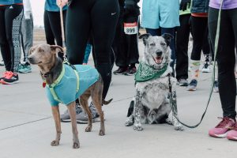](http://publish.illinois.edu/omegatausigma/files/2019/04/Road-Race-2019-Pic-3.jpg) [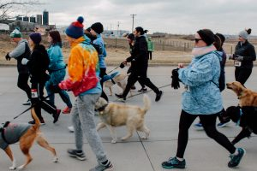](http://publish.illinois.edu/omegatausigma/files/2019/04/Road-Race-2019-Pic-4.jpg) [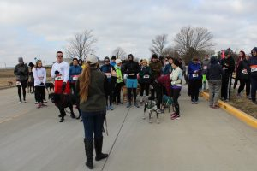](http://publish.illinois.edu/omegatausigma/files/2019/04/Road-Race-2019-Pic-2.jpg) [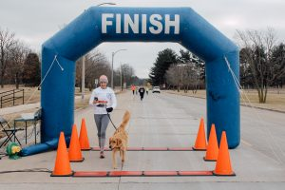](http://publish.illinois.edu/omegatausigma/files/2019/04/Road-Race-2019-Pic-8.jpg) [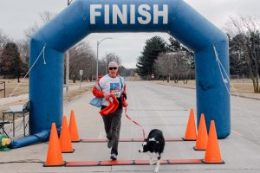](http://publish.illinois.edu/omegatausigma/files/2019/04/Road-Race-2019-Pic-7.jpg) [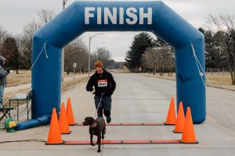](http://publish.illinois.edu/omegatausigma/files/2019/04/Road-Race-2019-PIc-6.jpg) [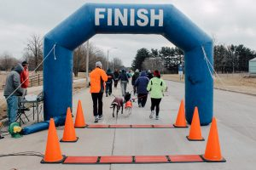](http://publish.illinois.edu/omegatausigma/files/2019/04/Road-Race-2019-Pic-5.jpg)