**OTS Pet Visits 2015:**

[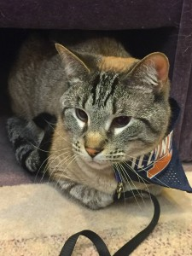](http://publish.illinois.edu/omegatausigma/files/2015/03/11149768_10203803264674283_3832492148517089786_o.jpg) [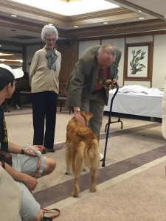](http://publish.illinois.edu/omegatausigma/files/2015/03/10989225_10204250893384721_4304176007248332986_o.jpg) [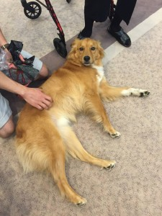](http://publish.illinois.edu/omegatausigma/files/2015/03/10001069_10204250893544725_6653697974853903367_o.jpg) [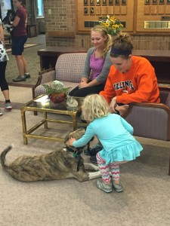](http://publish.illinois.edu/omegatausigma/files/2015/03/10263974_10204614532275466_4755779202607784930_o.jpg) [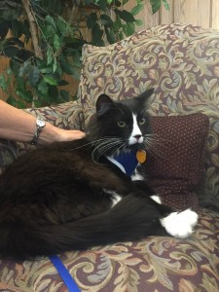](http://publish.illinois.edu/omegatausigma/files/2015/03/12032899_10204748951715868_401476466387477679_o.jpg) [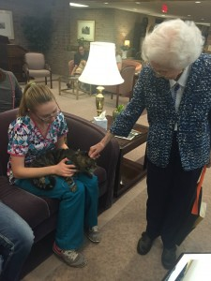](http://publish.illinois.edu/omegatausigma/files/2015/03/12017429_10204748951675867_1016409062548446362_o.jpg) [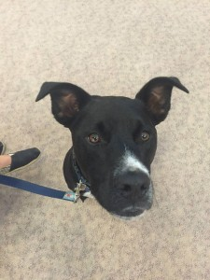](http://publish.illinois.edu/omegatausigma/files/2015/03/12045736_10204748951875872_4038619227907105536_o.jpg) [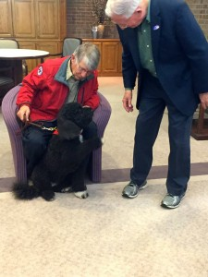](http://publish.illinois.edu/omegatausigma/files/2015/03/11080618_10203803256794086_8618482237473988882_o.jpg) [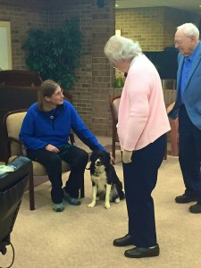](http://publish.illinois.edu/omegatausigma/files/2015/03/4_7_15_OTS-pet-visit_Dr.-Matheson.jpg) [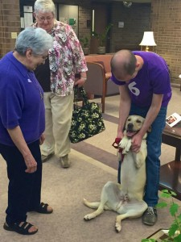](http://publish.illinois.edu/omegatausigma/files/2015/03/4_7_15_OTS-pet-visit_Matt-Shockey.jpg) [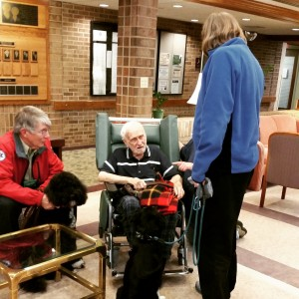](http://publish.illinois.edu/omegatausigma/files/2015/03/IMG_20150407_185839.jpg) [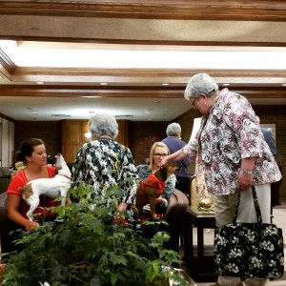](http://publish.illinois.edu/omegatausigma/files/2015/03/IMG_20150407_185953.jpg) [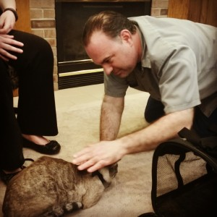](http://publish.illinois.edu/omegatausigma/files/2015/03/IMG_20150407_190118.jpg) [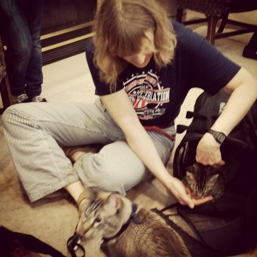](http://publish.illinois.edu/omegatausigma/files/2015/03/IMG_20150407_190314.jpg) [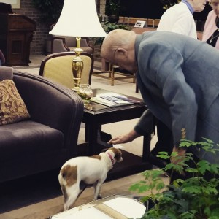](http://publish.illinois.edu/omegatausigma/files/2015/03/IMG_20150407_190500.jpg) [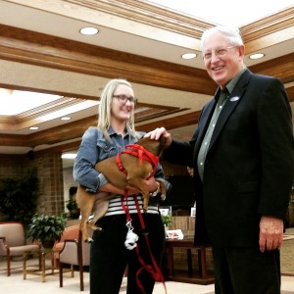](http://publish.illinois.edu/omegatausigma/files/2015/03/IMG_20150407_190543.jpg) [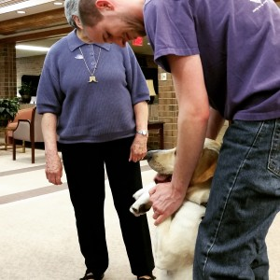](http://publish.illinois.edu/omegatausigma/files/2015/03/IMG_20150407_190611.jpg) [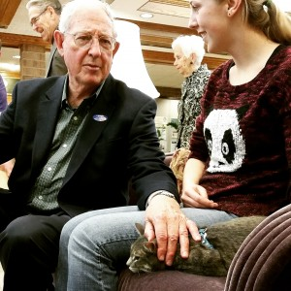](http://publish.illinois.edu/omegatausigma/files/2015/03/IMG_20150407_190716.jpg)