**OTS Grand Council 2016**

[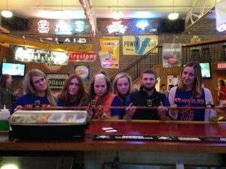](http://publish.illinois.edu/omegatausigma/files/2015/03/14670735_10154119575538667_3361504512348761295_n.jpg) [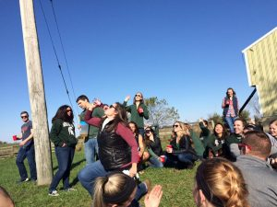](http://publish.illinois.edu/omegatausigma/files/2015/03/14642156_10103702639078519_1879422657892901812_n.jpg) [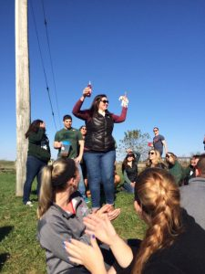](http://publish.illinois.edu/omegatausigma/files/2015/03/14650092_10103702639008659_7456398321007928925_n.jpg) [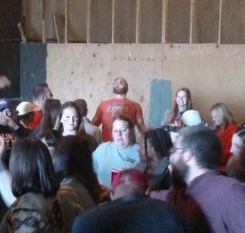](http://publish.illinois.edu/omegatausigma/files/2015/03/14670869_10101772965880169_6811114625398390459_n.jpg) [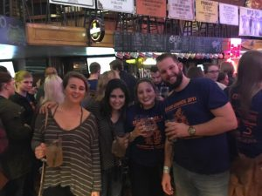](http://publish.illinois.edu/omegatausigma/files/2015/03/14720329_10157757581020121_8519434054070179592_n.jpg) [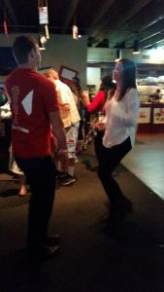](http://publish.illinois.edu/omegatausigma/files/2015/03/14702402_1210061792350564_8754892725925158984_n.jpg) [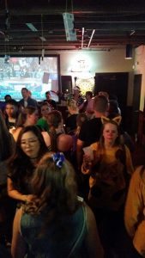](http://publish.illinois.edu/omegatausigma/files/2015/03/14720599_1210061622350581_7960085220044116592_n.jpg) [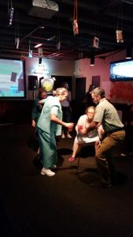](http://publish.illinois.edu/omegatausigma/files/2015/03/14729400_1210061509017259_6989312042354925084_n.jpg) [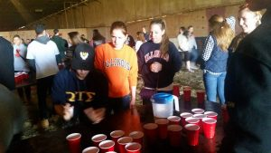](http://publish.illinois.edu/omegatausigma/files/2015/03/14705643_1210060899017320_4696049026141626006_n.jpg) [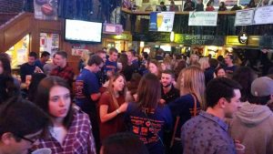](http://publish.illinois.edu/omegatausigma/files/2015/03/14702424_1210060509017359_4751035574050890348_n.jpg) [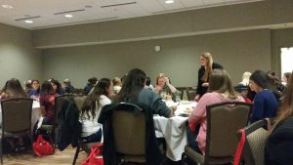](http://publish.illinois.edu/omegatausigma/files/2015/03/14717264_1210060392350704_7632604998577987241_n.jpg) [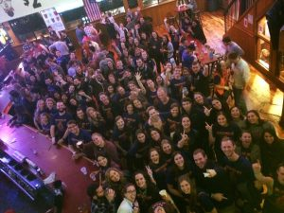](http://publish.illinois.edu/omegatausigma/files/2015/03/14731172_10153841315427484_6611094643963749897_n.jpg) [](http://publish.illinois.edu/omegatausigma/files/2015/03/14641984_1209041649119245_8728835840212774398_n.jpg) [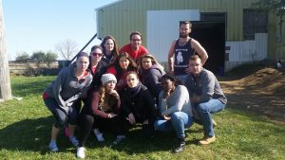](http://publish.illinois.edu/omegatausigma/files/2015/03/14718824_1209041515785925_539384377600790684_n.jpg) [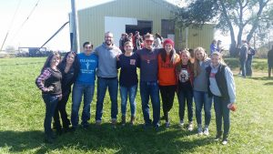](http://publish.illinois.edu/omegatausigma/files/2015/03/13879180_1209041472452596_328255408115974349_n.jpg) [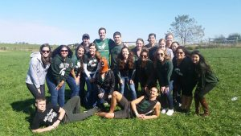](http://publish.illinois.edu/omegatausigma/files/2015/03/14657253_1209041355785941_7275313091572342303_n.jpg) [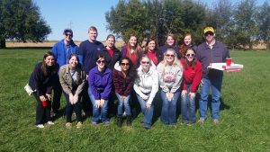](http://publish.illinois.edu/omegatausigma/files/2015/03/14681850_1209041165785960_2134320086590935654_n.jpg) [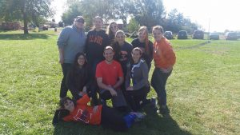](http://publish.illinois.edu/omegatausigma/files/2015/03/14729316_1209040992452644_6031796089373744767_n.jpg) [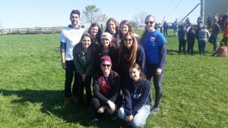](http://publish.illinois.edu/omegatausigma/files/2015/03/14721757_1209040815785995_4927449506453231443_n.jpg) [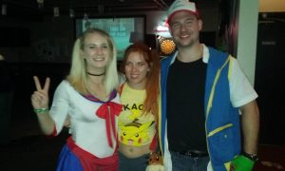](http://publish.illinois.edu/omegatausigma/files/2015/03/14690970_10210440646068514_1380501433584105506_n.jpg) [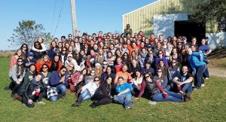](http://publish.illinois.edu/omegatausigma/files/2015/03/14718820_10154036696698861_2214108263474134403_n.jpg) [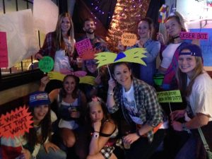](http://publish.illinois.edu/omegatausigma/files/2015/03/14732202_10154122835738667_5081763731309986798_n.jpg) [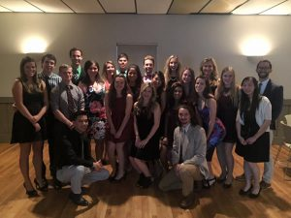](http://publish.illinois.edu/omegatausigma/files/2015/03/14650777_10211668633135497_8419240843778350816_n.jpg) [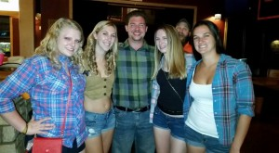](http://publish.illinois.edu/omegatausigma/files/2015/03/12122498_10153813719450572_5898772528532644343_n.jpg)[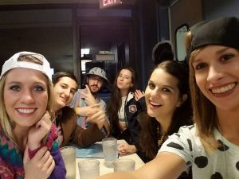](http://publish.illinois.edu/omegatausigma/files/2015/03/14610961_10154091610563553_6465140439598520119_n.jpg) [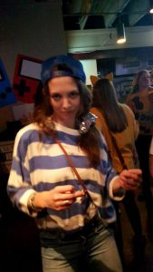](http://publish.illinois.edu/omegatausigma/files/2015/03/14729112_1122875984455241_8696236563703053687_n.jpg)