**OTS Grand Council 2015:**

[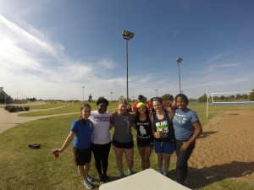](http://publish.illinois.edu/omegatausigma/files/2015/03/11222549_10205119009911603_1445959915428704249_o.jpg) [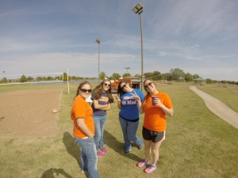](http://publish.illinois.edu/omegatausigma/files/2015/03/10988943_10205119009631596_2216615629983499877_o.jpg) [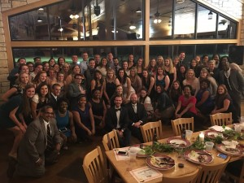](http://publish.illinois.edu/omegatausigma/files/2015/03/12052494_10205119002351414_465682323569382036_o.jpg) [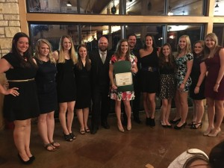](http://publish.illinois.edu/omegatausigma/files/2015/03/12109768_10205119002391415_4308945625099970534_o.jpg) [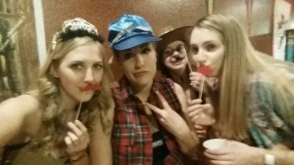](http://publish.illinois.edu/omegatausigma/files/2015/03/12109080_10153813719325572_5624523801969447038_n.jpg) [](http://publish.illinois.edu/omegatausigma/files/2015/03/12140597_10153813718565572_6008543968567999804_n.jpg) [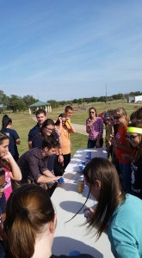](http://publish.illinois.edu/omegatausigma/files/2015/03/12088537_10153813716835572_8642737141982299515_n.jpg)[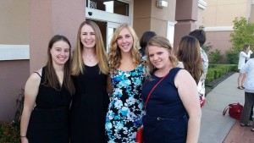](http://publish.illinois.edu/omegatausigma/files/2015/03/10996092_10153813718315572_1344766403131265056_n.jpg) [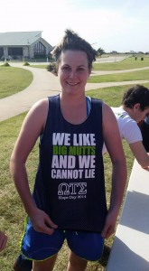](http://publish.illinois.edu/omegatausigma/files/2015/03/12115870_10153813716975572_489921919866487676_n.jpg) [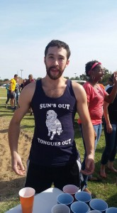](http://publish.illinois.edu/omegatausigma/files/2015/03/12118744_10153813716730572_54160710095608682_n.jpg) [](http://publish.illinois.edu/omegatausigma/files/2015/03/12115941_10153813716630572_6282870238955718506_n.jpg) [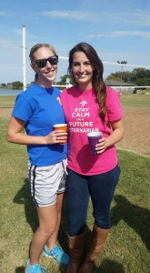](http://publish.illinois.edu/omegatausigma/files/2015/03/12119083_10153813716530572_4811756569113509213_n.jpg) [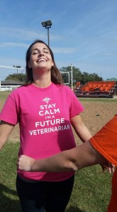](http://publish.illinois.edu/omegatausigma/files/2015/03/10312537_10153813716400572_6541964775996599974_n.jpg) [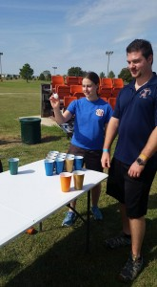](http://publish.illinois.edu/omegatausigma/files/2015/03/12079559_10153813716085572_8543950031905690050_n.jpg) [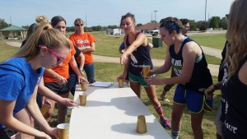](http://publish.illinois.edu/omegatausigma/files/2015/03/12108780_10153813715700572_2788557714186942115_n.jpg) [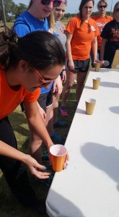](http://publish.illinois.edu/omegatausigma/files/2015/03/12065623_10153813715475572_8089603976292253250_n.jpg) [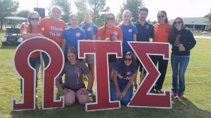](http://publish.illinois.edu/omegatausigma/files/2015/03/12119119_10153813711645572_6263894569103737774_n.jpg) [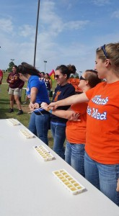](http://publish.illinois.edu/omegatausigma/files/2015/03/12088076_10153813711045572_7640023973110152658_n.jpg) [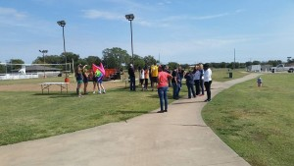](http://publish.illinois.edu/omegatausigma/files/2015/03/12079627_10153813710980572_3071746743352978474_n.jpg) [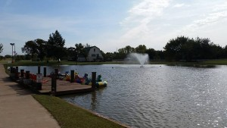](http://publish.illinois.edu/omegatausigma/files/2015/03/12079181_10153813710875572_4255630256347883851_n.jpg) [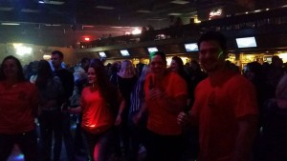](http://publish.illinois.edu/omegatausigma/files/2015/03/12141791_10153813710695572_2816093838264598883_n.jpg) [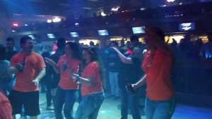](http://publish.illinois.edu/omegatausigma/files/2015/03/12088463_10153813710545572_5853474821978494563_n.jpg) [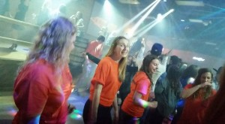](http://publish.illinois.edu/omegatausigma/files/2015/03/12096532_10153813710440572_5933031797158627674_n.jpg) [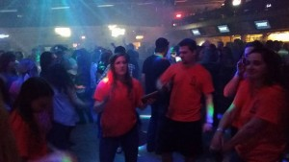](http://publish.illinois.edu/omegatausigma/files/2015/03/12140616_10153813710390572_7884474247184204436_n.jpg) [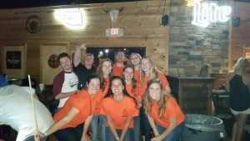](http://publish.illinois.edu/omegatausigma/files/2015/03/10351384_10153813710280572_5654400691079262916_n.jpg) [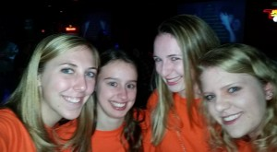](http://publish.illinois.edu/omegatausigma/files/2015/03/12105740_10153813710235572_4659472682386588049_n.jpg) [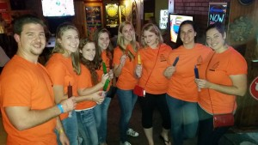](http://publish.illinois.edu/omegatausigma/files/2015/03/12088294_10153813710205572_8799500747464448506_n.jpg)