**OTS Fall Pet Wash 2015:**

[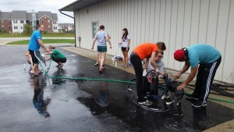](http://publish.illinois.edu/omegatausigma/files/2015/03/12038345_10153160144763861_3947776145938244873_n.jpg) [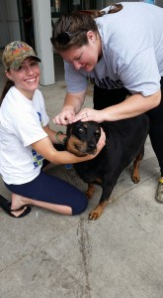](http://publish.illinois.edu/omegatausigma/files/2015/03/12027748_10153160144603861_3385409369051026662_n.jpg) [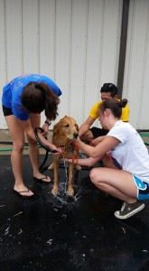](http://publish.illinois.edu/omegatausigma/files/2015/03/12047112_10153160144558861_214577530189773217_n.jpg) [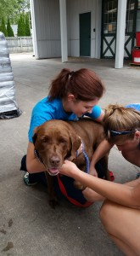](http://publish.illinois.edu/omegatausigma/files/2015/03/12027737_10153160144483861_8782250846707648287_n.jpg) [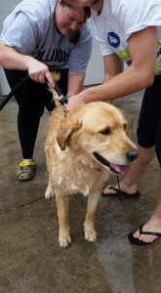](http://publish.illinois.edu/omegatausigma/files/2015/03/12032988_10153160144433861_5299696940652965717_n.jpg) [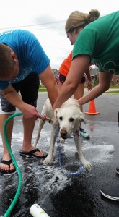](http://publish.illinois.edu/omegatausigma/files/2015/03/12043194_10153160144393861_8621805056522778025_n.jpg) [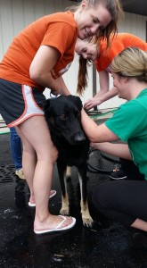](http://publish.illinois.edu/omegatausigma/files/2015/03/12042631_10153160144313861_9131926866312982196_n.jpg) [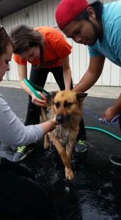](http://publish.illinois.edu/omegatausigma/files/2015/03/11219535_10153160144193861_7782924321520400515_n.jpg) [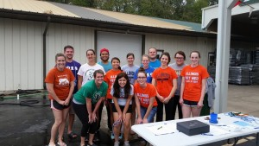](http://publish.illinois.edu/omegatausigma/files/2015/03/1613940_10153160144098861_7409157808655902860_n.jpg)