**2018-2019 Pictures:**

**Club fair:** [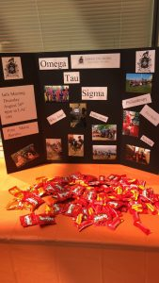](http://publish.illinois.edu/omegatausigma/files/2018/09/OTS-Club-Fair.jpg)

**Paintball:** [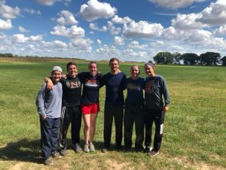](http://publish.illinois.edu/omegatausigma/files/2018/09/OTS-Paintball.jpg)