**Halloween Pumpkin Carving 2015:**

[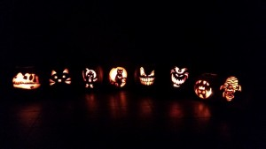](http://publish.illinois.edu/omegatausigma/files/2015/03/12193620_10153206393258861_815506300512801073_n.jpg)[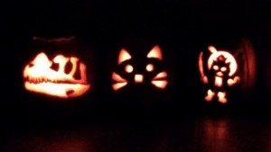](http://publish.illinois.edu/omegatausigma/files/2015/03/11181959_10153206393518861_1815353621416342259_n.jpg)[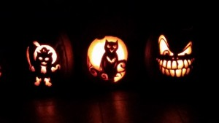](http://publish.illinois.edu/omegatausigma/files/2015/03/12193609_10153206393428861_6098672030834057714_n.jpg)[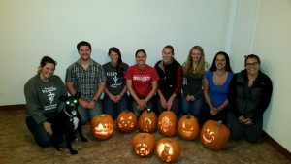](http://publish.illinois.edu/omegatausigma/files/2015/03/12193813_10153206393613861_8271126401826597827_n.jpg)