**Curtis Apple Orchard 2015:**

[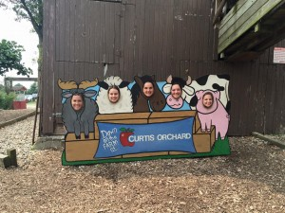](http://publish.illinois.edu/omegatausigma/files/2015/03/11902234_10204625988001852_8598512070841326972_n.jpg) [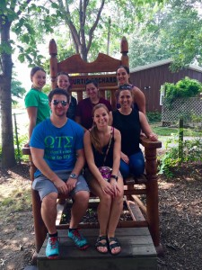](http://publish.illinois.edu/omegatausigma/files/2015/03/11987163_10204625987641843_4672912453582106466_n.jpg) [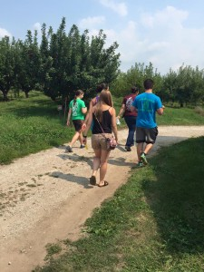](http://publish.illinois.edu/omegatausigma/files/2015/03/11986943_10204625992481964_4943093568467840650_n.jpg) [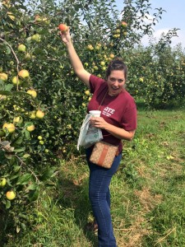](http://publish.illinois.edu/omegatausigma/files/2015/03/11953079_10204625992521965_6243326709593188794_n.jpg) [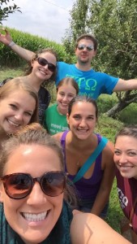](http://publish.illinois.edu/omegatausigma/files/2015/03/11947410_10204625989201882_6592531030613636317_n.jpg)