OTS Spring Sale 2016

Here are the designs for the OTS Spring Clothing Sale. Orders are payment are due March 30th at 5 pm. Cash and checks can be placed in Leah Kruckman or Krissy Kozak’s mailbox (Class 2018-BSB). Happy Shopping!

Ladie’s Quarter Zip shirt- $48 (Blue, Peach or Green)
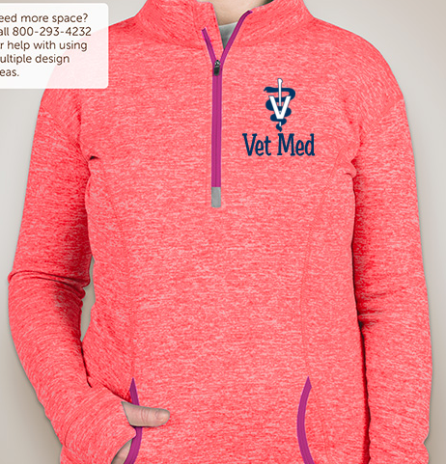
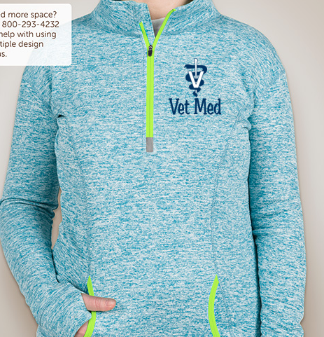

Polycarbonate Animal Waterbottle- $10

Basketball shorts-$30 (Blue or Grey)
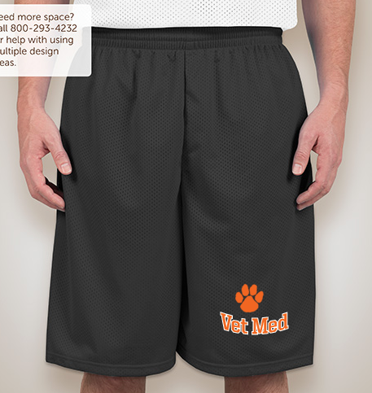
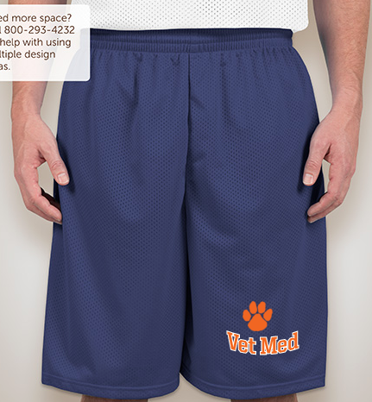

Best Friends t-shirt- $20 (Navy or Grey)

Ladie’s V-neck-$20

Running Shorts-$40 (Navy or Yellow)
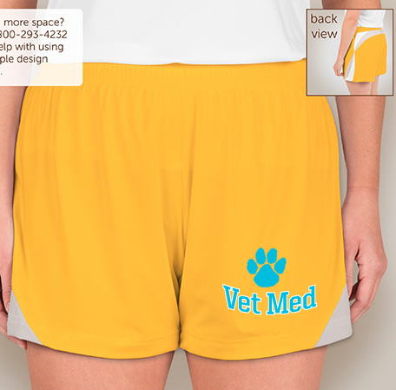
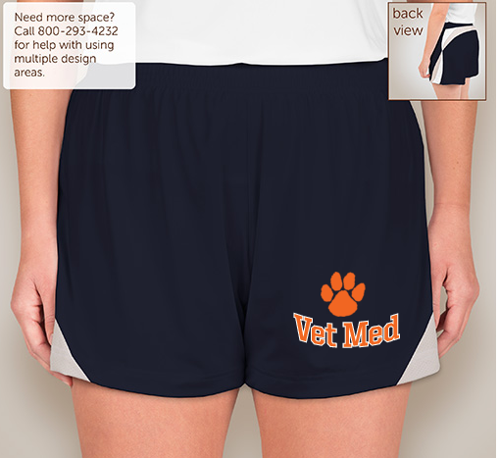

Sick Puppies Tank-$25

