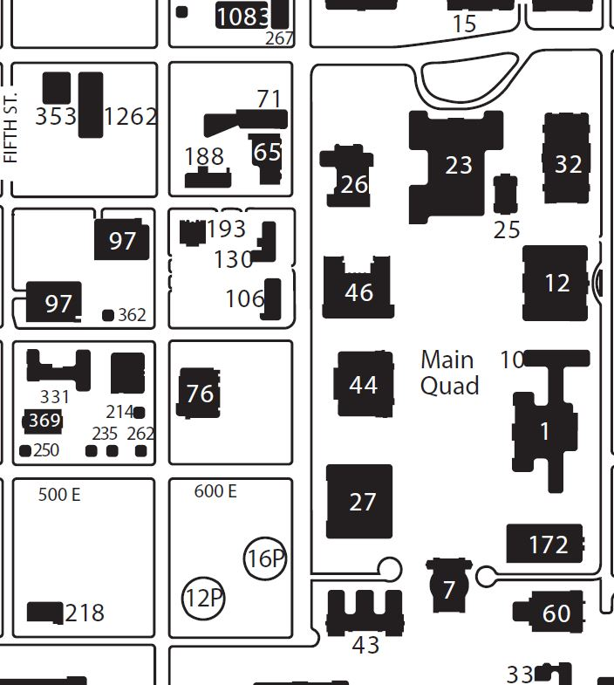

ILLINI UNION
GREEN ST.

ALTGELD

E. JOHN ST.

PARKING

WRIGHT ST.

SIXTH ST.

LINCOLN
HALL

CHALMERS ST.

PARKING

Friday
- Preconference: Lincoln Hall 1060
- Opening Reception: Lincoln Hall Atrium & Foyer (1st floor)

Saturday/Sunday
- Breakfasts & Lunches: Altgeld 239
- Speaker Panels: Altgeld 314
- Poster Presentations: Illini Union 407
- Saturday Dinner: Illini Union 314 A&B
Accommodations
If you have questions about the conference, find a staff member with a bright blue lanyard!

ADA Entrances
Lincoln Hall, Illini Union, and Altgeld Hall all have accessible entrances. Altgeld Hall’s accessible entrance is on the West side of the building (Wright Street, by the Post Office). There are signs to take anyone using that entrance to the appropriate floors for the conference.

Lactation Space
Private lactation space is available at Lincoln Hall and Altgeld Hall. For a complete list, visit the Accommodations tab on the OCMC website: publish.illinois.edu/OCMC-2019.

Lincoln Hall: 4000 [Find a staff member to help unlock it for you]

Altgeld Hall: 241

Gender neutral bathrooms are available on campus.
The nearest one is in the English building, South of Altgeld, in room 0008 A. For a complete list, visit the Accommodations tab on the OCMC website: publish.illinois.edu/OCMC-2019.

Dietary Restrictions
All food throughout the conference will be marked to accommodate dietary restrictions. If you have a question about the meals, please find a staff member or caterer.

