FOR IMMEDIATE RELEASE 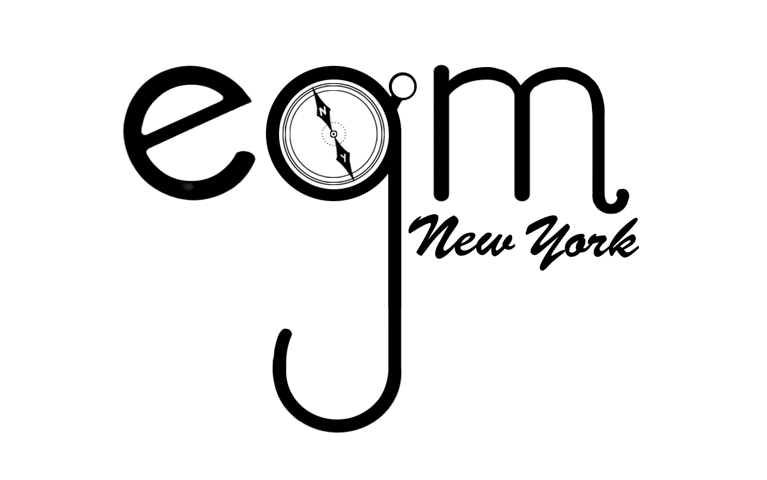

Press Contact:
Yasmina Edwards
EGM NY
T: 646-331- 0358
E: contact@egmny.com

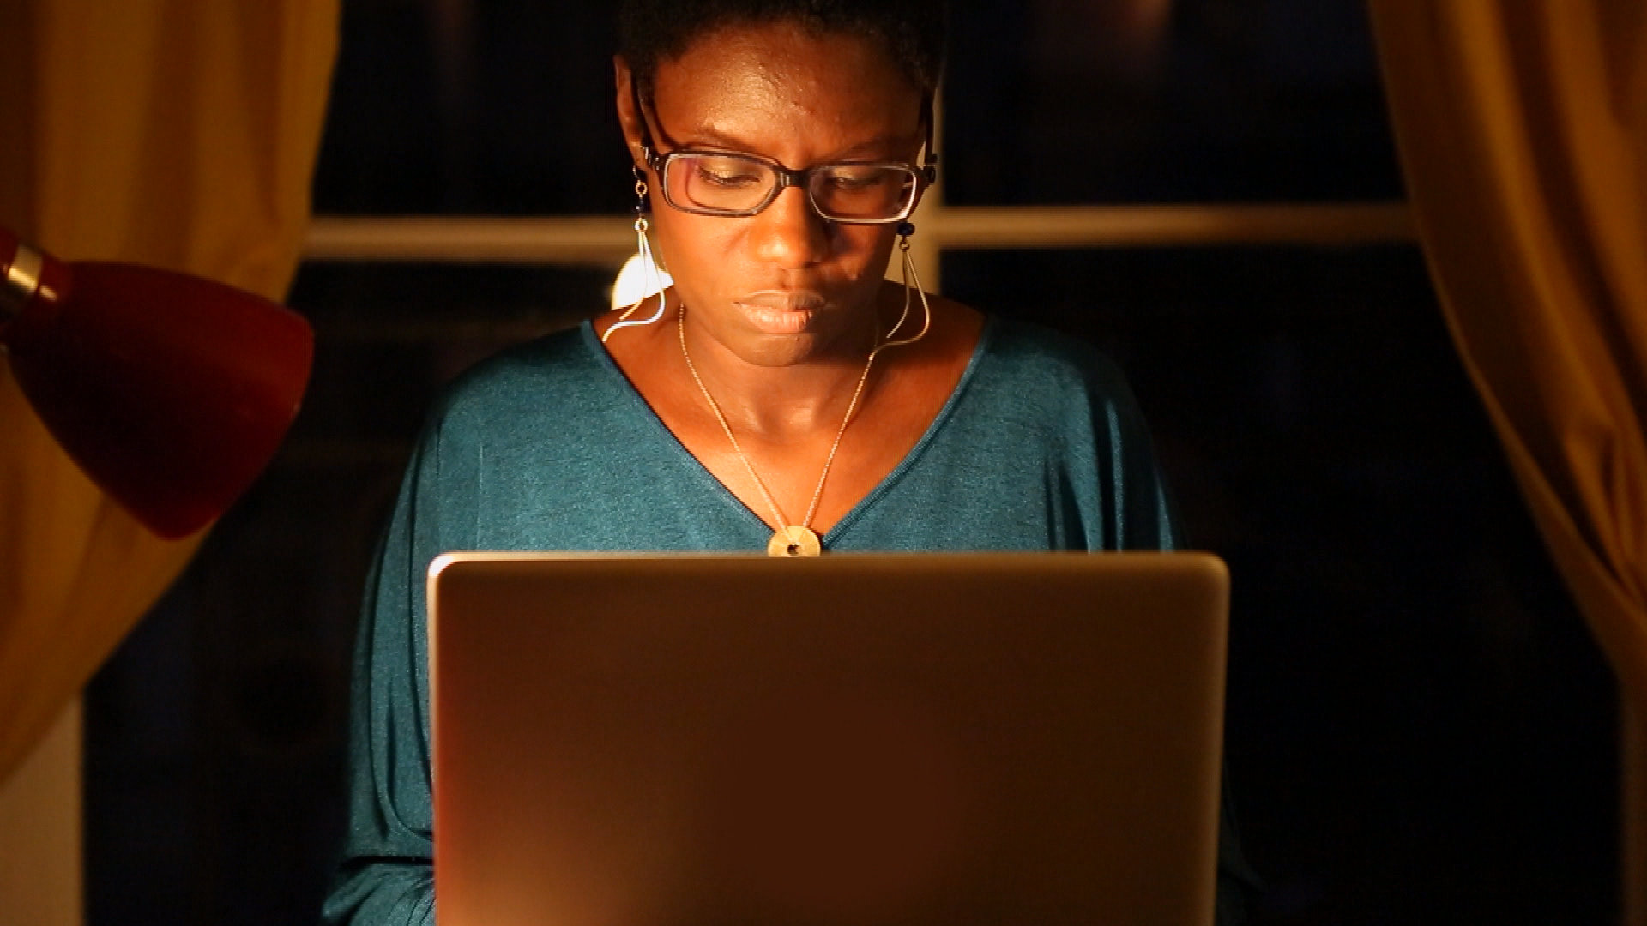

The University of Illinois at Urbana-Champaign

Networks of Hate

(Friday, October 21, 2016): The University of Illinois will screen Networks of Hate (2014), a French film directed by Rokhaya Diallo.

WHO: Rokhaya Diallo
WHAT: Screening of Networks of Hate
WHEN: Friday, October 21 | 7 pm
WHERE: Spurlock Museum, Knight Auditorium, 600 S Gregory, Urbana, IL

On October 21, 2016, 2015 French journalist, writer and award winning filmmaker, Rokhaya Diallo will introduce her film, Networks of Hate at University of Illinois at Urbana Campaign. The film examines key areas, such as the effect of the internet and today’s social networks and how they have become outlets through which innumerable racist, homophobic, and sexist ideas are expressed.

Due to Rokhaya’s widely recognized work in favor of racial, gender and religious equality, she was targeted on Twitter in a call to rape. The violence of this action prompted her to engage in an investigation on cyber hate and freedom of speech online. During her investigation, she met several victims of cyber hate, both public personalities such as Audrey Pulvar, a popular TV host, and Christine Boutin, a politician, as well as everyday people harassed, for a variety of reasons or no reason at all. Throughout the film she poses questions such as “Is the Internet a vector of hatred?” And “Why do cyber haters favor social media?”

Networks of Hate documents Rokhaya’s journey for justice against cyber hate. Join her for an enlightening story followed by Q&A.

Rokhaya Diallo:
Rokhaya Diallo is a French journalist, writer, and award winning filmmaker. Her powerful and courageous work dismantles the barricades of racism and sexism through the promotion of equality and pluralism.
Rokhaya is the host of two TV shows for BET France, a contributor to the RTL radio program, “On refait le Monde” (We change the World), and a pundit on several networks, including Canal +, TV5, and France 24. Through analyzing the dynamic reconstruction of French culture and the origins of societal fracturing she co-authored and hosted “Egaux mais pas trop” (Equals but not too much) on LCP-AN. Recognized as an international authority in her field, Rokhaya has contributed to the Huffington Post , and regularly writes for Elle Magazine and the newspaper Liberation. As one of the most influential black figures in Europe today Rokhaya‘s insight has been sought by both BBC Radio and NPR regarding her stance on anti-racism

Rokhaya directed and co-produced the documentaries: Steps to Liberty (2013); Networks of Hate (2014); and Not your Mama’s Movement (2016). Her passionate work to break down gender prejudice and racial discrimination is appreciated worldwide. With great anticipation of reaching out to the American public, her most recent work, Not Your Mama's Movement, will be premiering at the Schomburg Center in New York on October 26, 2016.
Among Rokhaya’s published works are Racism: A Guide (2011), France Belongs to Us (2012), France: One and Multicultural (2012), and How To Talk To Kids About Racism (2013). In 2015, Rokhaya released her first graphic novel Pari(s) d’Amies, followed closely by her newest book Afro!
Additional information regarding Rokhaya’s biography and current endeavors can be found on her website http://www.rokhayadiallo.com/ and blog RokMyWorld

