At the January 2015 Library Retreat, attendees were seated in groups. Each group was given a discussion prompt. Each prompt was discussed by four tables. Each prompt was structured with a statement or set of statements followed by questions for consideration. This document presents each discussion prompt and a Wordle representation of the information submitted by the four groups on their discussion worksheets.

- John Seely Brown, the author of The Social Life of Information, said that “The challenges we face are both fundamental and substantial. We have moved from an era of equilibrium to a new normal – an era of constant disequilibrium. Our ways of working, ways of creating value, and ways of innovating must be reframed.” How does the library currently approach innovation? What does it mean to reframe those innovation approaches? How should the library approach current or new staffing and organizational models that facilitate nimbleness? Of the ideas the group has generated, which three do you believe would be the most productive to pursue?

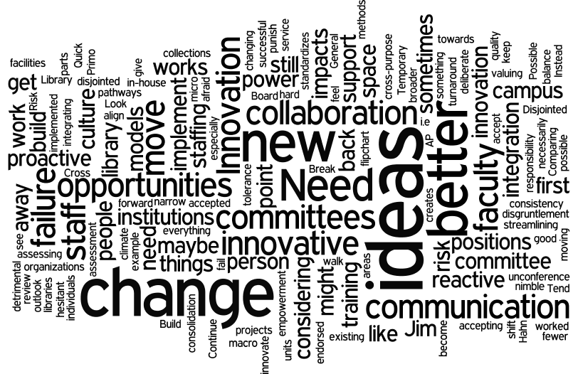

- In Boswell: A Life, Samuel Johnson wrote: “When a man writes from his own mind, he writes very rapidly. The greatest part of a writer's time is spent in reading, in order to write; a man will turn over half a library to make one book.” The monograph continues to be a valued form for scholarship in many disciplines, particularly the humanities. What services and resources are most aligned with the work of faculty and graduate students who write monographs? What additional resources and services could the Library develop that would be valuable to them? What partnerships – on campus and off campus – would enable the Library to make such developments? Of the ideas the group has generated, which three do you believe would be the most productive to pursue?

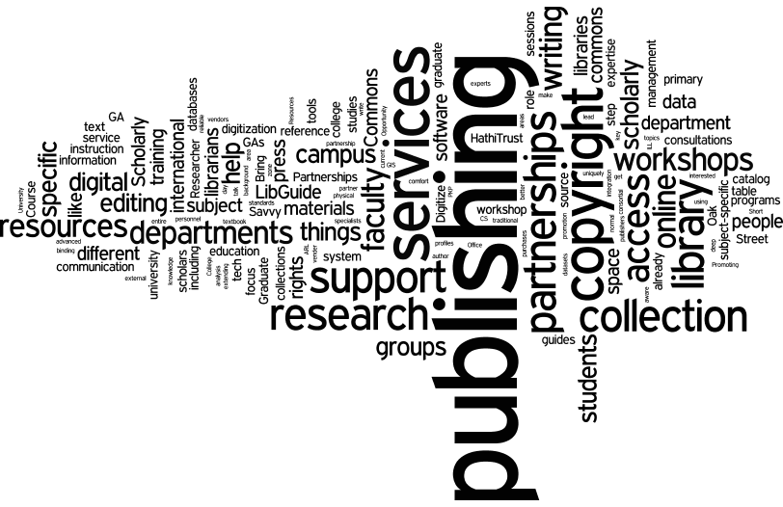

- Jeff Bezos, founder of Amazon, once said that it is important to identify what is constant and does not change. What, if any, are the enduring constants for the University and the University Library? How should these things inform our planning and programmatic development work? Which ones should we pay attention to for future planning? Which ones should we stop clinging to and why? Of the ideas the group has generated, which three do you believe would be the most productive to pursue?

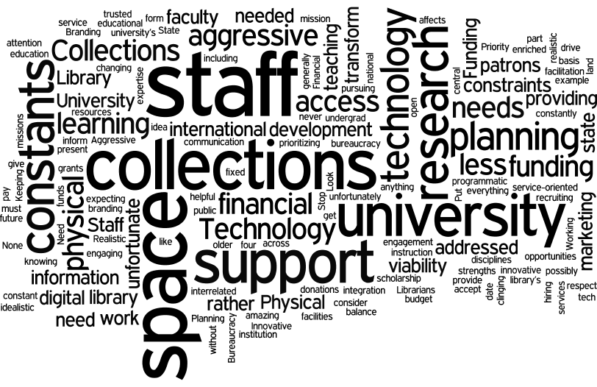

- As the CIC Library Directors continue to explore shared programmatic initiatives, the Library has an opportunity to re-think our local efforts. In light of the shared print repository program, the fact that different CIC schools have strengths in collecting, and the Library's involvement in the HathiTrust/Google Books Project, what should be the Library's priorities for its on-site tangible collections? How should user services be adapted or changed given this increased reliance on shared digital and print collections? Of the ideas the group has generated, which three do you believe would be the most productive to pursue?

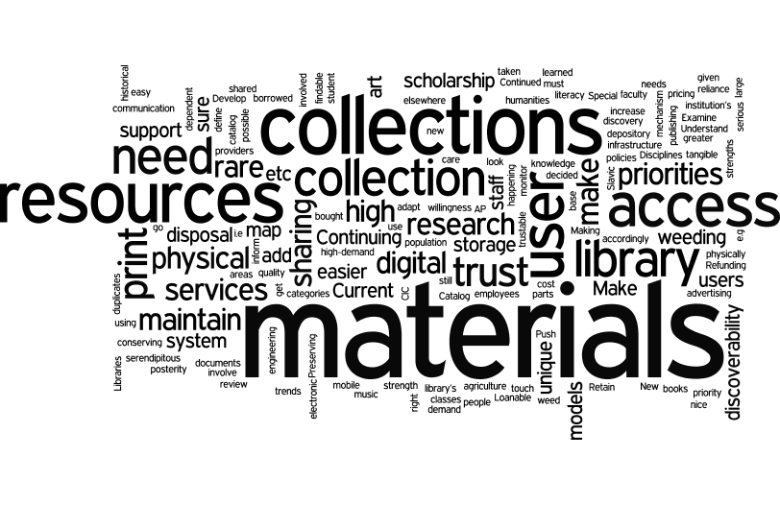

- As faculty and researchers embrace new research practices, new research methods, and new approaches to disseminating their scholarship, what roles should the Library adopt to support the full life cycle of scholarly knowledge production, dissemination, and preservation? Are there partnerships – on campus and off campus – that the Library should create and/or nurture in order to engage in these roles? Of the ideas the group has generated, which three do you believe would be the most productive to pursue?

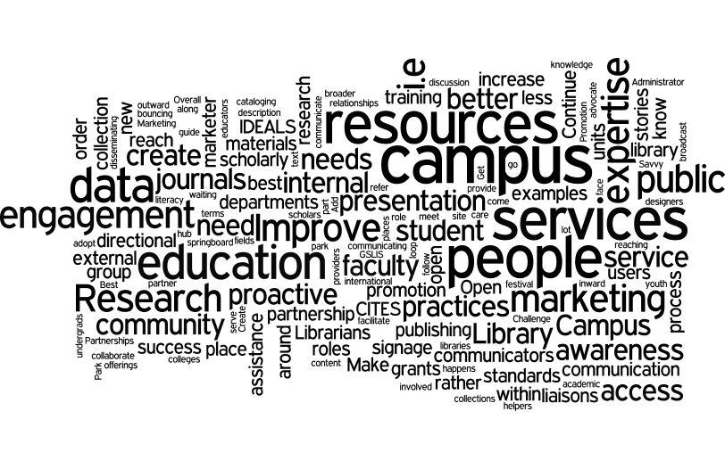

- In his October 27 address to the Library, the Provost identified “re-envision the student experience” as one of the University's key initiatives. How did the Library contribute to the traditional student experience and what about those should be re-envisioned? What are the Library's current contributions to this campus initiative and how well are these known on campus? What additional contributions could the Library make and what partnerships would enable doing so? Of the ideas the group has generated, which three do you believe would be the most productive to pursue?

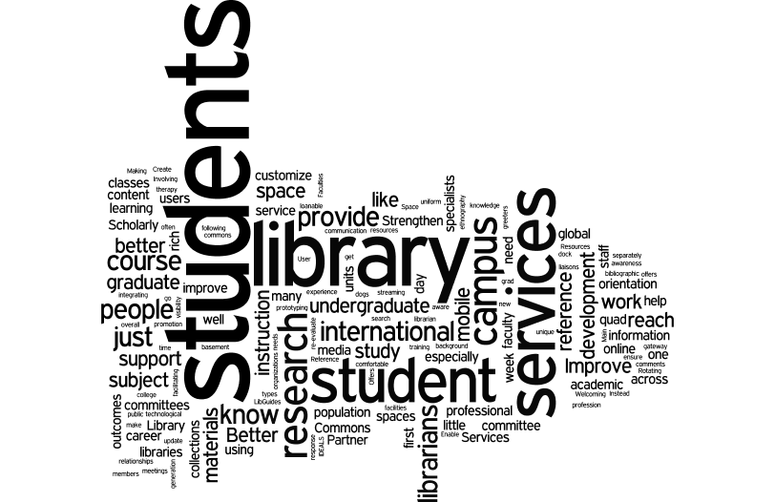

- The Library has a strong and unique partnership with the Graduate School of Library and Information Science (GSLIS). GSLIS students work as graduate assistants in our libraries, and library faculty and staff contribute to the teaching mission at GSLIS. GSLIS and the Library have a number of shared research projects and grants as well. What are the characteristics of our relationship that make it strong? How is it evolving? What ideas do you have for growing our work together? Are there other campus units where we should pursue a similar relationship? Of the ideas the group has generated, which three do you believe would be the most productive to pursue?

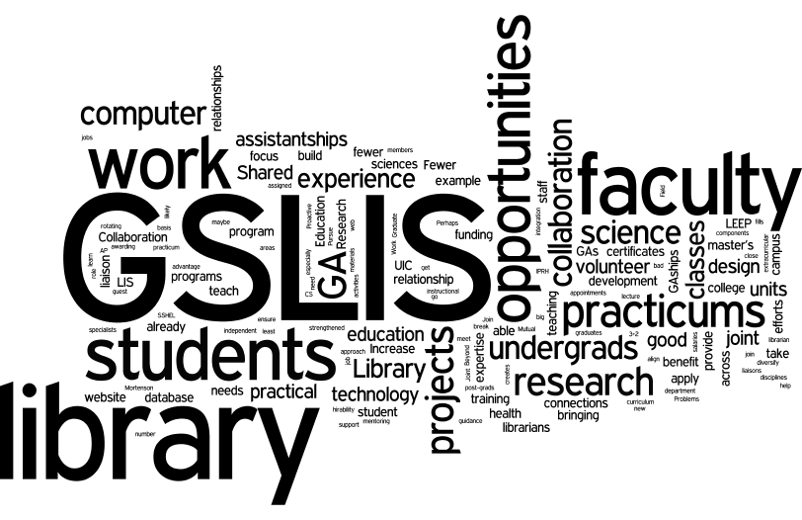

- Many online information environments provide a personalized experience based on user analytics. For example, Google “learns” about an individual's interests, search patterns, etc., and then uses that for relevancy ranked search results. Amazon does something similar and “pushs” recommendations to its users. It is now possible for such analytics and data mining to be applied to Library databases and other discovery tools. What would be the advantages for our users if we invested resources to create personalized information environments? Or, should the Library focus its resources on delivery of full-text and encourage users to search in Google, Amazon, etc. for discovery? Or, is there another approach? Of the ideas the group has generated, which three do you believe would be the most productive to pursue?

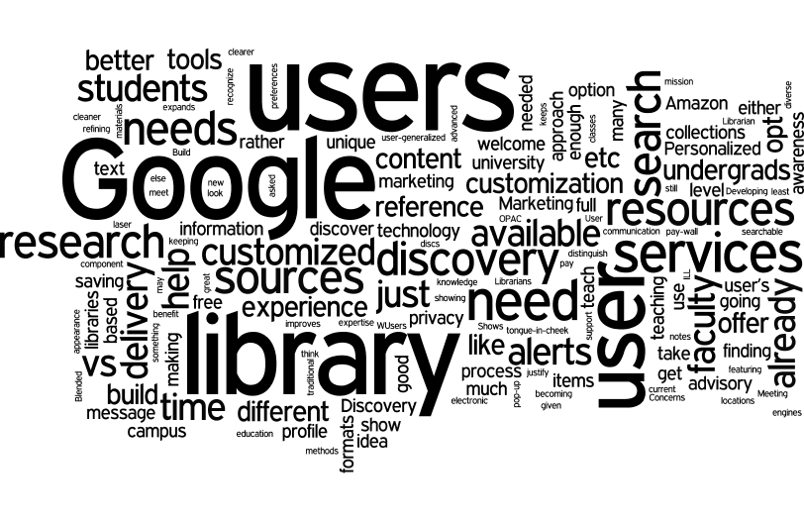

- The Library manages one of the largest physical footprints of space on campus – hundreds of thousands of square feet. For this discussion, focus on the space that is for users. What is the purpose of having space for users? What are the different types of user spaces? Who benefits from this space and who does not? What could the Library do to better align the design of the space with our intentions for its use and user needs and experiences? Of the ideas the group has generated, which three do you believe would be the most productive to pursue?

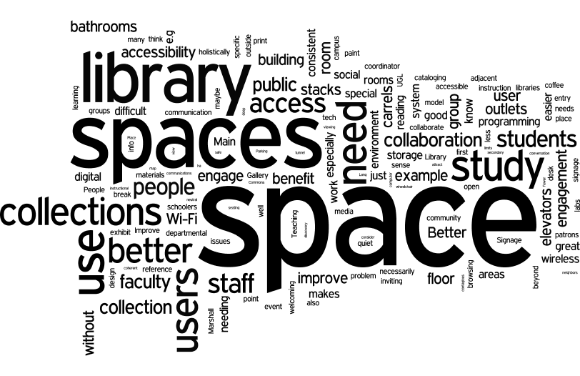

- In his October 27 address to the Library, the Provost identified “intensify our international presence” as one of the University's key initiatives. What are the components of the University’s international presence – in teaching, research, service, etc.? What are the Library's current contributions to this initiative and how well are these known on campus? What additional contributions could the Library make and what partnerships would enable doing so? Of the ideas the group has generated, which three do you believe would be the most productive to pursue?

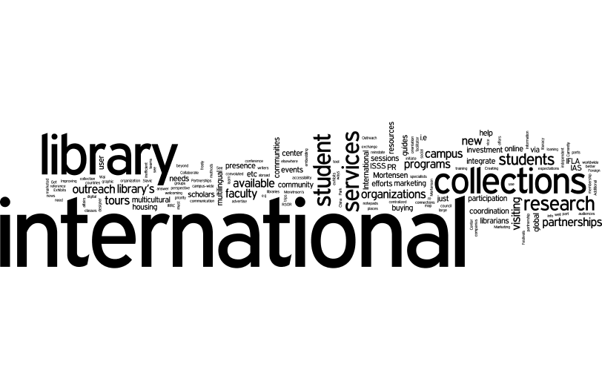

- Interdisciplinary is a way of life on most university campuses in the 21st century. “Launch large scale interdisciplinary research efforts aligned with the visioning future excellence themes” was an initiative highlighted in the Provost’s October 27th address to the Library. What are the Library's current contributions to interdisciplinary research efforts? How does the Library track emerging interdisciplinary areas on campus? What additional contributions could the Library make to interdisciplinary research and what partnerships would enable doing so? Of the ideas the group has generated, which three do you believe would be the most productive to pursue?

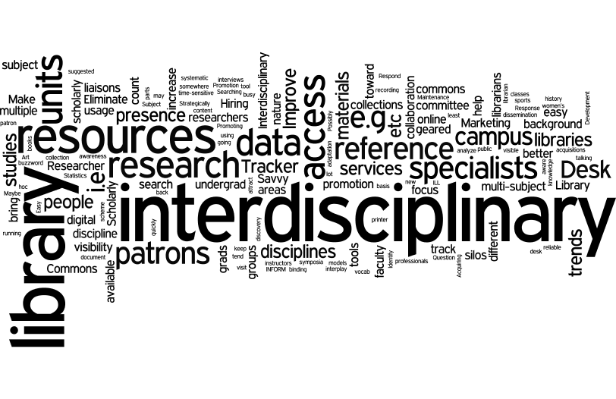

- In his October 27 address to the Library, the Provost identified “increase and embrace diversity” as one of the University's key initiatives. What are the components of the University’s diversity initiative – in the workplace, in teaching, as a focus of research, etc.? What are the Library's current contributions to this campus initiative and how well are these known on campus? What additional contributions could the Library make and what partnerships would enable doing so? Of the ideas the group has generated, which three do you believe would be the most productive to pursue?
