Library Advancement Loanable Items

- General Library Banner
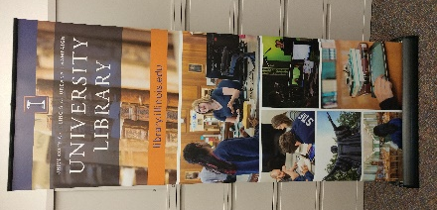
Portable display banner that is both lightweight and easy to set up. Comes in carrying case with shoulder strap. Stands alone on floor or height may be adjusted to be used on top of a table. Suitable for use within Library and non-Library spaces.

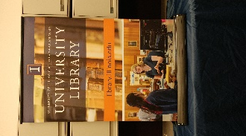

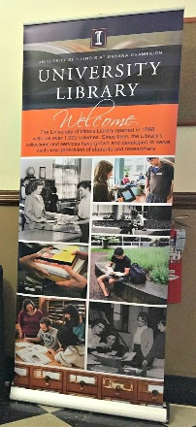

- Library Welcome Banner
Portable display banner that is both lightweight and easy to set up. Comes in carrying case with shoulder strap. Stands alone on floor or height may be adjusted to be used on top of a table. Best used within Library spaces only.

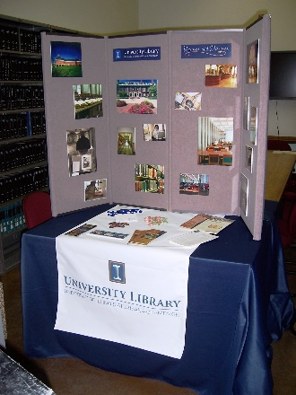
- Library In a Box
Portable folding display board (with various detachable graphics), tablecloth, and Library-related literature. The adjustable display board may be placed on any rectangular table (a 6-8’ table is ideal). Everything fits inside one large, heavy-duty case with wheels which can be shipped.

- Table Cloth - Navy
To be return as received (if soiled wash and fold before putting back in bag/box).

- Vinyl Table Runner - 76” x 29”

University Library faculty and staff are encouraged to utilize these displays for Library events, including presentations and meetings. They may be used for any event which promotes the University Library and any one or more of its units, services, and programs.

To request the use of a display, Library faculty and staff must contact the Office of Advancement at (217) 333-5683 or send an e-mail to Krystle Simmons at klsimmns@illinois.edu. Please reserve these displays and/or materials at least two–four weeks prior to your planned event. Displays should be picked up at, and returned to, the Office of Advancement (227 Main Library).

