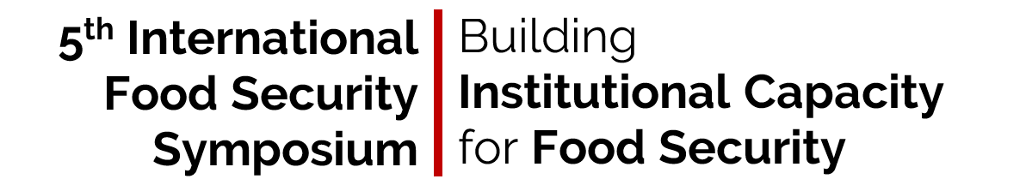
Symposium Program Draft

Tuesday | April 2, 2019 Morning Session |  |  |  |  | Contact
8:30 – 9:00 AM | Registration, Coffee/Tea and Pastries |  |  | Heritage Room
9:00 – 10:15 AM | Opening Remarks |  |  | Monsanto Room
 | Paul McNamara
 | Dean Kimberlee Kidwell
 |  | College of ACES, University of Illinois at Urbana-Champaign
9:15-10:15 | Dr. Saweda Liverpool-Tasie
 |  | Department of Agricultural, Food, and Resource Economics, Michigan State
10:15 – 10:30 AM | Coffee and Tea Break |  |  | Heritage Room
10:30 – 11:45 AM | Session I: Information and Communication Technologies to Strengthen Institutions for Food Security |  |  | Monsanto Room
 | Accelerating technical change through video-mediated agricultural extension: Evidence from Ethiopia
 |  | Simrin Makhija, International Food Policy Research Institute
 | Agriculture extension by radio: Experiences from Semi-Arid Kenya
 |  | Fiona Mwaniki, Kilimo Media International
 | Exploring Videos for Extension: Experiences from the Field
 |  | AgReach: SANE + Winter Break Trip
12:00-1:00PM | Lunch Break/Poster Session |  |  | Heritage Room
 | April 2, 2019 Afternoon Session
1:00 – 2:30 PM | Session II: Approaches to Building Capacity in Research and Extension |  |  | Monsanto Room
 | Capacity Development at Njala University
 |  |  | Richard Cooke, University of Illinois
 | Building Capacity in Extension: Co-creation of Gender Training Materials
 |  | Anna Snider, Land O’ Lakes
 | Experiences from the Soybean Innovation Lab
 |  | Peter Goldsmith, University of Illinois/Soybean Innovation Lab
 | Strengthening Agricultural and Nutrition Extension: Exploring the Theory of Change and the Strengthening Approach in Malawi
 |  | Paul McNamara, AgReach
2:30 – 2:45 PM | Coffee and Tea Break |  |  | Heritage Room
2:45 – 4:00 PM | Session III: Strengthening Higher Education Institutions |  |  | Monsanto Room
 | Need assessment for mid- career value chain based curriculum for agricultural extension in Njala University Sierra Leone
 |  | Oladele Idowu, Sasakawa Africa Fund for Extension Ethiopia
 | Experiences of UC-Davis RIFA program
 |  | Kathryn Lincoln, University of California-Davis
 | Strengthening Partnerships for Higher Education – The SPHEIR Approach
 |  | Hitomi Ho, AgReach
4:00 – 5:00 PM | Improving Service Delivery and Transforming Institutions in Fragile States; Towards a More Politically-Informed Approach |  |  | Monsanto Room
 | Dr. Edward Laws, Senior Research Associate, Overseas Development Institute
5:00 – 6:00 PM | Reception |  |  | Heritage Room
Wednesday | April 3, 2019 Morning Session |  |  |  |  |  | Contact
8:30 – 9:00 AM | Registration, Coffee/Tea and Pastries |  |  |  | Heritage Room
9:00 – 10:15 AM | Session IV: Evidence of Agricultural Development Approaches through Research |  |  |  | Monsanto Room
 | Using network analysis to advance understanding and integration of knowledge domains in agroforestry research
 |  | Sarah Brown, University of Illinois
 | Internationally comparable metrics for agricultural extension: Potential indicators, data sources, and emerging patterns
 |  | Carlo Azzarri, International Food Policy Research Institute
 | Does participation in a climate-smart agriculture program enhance environmental sustainability and food security? Evidence from southern Malawi
 |  | Festus Amadu, AgReach
10:15 – 10:30 AM |  | Coffee and Tea Break Heritage Room
10:30 – 11:00 AM | Jitter Talks—Lightning Talks with Coffee |  |  |  | Heritage Room
 | Best Practice for Using Nutrition and Gender Measurement Tools in Zambia
 |  | Mulako Kabisa, Indaba Agricultural Policy Research Institute
 | Approaches for Gendered Outcomes: ASMC’s Experience
 |  | Maria Jones, University of Illinois
 | Addressing the Gap – Numeracy Levels of Extensionists
 |  | Nicole Lee, University of Illinois
 | Mobile Strengthening Tools: Apps for Agricultural Development
 | Paul McNamara, AgReach
11:00-11:40 | Expert Panel – The Future of Food (In)Security |  |  |  | Heritage Room
Anna Snider – Land O’ Lakes
Saweda Liverpool-Tasie, Michigan State University
Paul McNamara – AgReach
Alex Winter-Nelson, University of Illinois
11:40-12:00 PM | Closing Remarks Paul McNamara  To-Go Lunch |  |  |  | Heritage Room

