



**CIVIL ENGINEERING STUDIES**

Illinois Center for Transportation Series No. xx-xxx [ICT will provide]

UILU-ENG-20xx-xxxx [ICT will provide]

ISSN: 0197-9191

Title of Report Goes Here Title of Report Goes Here

Prepared By

**Author Name**

**Author Name**

**Author Name**

**Etc.**

University of Illinois at Urbana-Champaign   
[change if necessary]

Research Report No. FHWA-ICT-xx-xxx [ICT will provide]

A report of the findings of

**ICT PROJECT R27-XXX**

**Title of Project Goes Here Title of Project   
Goes Here Title of Project Goes Here**

https://doi.org/########## (ICT will provide)

**Illinois Center for Transportation**

**Month Year**

# Technical Report Documentation Page

|  |  |  |  |  |  |  |
| --- | --- | --- | --- | --- | --- | --- |
| **1. Report No.**  ICT will provide prior to posting | **2. Government Accession No.**  N/A | | | **3. Recipient’s Catalog No.**  N/A | | |
| **4. Title and Subtitle**  Enter title and subtitle, with volume and part numbers, if applicable | | | | **5. Report Date**  Enter same date as shown on report cover | | |
| **6. Performing Organization Code**  N/A | | |
| **7. Author(s)**  Enter name(s) of all authors responsible for writing the report, performing the research, or credited with any content in the report. Form of entry is first name, middle initial (if applicable), and last name. Primary author is listed first.  Optional: after each author name, enter ORCID (http://orcid.org) URL, when available. Example: Jane G. Smith, http://orcid.org/0000-0002-0543-4268 | | | | **8. Performing Organization Report No.**  ICT will provide prior to posting | | |
| **9. Performing Organization Name and Address**  Illinois Center for Transportation  Department of Civil and Environmental Engineering  University of Illinois at Urbana-Champaign  205 North Mathews Avenue, MC-250  Urbana, IL 61801 | | | | **10. Work Unit No.**  N/A | | |
| **11. Contract or Grant No.**  R27-XXX | | |
| **12. Sponsoring Agency Name and Address**  Illinois Department of Transportation (SPR)  Bureau of Research  126 East Ash Street  Springfield, IL 62704 | | | | **13. Type of Report and Period Covered**  ICT will provide prior to posting | | |
| **14. Sponsoring Agency Code** | | |
| **15. Supplementary Notes**  Conducted in cooperation with the U.S. Department of Transportation, Federal Highway Administration.  [https://doi.org/###############](https://doi.org/) (ICT will provide) | | | | | | |
| **16. Abstract**  Enter a brief factual summary of the most significant information, including the purpose, methods, results, and conclusions of the work. When appropriate, the abstract should include advice on how the results of the research can be used. The abstract should not exceed 300 words. For guidance, please see ANSI/NISO Z39.14-1997 (R2015) Guidelines for Abstracts: <https://www.niso.org/publications/ansiniso-z3914-1997-r2015-guidelines-abstracts>. | | | | | | |
| **17. Key Words**  Enter words, terms, or phrases that identify important topics in the report. When possible, terms should be selected from the Transportation Research Thesaurus (TRT) (http://trt.trb.org) in addition to terms not found in the TRT. | | | **18. Distribution Statement**  No restrictions. This document is available through the National Technical Information Service, Springfield, VA 22161. | | | |
| **19. Security Classif. (of this report)**  Enter security classification of this report (e.g. Unclassified). Reports carrying a security classification will require additional marking giving security and downgrading information as specified by the sponsoring agency. | | **20. Security Classif. (of this page)**  Enter the security classification of the form (e.g. Unclassified). When at all possible, Form DOT F 1700.7 should remain unclassified. If a classification is required, identify the classified items on the page by an appropriate symbol as per instruction from the sponsoring agency. | | | **21. No. of Pages**  ICT will add prior to posting | **22. Price**  N/A |

**Form DOT F 1700.7 (8-72) Reproduction of completed page authorized**

Acknowledgment, Disclaimer, Manufacturers’ Names

*[All publications for ICT projects should include the following acknowledgment.]*

This publication is based on the results of **ICT-R27-XXX [project number]: Project Title**. ICT-R27-XXX was conducted in cooperation with the Illinois Center for Transportation; the Illinois Department of Transportation; and the U.S. Department of Transportation, Federal Highway Administration.

Members of the Technical Review Panel (TRP) were the following:

[insert list of all TRP members and their affiliations, past and present, beginning with the chair]

*[All publications giving the results of any investigation should contain the following disclaimer statement.]*

The contents of this report reflect the view of the author(s), who is (are) responsible for the facts and the accuracy of the data presented herein. The contents do not necessarily reflect the official views or policies of the Illinois Center for Transportation, the Illinois Department of Transportation, or the Federal Highway Administration. This report does not constitute a standard, specification, or regulation.

*[If any trademark or manufacturers’ names appear in the report, add the following statement to the end of the disclaimer.]*

Trademark or manufacturers’ names appear in this report only because they are considered essential to the object of this document and do not constitute an endorsement of product by the Federal Highway Administration, the Illinois Department of Transportation, or the Illinois Center for Transportation.

Executive Summary

The executive summary must be no longer than three pages. It should present the study’s primary objectives and scope or the reasons for writing the report. The techniques or approaches should be described only to the extent necessary for comprehension, and findings and conclusions should be presented concisely and informatively. The executive summary should not contain unfamiliar terms that are not defined, undefined acronyms, reference citations, or displayed equations or lists.

When writing the executive summary, please use past tense verbs.

**A Word About Writing**

All ICT project reports must be written in good scientific English. Poor sentence structure and grammar lead to delays in ICT’s technical editing process, the TRP’s review, and final publication. ***Reports containing excessive errors in grammar, syntax, spelling, and punctuation will be returned to the Principal Investigator (PI) for improvement***.

The PI is responsible for ensuring that the report conforms to standards of good writing. Therefore, if someone else writes a report (such as a coauthor or student), the PI should review the report before submitting it to ICT for editing.

TABLE OF CONTENTS

*To update the Table of Contents, right click on the field below and select “Update Field” and then “Update Entire Table.” Note: ICT styles must be correctly applied to appear in the Table of Contents.*

CHAPTER 1: Introduction 2

SECTION TITLE [ICT HEADING 1] 2

Subsection Title [ICT HEADING 2] 2

Chapter 2: Formatting Figures 3

Chapter 3: Formatting Equations 6

Chapter 4: Formatting Tables 7

References 8

LIST OF FIGURES

*To update the List of Figures, right click on the field below and select “Update Field” and then “Update Entire Table.” All figure captions using the ICT Figure Caption style will appear in the List of Figures.*

Figure 1. Photo. After grouting large-scale beam specimen 4F1. 3

Figure 2. Graph. AUC profile of reference (original data), predicted (ARMA) method, and VAR method. 4

Figure 3. Photo. Transverse cracking in a concrete bridge and steel girder bridge. 4

Figure 4. Multiple elements. Example of a Section 508 noncompliant composite figure. 5

Figure 5. Equation. Simplified equation for two-dimensional ellipsoid to represent the second and third PCs. 6

LIST OF TABLES

*To update the List of Tables, right click on the field below and select “Update Field” and then “Update Entire Table.” All figure captions using the ICT Table Caption style will appear in the List of Tables.*

Table 1. Mix Designs 7

Table 2. 508 Noncompliant Table—Complex Table Using Merged Cells 7

ICT REPORT FORMAT AND TEMPLATE

This document is set up as a template for use with ICT reports. It contains the formatting styles for ICT reports so that you can simply apply the styles as you go. Please do not change language or style settings on the template. Here are some brief instructions:

To see/apply the pre-set styles, you’ll need to access the Word style gallery. Go to the Home tab. You will see the Styles gallery. (Your Tab/Ribbon layout might differ slightly from the one shown below.)

Styles Gallery

Home Tab



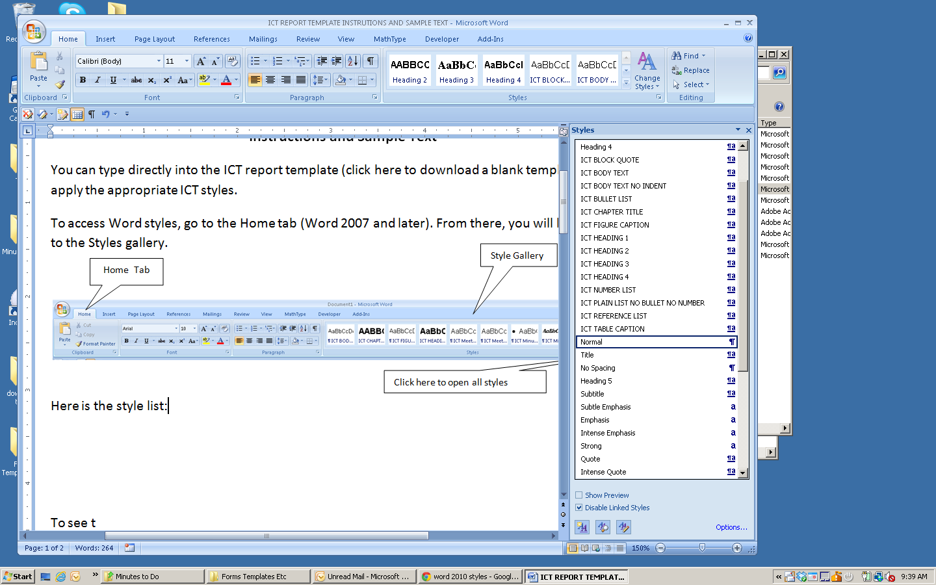

Click here to open a list of all styles

**🡨🡨Here is the fully expanded style list you will see when you open the list by clicking as shown above. All the styles you should use are preceded by “ICT.” Note: This is a sample list. The available styles might change as this template is updated.**

Simply click on the text in your report that you wish to apply a style to, then click on the desired style from this list.

The following pages contain sample heading styles, body text styles, and figure and table captions.

***Contact ICT Project Management if you have any questions about using Word templates and styles.***

***Email:*** [***ICTProjectManagement@illinois.edu***](mailto:ICTProjectManagement@illinois.edu)

CHAPTER 1: Introduction

SECTION TITLE [ICT HEADING 1]

Lorem ipsum dolor sit amet, an ius paulo doming, eu quo simul soluta. Vel ocurreret inciderint ad, no mundi periculis assueverit mei. Ad vel vidisse iuvaret, ut nam velit ludus. His ea dicunt ancillae hendrerit. Solet nominati quo ne, dicant accusamus consulatu vel te, has alia perfecto mnesarchum.

Nam dictas habemus propriae eu, est ad mutat solet cotidieque. Nam dolore deseruisse cu. No omnium postulant nec. Debet doctus vim ne.

Errem imperdiet usu ne, ei vel error iudicabit intellegat. Mea ne wisi eirmod, insolens platonem qui ea. Persius tibique quaestio sed ei, sed summo zril partem ne. Id mea esse paulo vulputate. Ad usu rebum dolor postea.

Subsection Title [ICT HEADING 2]

Modus ludus an per, sea delectus principes ut. Pro ea duis labores veritus, ut est etiam bonorum volutpat. Populo mediocrem eu ius. Pro cu tantas eligendi, malis theophrastus duo eu. Mei id novum noluisse moderatius, usu in dolore pericula. Paulo intellegat pro ut, cu cum alia theophrastus.

In vix corpora posidonium, te pri brute salutandi disputando. Et illum percipit quo, assum utamur dissentias no cum. Pro hinc putent referrentur cu, nibh omnes contentiones sed no. Ad mea ipsum atqui singulis, vocent salutatus duo ea.

Sub-Subsection Title [ICT HEADING 3]

Ad tale gubergren vix, quo an sumo veniam fierent. Porro melius facilisi pro an, vix docendi accusam postulant et, pro ne graece postea probatus. Et vim quis ullum epicuri, inermis veritus id mel. Suas definiebas persequeris vis an. Eum corpora forensibus adolescens ea, tritani mentitum vulputate te vel.

Sub-Sub-Subsection Title [ICT HEADING 4]

Soleat explicari complectitur at his, his suas assum latine cu, cu munere diceret utroque has. Cu nullam numquam omittantur mea, ex case habemus consulatu eos. Vel congue percipit ex, id mel mediocrem principes, ius ei quod convenire. Eam te lobortis consequat instructior, nec ex eros ipsum intellegat, minim antiopam partiendo eam ei.

Chapter 2: Formatting Figures

Each figure should be separate and should have its own figure number and caption. The basic requirements to create Section 508 compliant figures are listed below:

* Do not include sub-numbers (1-1, 1.2, etc.) with figures.
* Number figures consecutively throughout the report and appendices, not per chapter.
* Provide [alternative text](https://www.fhwa.dot.gov/publications/research/general/15058/004.cfm) that describes the information conveyed in the figure. To add alternative text, right click on the figure and select “Edit Alt Text.”
* Include a description of the image type (photo, graph, equation, chart, diagram, illustration).
* Avoid composite figures with multiple captions (See Figure 4).

This photo shows the top of the concrete precast deck of beam 4F1 after grouting the specimen in place. Six shear pockets can be seen in the deck; each is filled with fresh grout, and the shear studs are not visible. The concrete deck has lifting hooks in it. The beam is in a load testing frame inside a structural testing lab. A steel column and one of the actuators used for testing are visible.

Figure 1. Photo. After grouting large-scale beam specimen 4F1.

Source: Provines, et al., 2019

This figure plots area under the curve (AUC) on the y-axis (range 0.5 to 1) versus seconds on the x-axis (range 17 to 21). The solid line is extended, the dashed line is predicted, and the dash-dot line is vector autoregression model. From 17 through 19 seconds, values for all lines are just over 0.65. From 19 through 21 seconds, the predicted and VAR lines are very similar, staying near 0.65 until increasing to just over 0.7 at 21 seconds. The extended line increases to 0.7 at 20 seconds and 0.85 at 21 seconds.

Figure 2. Graph. AUC profile of reference (original data), predicted (ARMA) method, and   
VAR method.

Source: Flannagan et al., 2019

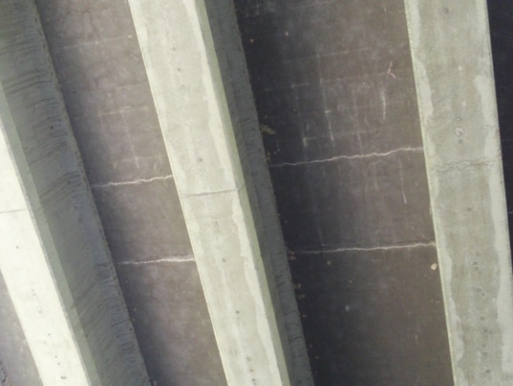

A. Transverse cracking in a concrete bridge.

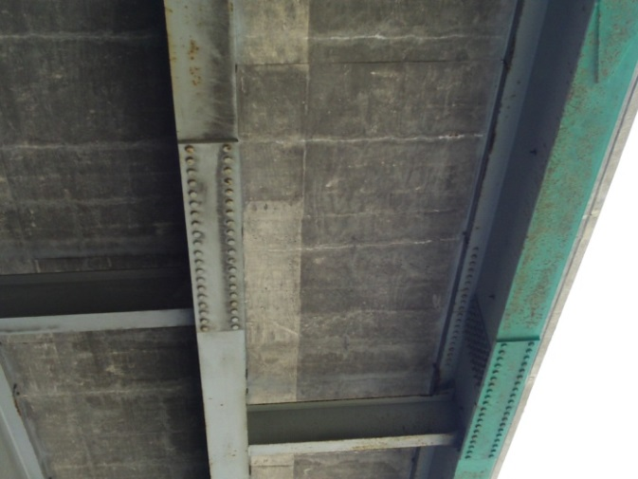

B. Transverse cracking in a steel girder bridge.

Figure 3. Photo. Transverse cracking in a concrete bridge and steel girder bridge.

Source: ICT, 2020

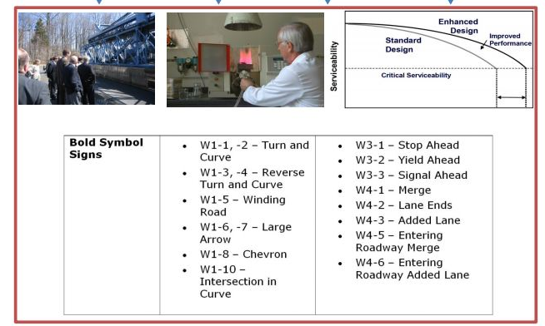

Figure 4. Multiple elements. Example of a Section 508 noncompliant composite figure.

Source: FHWA, 2017

Chapter 3: Formatting Equations

The basic requirements to create Section 508 compliant equations are listed below:

* Label equations as figures.
* Format equations as .jpg files. Note that not all computers and operating systems can interpret special math and scientific fonts.
* Provide [alternative text](https://www.fhwa.dot.gov/publications/research/general/15058/004.cfm?#_Toc474772831) with equations.

Open parenthesis y minus mu subscript 2 divided by 3 sigma subscript 2 close parenthesis squared plus open parenthesis z minus mu subscript 3 divided by 3 sigma subscript 3 close parenthesis equals 1.

Figure 5. Equation. Simplified equation for two-dimensional ellipsoid to represent the second and third PCs.

Source: Flannagan et al., 2019

Chapter 4: Formatting Tables

The basic requirements to create Section 508 compliant tables are listed below:

* Create tables using the built-in feature in Microsoft Word. Do not include pictures of tables.
* Do not include sub-numbers (1-1, 1.2, etc.).
* Consecutively number tables throughout the report and appendices, not per chapter.
* Avoid using complex tables with merged and/or split cells (see Table 2).

Table 1. Mix Designs

|  | **Control Mix** | **Type K Mix** |
| --- | --- | --- |
| Water* | 267 | 286 |
| Type I Cement* | 608 | 455 |
| Type K | — | 90 |
| Fine Aggregate* | 1129 | 1069 |
| Coarse Aggregate* | 1825 | 1831 |
| W/C Ratio | 0.44 | 0.52 |

* Quantities are in lb/yd3 (1 lb/yd3 = 0.59 kg/m3)



Table 2. 508 Noncompliant Table—Complex Table Using Merged Cells

|  |  |  |  |  |  |  |  |
| --- | --- | --- | --- | --- | --- | --- | --- |
| Assigned Projects | | | | | | Future Projects | |
| Division A | | | Division B | | | Funded | Pending |
| Initiated Pending / Ongoing | | Completed | Initiated Pending / Ongoing | | Completed |
| 1 | 3 | 8 | 2 | 2 | 8 | 8 | 2 |

References

An example reference list is demonstrated below using the APA citation style. **You are not required to follow this exact formatting style for references**. However, you must be consistent in how you format each type of reference in terms of author names, year, date of publication, title, city of publication, etc.

American Psychological Association. (2020). *Reference examples*. Retrieved January 30, 2020, from, <https://apastyle.apa.org/style-grammar-guidelines/references/examples>

Amirkhanian, S. (2020). Utilization of scrap plastics in asphalt binders. In F. S. Pacheco-Torgal, S. Amirkhanian, H. Wang, & E. Schlangen (Eds.), *Eco-efficient pavement construction materials* (pp. 13–32). Woodhead Publishing. <https://doi.org/10.1016/B978-0-12-818981-8.00002-3>

Federal Highway Administration. (2017). *Turner-Fairbank Highway Research Center R&D Communication Reference Guide* (FHWA-HRT-15-058). Federal Highway Administration Research and Technology. [https://www.fhwa.dot.gov/publications/research/general/15058/005.cfm?#  
_Toc474772847](https://www.fhwa.dot.gov/publications/research/general/15058/005.cfm?#_Toc474772847)

Flannagan, C. A., Selpi, Boyraz Baykas, P., Leslie, A., Kovaceva, J., & Thomson, R. (2019). *Analysis of SHRP2 data to understand normal and abnormal driving behavior in work zones* (Report No. FHWA-HRT-20-010). FHWA. <https://www.fhwa.dot.gov/publications/research/safety/20010/index.cfm>

Hernandez, J. A., Gamez, A., Al-Qadi, I. L., & De Beer, M. (2014). Analytical approach for predicting three-dimensional tire-pavement contact load. *Transportation Research Board: Journal of the Transportation Research Board*, *2456*(1), 75–84. <https://doi.org/10.3141/2456-08>

Kim, R. E., Kang, S., Spencer, B. F., & Al-Qadi, I. L. (2019). Impact of pavement roughness and deflection on fuel consumption using energy dissipation. *Journal of Engineering Mechanics*, *145*(10). <https://doi.org/10.1061/(ASCE)EM.1943-7889.0001653>

Provines, J. T., Ocel, J. M., & Zmetra, K. (2019). *Strength and fatigue resistance of clustered shear stud connectors in composite steel girders* (FHWA-HRT-20-005). Federal Highway Administration. <https://www.fhwa.dot.gov/publications/research/infrastructure/structures/bridge/20005/>

Schaefer, N. K., & Shapiro, B. (2019, September 6). New middle chapter in the story of human evolution. *Science*, *365*(6457), 981–982. <https://doi.org/10.1126/science.aay3550>

Scholz, M. (2019). *Sustainable water treatment: Engineering solutions for a variable climate*. Elsevier. <https://doi.org/10.1016/C2017-0-04643-8>

Zhao, S., & Al-Qadi, I. L. (2019). Algorithm development for real-time thin asphalt concrete overlay compaction monitoring using ground-penetrating radar. *NDT & E International*, *104*, 114–123. <https://doi.org/10.1016/j.ndteint.2019.04.008>