Clothing
- Waterproof camouflage coat
- Waders/boots
- Camouflage pants
- Camouflage hat
- Face mask/face paint
- Dark or camouflage gloves

Basic Hunting Equipment
- Hunting license/federal duck stamp/permits
- Windshield card (if applicable)
- Shotgun and ammo (non-toxic shot)
- Appropriate choke tubes and choke tube wrench
- Gun case
- Hunting backpack or waist pack
- Compass
- Maps
- Basic first aid kit

Calls & Decoys (optional, but one call and decoys are recommended)
- Floating/field goose decoys
- Floating/field mallards
- Appropriate calls
- Decoy bag
- Decoy weights
- Decoy cord
- Confidence decoys
- Decoy anchors
- 6-in-1 whistle
- Double-reed duck call
- Goose flute

Optional Hunting Equipment
- Knife
- Knife sharpener
- Binoculars
- Flashlight/headlamp
- Shooting glasses
- Hearing protection

Lottery Application Deadline
- First Lottery (Residents-only) – Late Summer 2017
- Second Lottery – Late Summer 2017
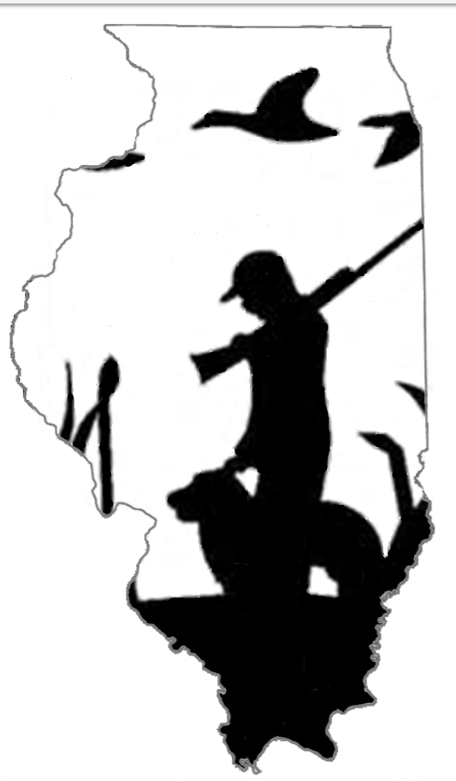
- Third Lottery – Late Summer 2017

