Clothing
- Brush chaps
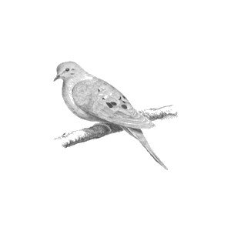
- Boots
- Insulating layer (fleece or wool)
- Hat/cap
- Gloves
- Hunter orange (as required by law)

Basic Hunting Equipment
- Hunting license and permits
- Windshield card (if applicable)
- Shotgun
- Ammo
- Choke tubes
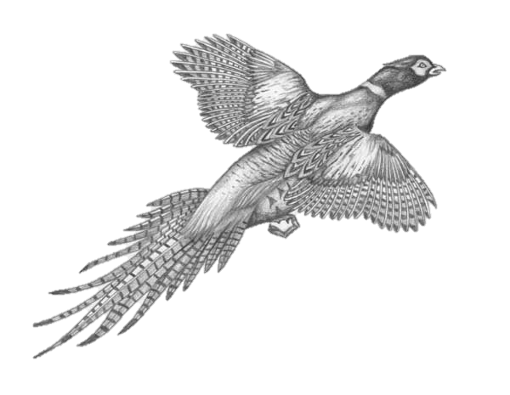
- Gun case
- Gun care/cleaning kit
- Choke tube wrench
- Water bottle
- Maps
- Shooting glasses
- Hearing protection
- Basic first aid kit
- Flashlight/headlamp
- Hunting knife
- Game shears (optional)

Optional Hunting Accessories
- Handsaw
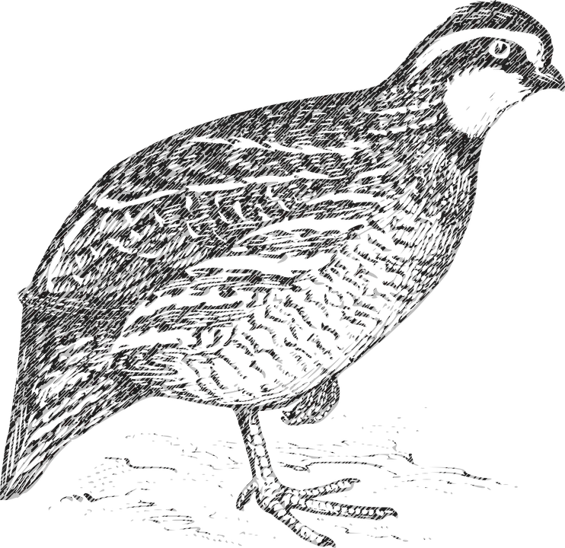
- GPS unit
- Hatchet
- Hunting blind & chairs
- Treestand & safety harness
- Range finder (extremely useful for bowhunting)
- Scent control/cover scent
- Basic firearm/bow maintenance kit
- Deer cart/sled
- Handwarmers
- Snacks

Lottery Permit Application Deadlines (2017)
- Free upland game Aug 1 – Aug 31
- Dove first lottery June 1 – June 30
- Dove second lottery July 7 – July 21
- Dove third lottery July 28 – August 25

