Clothing
- Camouflage coat
- Camouflage pants
- Camouflage hat
- Hunter orange vest/hat (depending upon current season, this may or may not be required)
- Camouflage facemask/face paint
- Boots
- Gloves

Basic Hunting Gear
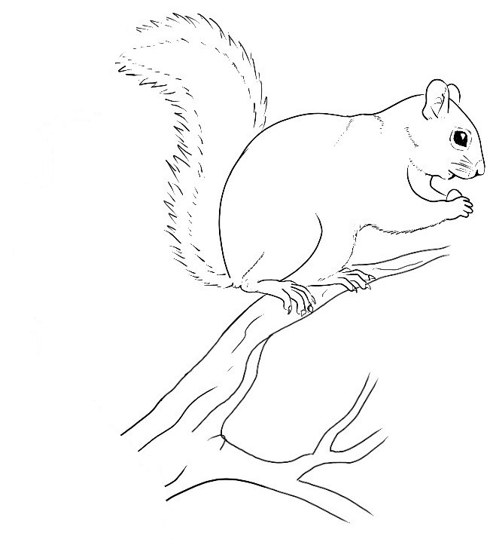
- Hunting license/permits
- Windshield card (if applicable)
- Firearm and ammo OR bow and arrows
- Backpack/fanny pack
- Hunting knife
- Knife sharpener
- Flashlight/headlamp
- Compass
- Maps
- Basic first aid kit
- Binoculars
- Water

Optional Hunting Accessories
- Handsaw
- GPS unit
- Hatchet
- Hunting blind & chairs
- Range finder (extremely useful for bowhunting)
- Scent control/cover scent
- Basic firearm/bow maintenance kit
- Handwarmers
- Snacks

Small game hunting on IRAP leased sites is available for public access
- Free upland game permit application period: Aug 1 – Aug 31
- Squirrel hunting from Aug 1 – Sept 30
- Rabbit hunting from Dec 10 – Dec 31
- For Foot Traffic Only. Illinois Hunting Rules and Regulations must be followed

Statewide Seasons on IDNR Sites (2017-2018)
- Squirrel: Aug 1 – Feb 15
- Rabbit: Nov 4 – Feb 15

