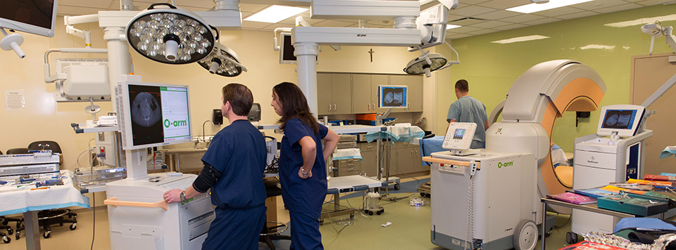

ENGINEERING AT ILLINOIS
1st Health Care Engineering Systems Symposium
September 15, 2014
Chancellor Room
I Hotel, Champaign, IL

Health Care Engineering Systems Center

HCESC-JUMP/ARCHES SYMPOSIUM
Monday, September 15, 2014
Chancellor Room, I Hotel

AGENDA

8:30 AM - 9:00 AM Arrival of the Participants
Breakfast and Registration

9:00 AM - 10:00 AM Rashid Bashir-Opening of Symposium

Ilesanmi Adesida- Provost, UIUC
Opening Remarks

Kevin Schoeplein - CEO, OSF Healthcare System
Remarks and Presentation of William Di Somma

William Di Somma- Managing Director, Jump Trading
Remarks

Andreas Cangellaris- Dean, COE
Remarks and Presentation of the HCESC Director

T 'Kesh' Kesavadas-Director, Health Care Engineering Systems Center
Remarks

John Vozenilek-Director, Jump Trading Simulation and Education Center
Remarks

Rashid Bashir-Opening of the presentations

10:00 AM - 10:50 AM OSF’s Clinical Agenda
John Vozenilek Stephen Hippler
Moderator
Priorities of OSF’s Healthcare Analytics Team
Mark Hohulin

Clinical Challenges Facing Nursing Practice and the Complexities of a Highly Technology-driven Clinical Environment
Lori Wiegand

Current technologies used in Teleheath and the Potential Areas for Development of New Sensors, Imaging Technology, and Data Visualization
Suzanne Hinderliter

Current challenges in home monitoring. Impact of chronic health conditions on home health.
Lois Bentler-Lampe

“Black Box” for the Operating Suite
Ann Willemsen-Dunlap

Frontiers in Home Sleep Laboratory Monitoring
Sarah Zallek

Hydrodynamic Lab for Hydrocephalus Treatment Innovation
Julian Lin

Break

11:00 AM - 12:00 noon Understanding and Evaluating the Benefits of the Internet of Things for
Klara Nahrstedt Health Care
Moderator Roy Campbell

Security Concerns in Android mHealth Apps
Carl Gunter

Measurement-driven Accident Analysis and Safety-based Design
Ravishankar K. Iyer

Human Augmentation System for Insertion of Surgical Devices
Thenkurussi (Kesh) Kesavadas

Spherically Convergent Shear Waves during Blunt Head Trauma
Martin Ostoja-Starzewski

Biosensor Arrays for Multiplexed Disease Diagnostics
Brian Cunningham

Computer-Aided Characterization of Spinal Deformity
Harry Dankowicz

Modeling of Soft Tissue Cutting
Ashraf Idkaidek

3D, Interactive, Multi-player, Virtual Models for Education and Training of Health Care Personnel
Rizwan Uddin

MoboSens: Molecular Precision Wearable Biosensing Electronics Integrated on Ubiquitous Computing Platform
Gang Logan Liu

12:00 noon - 1:00 PM Lunch
Quad Room and Lobby

1:00 PM - 2:00 PM 3D Bio-printing for Fabricating Tissue Constructs and Biological
Rakesh Nagi Machines
Moderator Rashid Bashir

Multiscale Mechanics of Bone
Iwona Jasiuk

Decoupled Control of Material Mechanics and Permeability for 3D Cell Culture and Therapies
Hyunjoon Kong

Multi-Excitation Magnetic Resonance Elastography for Improved Biological Material Characterization
Aaron Anderson

OxiplexTS200, a Non-invasive Absolute Tissue Oximeter for Measurements in the Muscle and the Brain
Beniamino Barbieri

Research to Improve Medication Adherence among At-Risk Populations
Frank Naeymi-Rad

Biomedical Technology Commercialization Opportunities through an NSF Industry University Cooperative Research Center
Gregory Pluta

Technologies for Certification of Medical Devices and Processes
Sayan Mitra

Development of Multimodal Multifunctional Probes for Image-guided Surgery
Wawrzyniec Dobrucki

Chemical Imaging and Printed Structures for Simulation in Pathology
Rohit Bhargava
Break

2:00 PM - 3:00 PM Development and Integration of Optical Imaging Devices in Medicine
Rohit Bhargava and Surgery
Moderaror Stephen A. Boppart

Using Simulation to Study, Evaluate, and Enhance Clinical Judgment
Alex Kirlik

Development of a MOtion-Detection Device (MODD) for the Assessment and Training of Cognitive Functioning and Motor Control
Sean Mullen

Three-Dimensional Textured Graphene Bioelectronics
SungWoo Nam

Graphene Membrane Transistor for DNA Sensing and Manipulation
Jean-Pierre Leburton

IOLab: An inexpensive Approach to Wireless ECG's
Mats Selen

Portable Powered Orthotic Devices and Movement Simulators
Elizabeth T. Hsiao-Wecksler

A system for remote monitoring of rehabilitative physical therapy
Rama Ratnam

T 'Kesh' Kesavadas
Closing remarks

Symposium Information

Internet Access

The Wi-Fi is free! You may connect to UI Public for access.

Organizing Committee

Rashid Bashir
Rohit Bhargava
T 'Kesh' Kesavadas
Tony Michalos
Rakesh Nagi
Klara Nahrstedt
Paul Pribaz
John Vozenilek

For more information about the ARCHES program visit:

Health Care Engineering Systems Center: http://engineering.illinois.edu/hcesc/

Jump Simulation & Education Center: http://www.jumpsimulation.org/

