Semi-batch reactor for DS of H₂O₂
Standard Operating Procedure
Lab: Davenport 270
Department: Chemical and Biomolecular Engineering
PI/Manager of Space: Prof. David Flaherty
Written By: Pranjali Priyadarshini and Jason Adams
Section 1: Overview
Type of SOP: ☒Process ☐Hazardous Material ☐Hazardous Class of Materials ☒Equipment
Synopsis:
This SOP is to provide guidelines and standard procedures for the two types of Semi batch system.
Section 2: Risk Assessment Summary (Hazards and control measures)
Information obtained from performing a risk assessment should be entered into this section.

Materials:
Material (name, CAS #, other ID) | Hazards
Methanol | High toxicity upon ingestion.
H₂ | Flammable
HCl, H₂SO₄, HClO₄ | Corrosive
TiOSO₄/H₂SO₄ | Corrosive

Relevant References for Material Hazards:
Methanol: http://avogadro.chem.iastate.edu/MSDS/methanol.htm
H₂: http://avogadro.chem.iastate.edu/MSDS/hydrogen.pdf
H₂SO₄: https://www.sciencelab.com/msds.php?msdsId=9925146
HCl: http://www.sciencelab.com/msds.php?msdsId=9924285\

Equipment Hazards:
None.
Hazardous Conditions:
When using corrosive acids, use appropriate PPE (gloves, safety glasses, lab coat)

Technique Hazards:
None.

Personal Protective Equipment
Safety glasses, nitrile gloves, lab coat (when handling acids)

Engineering Controls
None.

Section 3: Procedures

Overhead stirrer semi batch (with operando UV-vis) (Refer to figure 1 for the reference of different parts)
- Connect the stirrer shaft (a) to the overhead stirrer (b) through the adapter (c) to the vertical 14/20 connection (d) on the ‘cap’ of the reactor.
- Attach the bottom half of the reactor (e) to the top by tightening the screws on the connector (f). This should be gas tight. But do not overtighten (especially likely with the green connector) or else the reactor will break.
- Connect the condenser to one of the 14/20 connections at the side (connect preferable to the almost vertical one) with the adapter on top (g). The adapter is connected to the plastic tubing which is connected to the mass spectrometer (the red one!!).
- If using the in situ UV-Vis, use the reactor cap with 4 connections. The one at the vertical position (not the 14/20 outlet) is connected to the mass spec. The one with threads is used to insert the transmission dip probe (h) into the solvent. The cap needs to be screwed so that it is gas tight such that it is compressing the o-ring.
- Connect the gas outlet to the reactor at the bottom.
- Set gas flow rates on the MFCs using the controller panel. To do this, the arrow should be on the gas whose flow rate is being changed (use up down arrows to select the gas). Press select, press down, press enter. In the next menu, press down till you reach SP. Press select and set the set point using the up down keys. Then press enter.
- Do step 5 before pouring in the liquid or else the liquid will flow out from the bottom of the reactor.
- After setting the gas flow rates, connect the chiller to the reactor if changing temperature or running at some other conditions except RT.
- Turn the chiller on by turning the switch on the chiller up if cooling, down if heating. Set the temperature by rotating the dial on the chiller. See to it that the flow of the refrigerant (50% (v/v) aqueous ethylene glycol) is on by turning the knob on the chiller controlling the flow anti-clockwise.
- Turn the mass spec on by turning the filament and multiplier on. The mass spec needs about 15 min to warm up. After 15 min, start the mass spec measurement to record the H2/N2 and O2/N2 ratio. The masses that need to be monitored on mass spec is up to the discretion of the user. This can be done by enabling the channels on the LabVIEW code when start is hit and entering the mass to be monitored.
- Start the overhead stirrer by turning the switch to on and setting the RPM by turning the knob to the desired value. (>1000 RPM to avoid diffusion limitations).
- Let the H2/N2 and O2/N2 ratio reach a steady state on the mass spec (may take about an hour)
- Two reactors can be connected in the above fashion and the gas concentrations of each reactor can be monitored one at a time by switching the three way valve to the desired reactor. There are also 2 pools of reactors. The overhead stirred reactors are one pool and the round bottomed reactors are the other pool. A three way valve is used to switch between the two pools of the reactors.
- After the gas ion currents (and ratios) have attained a steady value on the mass spec, catalyst can be added to the reactor.
- If UV-VIS is being used, reference and dark should be taken before adding the catalyst (see UV-VIS SOP for instructions on how to use the software and directions for taking spectrum correctly).
- The catalyst is ground firmly and a 5 ml pipette tip with its end cut and a plastic tubing attached to it is used as a funnel to pour the powdered catalyst directly into the solvent. Care should be taken to pour all the catalyst into the solvent directly and preventing any particles from sticking to the walls of the reactor.
- Start the stopwatch and the AVAsoft program to start recording the spectra.
- Take aliquots at time intervals as required. Aliquot is taken by inserting a syringe with a needle at the end. Then, the needle is disconnected and a filter is connected and the aliquot is collected through the filter into a test tube to separate any particles. (Generally, start with more points at the beginning, so take aliquots every 5 or 10 minutes. After 30-60 min, decrease the frequency of the aliquots to every 30-60 mins as desired)
- Depending on the composition of system, two types of indicators are used. In absence of acids, neocuproine-CuSO4 is used (1.668 g CuSO₄ in 600 ml H₂O + 2.080 g neocuproine in 200 ml EtOH). For low concentrations of H₂O₂ (<1 mM) use 500 ul indicator and 500 ul sample and measure the absorbance in the Spectronic 20 UV-VIS (not to be confused with Avantes UV-Vis used for in-situ and operando measurements) at 454 nm. In case of higher concentrations, use 370 ul sample + 1.3 ml sample. After letting this mixture react for 10 min, this 200 ul of this sample is diluted in 2 ml water and then absorbance is measured at 454 nm. H₂O₂ concentrations can be calculated from a calibration curve. In presence of acids, TiOSO₄/H2SO₄ indicator is used. 200 ul of the aliquot is mixed with 2 ml of the indicator and absorbance is measured at 410 nm.
- Take aliquots till roll over of H₂O₂ concentration is observed.
- After completion of the experiment, turn off the gas flow, chiller and turn the filament and multiplier of the mass spec off.
- Clean the frit of the reactor with aqua regia (3:1 (v:v) HCl+HNO₃))

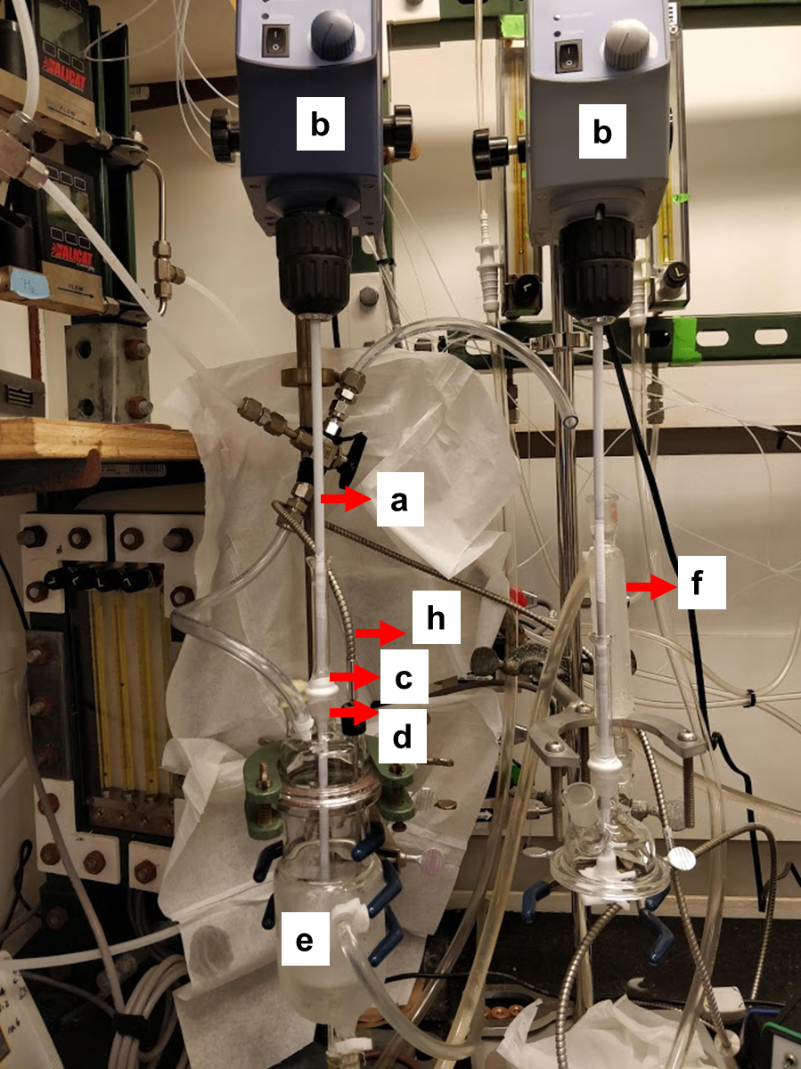
Figure 1: Picture of the semi batch reactor with labelled parts.
Three-neck round bottom flask semi batch (Refer to figure 2 for the reference of different parts)
- Ensure that the three round bottom flasks, septa, gas dispersion tubes, and magnetic stir bars are thoroughly cleaned before beginning the experiment. Gas dispersion tubes must be washed with either aqua regia or HNO3 and washed/sonicated three times in between experiments.
- Attach the gas dispersion tubes to the gas outlets labeled 2, 3, or 4 on the alicat gas manifold.
- Place the three-neck flasks above the stirrer units and connected it to the clamps.
- Add the desired amount of solvent to the flasks (typically 80 mL is good).
- Assemble the reactors as shown in figure 2 and make sure that the glass joints are well sealed.
- Set gas flow rates on the Alicat MFCs using their controller panel. To do this, click setpoint in the bottom right corner and adjust to the desired flow.
- Check for leaks in the system by using snoop. If no bubbles form at any of the glass joints, then the system is sufficiently leak tight.
- Adjust the flow rates to each individual reactor by adjusting the 4-way rotameter such that a flow rate of 21 sccm is displayed on the overhead rotameters at the reactor outlets.
- Turn the chiller on by turning the switch on the chiller up if cooling, down if heating. Set the temperature by rotating the dial on the chiller. See to it that the flow of the refrigerant (50% (v/v) aqueous ethylene glycol) is on by turning the knob on the chiller controlling the flow anti-clockwise. This will cool the condensers above the reactors to minimize evaporation.
- Turn the mass spec on by turning the filament and multiplier on. The mass spec needs about 15 min to warm up. After 15 min, start the mass spec measurement to record the H2/N2 and O2/N2 ratio. The masses that need to be monitored on mass spec is up to the discretion of the user. This can be done by enabling the channels on the LabVIEW code when start is hit and entering the mass to be monitored.
- Start the stirrer units by turning their knobs to their highest settings to minimize mass transfer limitations. Sometime the stir bar will lose traction, which can be fixed by turning off the stirrer and adjusting the stirrer units.
- Let the H2/N2 and O2/N2 ratio reach a steady state on the mass spec (may take about an hour). Make sure that all reactors are at steady state by adjusting the 4-port valve positions from 2-4. If another person is using the overhead stirrer and wants to switch to their reactor, adjust the valve to position 1 and turn the three-way valve (connected to the mass spec) away from the three-neck reactors.
- After the gas ion currents (and ratios) have attained a steady value on the mass spec, catalyst can be added to the reactor.
- Prior to starting the experiment measure out a desired amount of catalyst (preferably ground to ~200 mesh) for each reactor.
- Prepare three sets of test tube racks for the desired time intervals between aliquots. Each set of testubes should have the appropriate amount of indicator depending on the calibration curve used.
- To begin the experiment, slide the catalyst into the three-neck flask from a folded weigh paper. Be sure to push any catalyst on the edge of the flasks into the vessels using a spatula.
- Once the catalyst is put into the reactor the experiment has begun and the time should be started.on the stopwatch.
- Take aliquots at time intervals as required. Aliquot is taken by inserting a syringe with a needle at the end. Then, the needle is disconnected and a filter is connected and the aliquot is collected through the filter into a test tube to separate any particles. (Generally, start with more points at the beginning, so take aliquots every 5 or 10 minutes. After 30-60 min, decrease the frequency of the aliquots to every 30-60 mins as desired)
- Depending on the composition of system, two types of indicators are used. In absence of acids, neocuproine-CuSO4 is used (1.668 g CuSO₄ in 600 ml H₂O + 2.080 g neocuproine in 200 ml EtOH). For low concentrations of H₂O₂ (<1 mM) use 500 ul indicator and 500 ul sample and measure the absorbance in the Spectronic 20 UV-VIS (not to be confused with Avantes UV-Vis used for in-situ and operando measurements) at 454 nm. In case of higher concentrations, use 370 ul sample + 1.3 ml sample. After letting this mixture react for 10 min, this 200 ul of this sample is diluted in 2 ml water and then absorbance is measured at 454 nm. H₂O₂ concentrations can be calculated from a calibration curve. In presence of acids, TiOSO₄/H2SO₄ indicator is used. 200 ul of the aliquot is mixed with 2 ml of the indicator and absorbance is measured at 410 nm.
- Take aliquots till roll over of H₂O₂ concentration is observed and the H2/N2 ratio remains constant on the mass spec. It is important to sample multiple reactors throughout the experiment to ensure each are at steady state and to collect the final conversion on each reactor.
- After completion of the experiment, turn off the gas flow, chiller and turn the filament and multiplier of the mass spec off.
- Clean the frit of the reactor with aqua regia (3:1 (v:v) HCl+HNO₃))
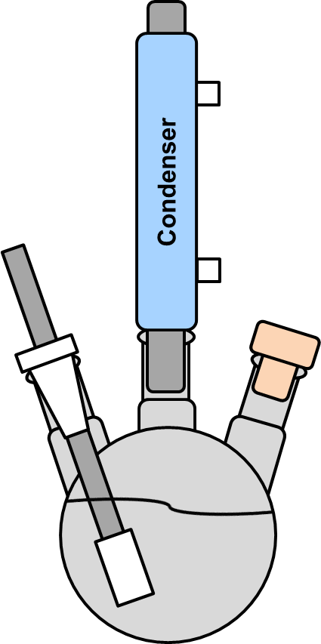
Three-Neck
Flask
Gas Dispersion
Tube
Septa
Figure 2. Three-Neck semibatch reactor including condenser, gas dispersion tube, septa, and flask.

Training Documentation
Signing this document means that you have read and understand all aspects of this Standard Operating Procedure.
The supervisor is the person that acknowledges you took the training and understand the procedure. They can be a lab manager or researcher assigned by the PI to oversee this particular SOP.
Name (Printed) | Name (Signed) | Supervisor | Date

