

Geoderma 470 (2026) 117830
Contents lists available at ScienceDirect

Geoderma

journal homepage: www.elsevier.com/locate/geoderma

Mitigating the soil carbon deficit of annual agriculture with perennial bioenergy crops in the U.S. Midwest
Ilsa B. Kantola ^{a,b,1}, Yuhei Nakayama ^{c,1}, Ezra Moses ª, Elena Blanc-Betes ^{a,b}, Sarah C. Davis ^{d}, Michael D. Masters ^{b,c}, Robert G. Darmody ^{e}, Andrew J. Margenot ^{a,c},
Evan H. DeLucia ^{a,b,f,g,h,*}
ª Institute for Sustainability, Energy, and Environment, University of Illinois at Urbana-Champaign, Urbana, IL, USA
^{b} Center for Advanced Bioenergy and Bioproducts Innovation, University of Illinois at Urbana-Champaign, Urbana, IL, USA
^{c} Department of Crop Sciences, University of Illinois at Urbana-Champaign, Urbana, IL, USA
^{d} Voinovich School of Leadership and Public Service, Ohio University, Athens, OH 45701, USA
^{e} Department of Natural Resources and Environmental Sciences, University of Illinois at Urbana-Champaign, Urbana, IL, USA
^{f} Carl R. Woese Institute for Genomic Biology, University of Illinois at Urbana-Champaign, Urbana, IL, USA
^{g} Department of Plant Biology, University of Illinois at Urbana-Champaign, Urbana, IL, USA
^{h} Institute for Genomic Biology, University of Illinois at Urbana-Champaign, Urbana, IL, USA

A R T I C L E I N F O

Handling Editor: Dr Naoise Nunan

Keywords: Bioenergy Cellulosic ethanol Maize ethanol Land use change Miscanthus Prairie Renewable fuel Switchgrass
A B S T R A C T

Maize (Zea mays L.) is the dominant bioenergy feedstock in the US Midwest but its cultivation since the early 1800s has incurred substantial losses in soil organic carbon (SOC). We quantified differences in SOC stocks under perennial bioenergy crops of Panicum virgatum L. (switchgrass) and Miscanthus x giganteus Greef et Deuter (miscanthus) planted on former maize and soybean fields relative to maize-based annual cropping and native prairie. Comparisons were made at seven locations across Illinois, USA, spanning a range of climate and soil
types. Across sites, SOC stocks to 1-m depth on an equivalent soil mass basis were 146 Mg C ha⁻¹ under prairie, 107 Mg C ha⁻¹ under miscanthus, 97.9 Mg C ha⁻¹ under switchgrass, and 87.7 Mg C ha⁻¹ under maize. Higher
SOC demonstrates the potential of perennial bioenergy crops to rebuild the SOC deficit accrued under nearly two centuries of maize-based annual cropping. SOC stock increased in the first 5 years under mature bioenergy crops at four out of seven sites. Carbon isotope (δ¹³C) analyses of surface depths confirmed short-term increases in SOC to be derived from miscanthus and switchgrass. Stocks of SOC could be increased over time under miscanthus or switchgrass cultivation even with annual harvesting, though our measured rates of SOC accumulation were lower than previous estimates for Illinois and varied by site.

Introduction

The nearly 200-year history of maize-based agriculture in the US Midwest (Warntz, 1957; Bogue, 2011) has led to an estimated halving of soil organic carbon (SOC) stocks under native tall-grass prairies in this region prior to European American agriculture (Huggins et al., 1998; David et al., 2009). Carbon (C) storage is generally greater in soils supporting perennial species relative to annual crop species, including native prairie grass communities but also perennial crop species (Tolbert et al., 2002; Liebig et al., 2005; Omonode and Vyn, 2006). When annual crops such as maize (Zea mays L.) are replaced with perennial grasses, C
inputs via roots and residues and the cessation of disturbance from tillage leads to more C retained from plant residues, increased SOC stocks (e.g. Liebig et al. 2005), and thus partial reversal of SOC deficits incurred under maize-based annual agriculture (Ferchaud et al., 2015; Kantola et al. 2025). To the extent that perennial bioenergy crops restore SOC to the saturated maximum conditions of former native prairies, reductions in net CO₂-C emissions of bioenergy production chains may be realized (Robertson et al., 2000; Adler et al., 2007; Davis et al., 2009; Davis et al., 2012; Hudiburg et al., 2015; Blanc-Betes et al., 2023a).
Perennial grasses that produce greater harvestable biomass per unit area than maize (Heaton et al., 2008; Don et al., 2012; Cadoux et al.,

* Corresponding author at: University of Illinois, 1404 IGB, 1206 W. Gregory Dr, Urbana, IL 61801, USA.
E-mail address: delucia@illinois.edu (E.H. DeLucia).
¹ I. B. Kantola and Y. Nakayama contributed equally to this work.

https://doi.org/10.1016/j.geoderma.2026.117830
Received 27 May 2025; Received in revised form 21 January 2026; Accepted 24 April 2026
Available online 6 May 2026
0016-7061/© 2026 The Author(s). Published by Elsevier B.V. This is an open access article under the CC BY license (http://creativecommons.org/licenses/by/4.0/).

2014) could reduce the land area required to meet the demand of a growing bioenergy market. For example, Miscanthus x giganteus Greef et Deuter (miscanthus) would require only one-third of the area to produce the same amount of ethanol that is produced by maize per unit land area (Heaton et al., 2008). Anderson-Teixeira et al. (2009) proposed that cultivation of Panicum virgatum L. (switchgrass) and miscanthus as perennial bioenergy crops would result in greater organic C inputs to soil than maize even with annual biomass harvesting and thus would be expected to increase SOC relative to maize-based cropping. In the first
decade after planting on soils with relatively high SOC stocks, mis-canthus and switchgrass increased C storage by 2.0 Mg ha⁻¹ y⁻¹ and
1.75 Mg ha⁻¹ y⁻¹, respectively (Kantola et al., 2025). On abandoned
agricultural land without recent fertilizer additions, a miscanthus crop resulted in a mean C sequestration rate of 0.83–1.37 Mg ha⁻¹ y⁻¹ over a decade (Adu Fosu and Davis, 2024).
Some uncertainty remains about the degree to which the C deficit induced by maize-based agriculture (Sandermann et al., 2017) can be reversed and at which timescales. Variation in C restoration rates is expected with the range in climate and soil characteristics across the former tallgrass prairie region of US Midwest, largely centered in Illinois as well as Iowa and Indiana. This study evaluates the change in SOC with land conversion from maize-based annual cropping to perennial bio-energy crops. A more detailed understanding of this opportunity to restore C will guide decisions about the expansion of advanced bio-energy crops in the former tallgrass prairie region of the US Midwest, where maize-based annual agriculture currently supports the demand for bioenergy.
Maximal biomass yield is the primary selection criterion for biomass feedstocks, though greater aboveground productivity does not neces-sarily correspond with greater SOC stock changes. For instance, accel-erated C turnover has been observed in agricultural soils where plant growth is stimulated by atmospheric CO₂, resulting in a net loss of SOC despite increases in aboveground C (Peralta and Wander, 2008; Moran and Jastrow, 2010). In other cases, SOC can increase while crop yields remain similar, as observed in high-yielding maize-based rotations (e.g., maize-soybean (Glycine max L.) with reduced tillage (Olchin et al., 2008). Carbon added to soils via belowground biomass (roots and rhi-zomes) tends to have a greater residence time than surface-deposited aboveground biomass (litter), suggesting greater potential SOC in-creases from the greater belowground biomass of perennial bioenergy crops than maize. Specifically, miscanthus and switchgrass have been hypothesized to increase SOC stocks due to large relative as well as absolute difference in allocations of biomass to the belowground portion compared to maize (Neukirchen et al., 1999; Ma et al., 2000; Garten et al., 2010; Strullu et al, 2011; Anderson-Teixeira et al., 2013; Kantola et al., 2023). Increased SOC from bioenergy cropping represents a valuable ecosystem and potential economic service for C emission re-ductions and understanding the temporal and spatial implications of accrual is crucial to future perennial acreage.
The former prairie region of the US Midwest is dominated by Mol-
lisols and Alfisols, which are found throughout state of Illinois, creating a limited sampling area that represents the larger region (Fehrenbacher et al., 1984). Due to agronomic practices aimed to maximize maize yields across the US Midwest, we expect perennial grass biomass pro-duction and resulting changes in SOC to vary more widely between sites/soil types than maize. On the other hand, miscanthus has demon-strated sustained productivity in varied soil types and soil properties (Kahle et al., 2001; Schneckenberger and Kuzyakov, 2007), though perennial crops are likely more susceptible to low wintertime temper-atures (Kaiser and Sacks, 2015) and less susceptible to dry conditions that challenge annual species (Joo et al. 2017; Kantola et al., 2023). Quantifying site-specific variation in SOC gains under bioenergy crops relative to native prairie and maize-based cropping systems can inform how to best scale the transition in bioenergy cropping for maximum soil C-based CO₂-C offsets.
To determine the potential for perennial bioenergy grasses to restore
agricultural soils to pre-cultivation prairie conditions, we quantified SOC stocks under native remnant prairie, maize-based annual cropping, and two bioenergy crops (miscanthus and switchgrass) across Illinois, including sites with variation in both soil types and climates typical of the broader US Midwest. First, we quantified SOC stocks by depth in-
tervals to 1-m depth among native remnant prairie, maize-based crop-ping systems, and relatively recently (<11 years) established perennial bioenergy crops. We then quantified SOC stock change over a 5-year
period in miscanthus and switchgrass and determined the origin of new C entering the soil by analyzing the stable carbon isotope (δ¹³C) of surface soils. This 5-year period encompasses the early stage of estab-lishment for miscanthus and switchgrass, for which initial gains in SOC may be greatest (Kantola, 2025). Soils under undisturbed remnant prairie were assumed to represent pre-agricultural SOC, and soils under maize-based annual agriculture represented past and current land use in the US Midwest (Li et al., 2023). We tested the hypothesis that native prairie would support higher SOC stocks than agricultural cropping systems but that SOC stocks under prairie would be more similar to perennial biofuel crops than to annual maize row crops. Due to differ-ences in soil properties and climate between sites, the magnitude of SOC differences would vary by site. As a result, we also hypothesized that replacement of maize-based agriculture with perennial bioenergy crops would increase SOC stocks, partially offsetting the maize agriculture-induced SOC deficit.

Methods

  - Study sites

Miscanthus and switchgrass were planted at seven locations along a north–south gradient in Illinois. Mean annual temperature varied by
≈6 ◦C and mean annual precipitation varied by ≈27 cm along this
gradient, with the northernmost site in DeKalb and the southernmost site at Dixon Springs being the coolest and driest, and warmest and wettest sites, respectively (Table 1). Soil textures varied among sites from sandy loam to silty clay loam, but most sites had silt loam soil (detailed descriptions in Arundale et al., 2014).
Replicate plots (n = 4; 10 × 10 m per plot) of each perennial species
were planted in three locations in 2002 and in four additional locations in 2004 (Table 1). Management practices for establishing and harvesting miscanthus and switchgrass are described in detail by Heaton et al. (2008) and Arundale et al. (2014). Irrigation was used in the first year to aid establishment and chemical or manual weed control was employed each year. The Champaign and Dixon Springs sites received 25 kg N ha⁻¹ the year after establishment only; other sites were not fertilized. At each of the seven locations, miscanthus and switchgrass plots were paired with an adjacent field planted in maize-based rotations (continuous
maize, maize-soybean, or maize-maize-soybean, Table 1). Replicate plots (n = 4; 10 × 10 m per plot) were randomly located in each adjacent
row crop field. A map of the location of the miscanthus and switchgrass plots is provided in Arundale et al. (2014).
For five of the seven sites a remnant prairie was available nearby (mean distance of 43 km) on a similar soil type. The highly limited amount of remaining remnant prairie in Illinois – less than 0.01% of the original area (Li et al., 2023) – constrained high spatial alignment of prairie and agricultural experimental sites. Despite this, the experi-mental design still enables testing with reasonable confidence the degree to which bioenergy crops rebuild SOC given marked losses of SOC from prairie to agriculture over the past 180 years (Huggins et al., 1998) and also enables quantification of SOC restoration potential (Sanderman et al., 2017) and its variation across locations representative of the greater US Midwest region of former tallgrass prairie.
We intentionally sought native prairie remnants instead of restored prairies, as SOC particularly at depth may not be accurately represented in the previously tilled areas of young (< 40 years) restored prairies in
Illinois (Li et al., 2023). High quality remnant native prairie sites were

Table 1
Study site locations in Illinois and corresponding soil characteristics. Soils textures are defined as silty clay loam (SiCL), loam (L), loamy sand (LS), and silt loam (SiL). A maize-maize-soybean rotation is indicated by maize (2)-soy. For soil descriptions see Arundale et al., 2014. Climate data (mean annual temperature, ºC / mean annual precipitation, cm / length of growing season in days (d) above 0 ◦C) are from the Illinois State Climatologist: https://stateclimatologist.web.illinois.edu/data/illinois
-climate-summaries/.
Site | Year | Location | Species | Soil Series | Soil Texture | Drainage | Climate (˚C/cm/˚C)
DeKalb | 2002 | 41.84◦N, -88.85◦W | maize | Elpaso^{m}, Drummer^{m} | SiCL | poor | 9 / 95 / 164
 |  |  | miscanthus
 |  | 41.77◦N, -89.34◦W | switchgrass prairie | Jasper^{m} | L | well-drained
Havana | 2004 | 40.30◦N, -90.82◦W | maize (2)-soy | Sparta^{m} | LS | excessive | 11 / 107 / 173
 |  |  | miscanthus
 |  |  | switchgrass
 |  | 40.46◦N, -90.11◦W | prairie | Sparta, Plainfield | LS | excessive
Champaign | 2002 | 40.04◦N, -88.34◦W | maize (2)-soy | Flanagan^{m} | SiL | somewhat poor | 11 / 104 / 178
 |  |  | miscanthus
 |  | 40.46◦N, -87.92◦W | switchgrass prairie | Clarence^{m} | SiCL | somewhat poor
Orr | 2004 | 39.80◦N, -90.82◦W | maize-soy | Rozettaª | SiL | well-drained | 11 / 98 / 173
 |  |  | miscanthus
 |  | 40.07◦N, -91.20◦W | switchgrass prairie | Clarksdaleª | SiL | well-drained
Brownstown | 2004 | 38.95◦N, -88.96◦W | maize-soy | Cisneª | SiL | poor | 12 / 107 / 186
 |  |  | miscanthus
 |  |  | switchgrass
 |  | 38.80◦N, -88.81◦W | prairie | Cisne | SiL | poor
Fairfield | 2004 | 38.38◦N, -88.39◦W | maize-soy miscanthus | Blufordª Wynooseª | SiL SiL | somewhat poor to poor poor | 12 / 114 / 177
 |  |  | switchgrass
Dixon Springs | 2002 | 37.45◦N, -88.72◦W | maize-soy | Grantsburgª | SiL | well-drained | 15 / 122 / 189
 |  |  | miscanthus
 |  |  | switchgrass
¹year of perennial crop establishment. ²soil texture of the surface horizon ^{m}soil is classified as a mollisol.
ªsoil is classified as an alfisol.

carefully selected to match soils to the agricultural sites based on a soil taxonomy (Series, USDA Soil Taxonomy).
Three of the prairies (DeKalb, Champaign, and Orr) were on ceme-tery grounds established in the mid-1800s. The prairie at Brownstown was next to a railway that was established in the 1860s. The prairie at Havana was the only remaining high quality prairie in the Illinois and Mississippi River Sand Area Natural Division (Ken Robertson, personal communication) characteristic of alluvial and glacial outwash land-scapes in the central US. While most of the prairies have only been actively managed for the last 20–30 years (e.g., periodic burning to simulate fires pre-Euroamerican settlement; Gleason, 1913), each has been in place for over 100 years and remained unplowed. All prairie plots were mesic or wet grasslands with diverse plant species that included Indian grass (Sorghastrum nutans), big bluestem (Andropogon gerardii), little bluestem (Schizachyrium scoparium), coneflower (Echi-nacea pallida), prairie dropseed (Sporobolus heterolepis), and compass plant (Silphium lacinatum). The Illinois Department of Natural Resources, Illinois Preserves Commission, Grand Prairie Friends, and Lee County Natural Areas Guardians manage the prairie plots used in this research. Soil maps by USDA-NRCS were used to identify soil types in each plot and soil types were confirmed by inspection of soil profiles (United States Department of Agriculture, Natural Resources Conservation Ser-vice). Most of the sites were characterized by silt loam surface soils and were developed on loess (Table 1). At DeKalb and Havana, soils expressed distinct soil textural classes that reflect the different parent
materials of landscape types: DeKalb had a silt clay loam soil and Ha-vana had a loamy sand on alluvial glacial outwash (see Arundale et al, 2014).

  - Soil sampling and analysis

Soils under maize-soybean, prairie, miscanthus, and switchgrass were sampled in 2008, and the agricultural cropping systems were sampled again in 2013. Soil organic C under prairies were considered to be at equilibrium, and thus soils were not resampled in 2013. At each site, soil was sampled to a depth of 1 m from four plots in each of the four vegetation treatments of miscanthus, switchgrass, maize, and prairie. Within each plot, soils were sampled with a hand-operated soil sampler (JMC Backsaver PN001, Newton, IA) at 0–10 and 10–30 cm depth in
replicate (n = 5 randomized locations) using a 3.18-cm diameter sam-
pling tube (JMC product # PN013, Newton, IA). In three of the five sampling locations within each experimental plot, soils were sampled to additional depths of 30–50 (same 3.18-cm sampling tube) and 50–100 cm using a wet sampling tube with a 1.75 cm diameter (JMC product # PN010, Newton, IA). The same sampling protocol was used in the adjacent maize-soybean plots. Wet masses were recorded, and soils were air-dried. Following air drying, soils were sieved (2 mm) to remove fine
roots and gravel. A sub-sample of air-dried soil was oven-dried at 105 ◦C
for 24 h to correct for residual moisture. Bulk density was calculated as the mass of dry soil in a given volume for 0–10, 10–30, 30–50, and

50–100 cm depths. Soils were first crushed with a grinding mill (model F-4, Quaker City, Phoenixville, PA), then a subsample was finely ground with a coffee grinder (Sunbeam Products Inc., Boca Raton, FL).
Sub-samples were oven-dried at 65 ◦C for > 48 h and wrapped in tin
capsules for analysis of total C and N concentrations by dry combustion using an elemental analyzer (Elemental Combustion System auto-analyzer 4010, Costech Analytical Technologies, Inc., Valencia, CA). The soils at these Illinois sites derived from tallgrass prairie and glacial till are both non-calcareous and strongly organic. Although several studies presenting soil δ¹³C ratios from IL have demonstrated no inor-ganic C (IC) above 50 cm (Kantola et al. 2025, Ampleman et al. 2014, Wang et al. 2018), even small quantities would have a large impact on % C and δ¹³C, especially at lower depths. Therefore, we used three metrics
to identify samples potentially containing inorganic C. Any samples, particularly those 50–100 with a δ¹³C ratio > -12.5, a C:N ratio above 12, or presenting a δ¹³C profile that increased with depth were
reweighed and fumigated with HCl vapor to remove potential inorganic C (Harris et al., 2001). Of the total samples run (826), only 13.9% fit these criteria, and of those that did only 12.2% were found to have changed significantly in either %C or δ¹³C post fumigation, representing 1.7% of the total data set. In addition, ten percent of surface soils from the data set were randomly chosen and fumigated to assess the impact of fumigation on δ¹³C analysis for samples believed to be IC free, and no change was observed, thus total C of the remaining samples was inter-preted as total SOC.
To account for the expected impact of agricultural management on soil bulk density, SOC stocks were calculated on an equivalent soil mass (ESM) basis (von Haden et al., 2020). Cumulative soil mass and SOC stock were fitted to a cubic spline model (Wendt and Hauser, 2013; von Haden et al., 2020) to calculate SOC stock at a reference soil mass using SimpleESM (Ferchaud et al., 2023) with R version 4.3.3 (R Core Team, 2024) in R studio version 2023.12.1.402 (Posit team, 2024). For the reference soil mass, a sample with the smallest cumulative soil mass in the sampled depth (0–100 cm) was selected to avoid extrapolation of SOC stock beyond the sampling depth. Soil organic carbon stocks were additionally calculated on fixed-depth basis for each depth interval (0–10 cm, 10–30 cm, 30–50 cm, 50–100 cm) to test for potential dif-ferences in SOC stocks between cropping systems by depth.
The incorporation of C derived from bioenergy crops was estimated by measuring the change in C isotope composition of soil C (Blanc-Betes et al., 2023b). The δ¹³C of soils of a maize-soybean rotation reflects C inputs from C₃ (soybean; -26.5‰) and C₄ (maize; -12.5‰) photosyn-thetic pathways (Ehlringer and Cerling, 2002; Schneckenberger and
Kuzyakov, 2007). If replaced by C₄ grasses (miscanthus, switchgrass), the signal from C₃ discrimination will be diluted and the resulting δ¹³C will become less negative. Thus, δ¹³C provides a natural tracer of SOC derived from C₄ plant matter and can be used to quantify residue con-tributions to SOC from switchgrass (Garten and Wullschleger, 2000) and miscanthus (Hansen et al., 2004; Schneckenberger and Kuzyakov, 2007). The change in measured soil δ¹³C provides a site-specific esti-mate of plant-derived SOC addition over the 5-year period.
Soil (0–30 cm depth) δ¹³C was measured in house with an isotope ratio mass spectrometer (DeltaV advantage, Thermo Fisher Scientific, Bremen, Germany). By convention, values of δ¹³C were defined relative
to the reference ratio of ¹³C to ¹²C in Pee Dee Belemnite (PDB) as fol-lows: δ¹³C‰ = [(R_{sample} – R_{PDB})/ R_{PDB}] × 1000; where R = ¹³C: ¹²C. Replicates of three laboratory standards ranging from -13.16‰ to
-28.51‰ were included with each run to calibrate the raw IRMS output
to the international PDB scale. These standards were calibrated against international standards distributed by the International Atomic Energy Agency (IAEA-603 calcite) and have a standard deviation close to 0.1‰. Nineteen out of 416 total soil samples from 2008 (4.6%) were ground and analyzed in triplicate and nine additional samples were analyzed in duplicate (6.7%), allowing an investigation of the uncertainty associated with the entire sample processing procedure. The precision of these subreplicates was 0.26‰ for δ¹³C (i.e., subsampling and SOC
quantification). An identical analytical regime was used for 2013 sam-ples, with similar precision.
To evaluate hypothesized contributions of advanced bioenergy crops to SOC over the 5-year initial establishment period, soil δ¹³C of the switchgrass and miscanthus plots were compared with δ¹³C measured in the same plots at the time of perennial bioenergy crops planting. The δ¹³C of soil at Champaign and Dixon Springs in 2002 measured at a depth of 0–30 cm (F. Dohleman, personal communication) reflected C isotopic discrimination resulting from the long-standing crop rotation of
a C₄ maize with C₃ soybean (mean δ¹³C of -20.93 ± 2.36). The amount
of SOC at a depth of 0–30 cm that was derived from the C₄ bioenergy crops, i.e. miscanthus or switchgrass, was calculated for Champaign and Dixon Springs with a two-end member mixing model as in Hansen et al.
(2004). The proportion of new C₄ carbon (X, miscanthus or switchgrass) in the soil was calculated as: X = (δ¹³C_{new} – δ¹³C_{old}) / (δ¹³C_{grass} – δ¹³C_{old}); where (δ¹³C_{new} is the isotopic composition of the soil after
establishment of miscanthus or switchgrass, δ¹³C_{old} is the isotopic composition of the soil prior to establishment of miscanthus or switch-grass, and δ¹³C_{grass} is the isotopic composition of miscanthus or switchgrass root material. While pre-establishment soils were not available at the other five sites (Dekalb, Havana, Orr, Brownstone, Fairfield), the five-year period between 2008 and 2013 allows the mixing model to be used at those sites as well to calculate incorporation of C₄ perennial material into SOC over this time interval.

  - Statistical analyses

To address the first objective of comparing SOC stocks (both at equivalent soil mass basis and at each depth interval of 0–10 cm, 10–30 cm, 30–50 cm, and 50–100 cm) between land use and cropping systems
i) across all sites and ii) within each site, we utilized linear mixed effect modeling and pairwise t-tests. We fitted linear mixed effect model using the lmer() function in the lmerTest package (Kuznetsova et al., 2017) and performed post-hoc pairwise t-tests between each cropping system. The p-values derived from t-tests received a Tukey adjustment for multiple comparisons using the emmeans() function in emmeans package (Lenth, 2024) and cld() function in multcomp package (Hothorn et al., 2008). For the comparison of SOC stock across all sites, a linear mixed effect model was fitted with cropping system as a fixed effect and age, defined as the number of years since establishment of bioenergy crops, nested within
site as a random effect. Given the significant cropping system × site
interaction detected from a separately fitted linear model, SOC stocks were additionally compared between cropping systems within each site similarly by fitting a linear mixed effect model and performing post-hoc pairwise t-tests, but with only age as random effect. Normality of re-siduals and homogeneity of variance for linear mixed effect models were visually inspected using the check_model() function in the performance package (Lüdecke et al., 2021). When necessary, data were transformed prior to model fitting as suggested by boxcox() function in the MASS package (Venables and Ripley, 2002). Results are reported as estimated
marginal means ± standard error of the mean.
To address the second objective of evaluating change in SOC stock from 2008 to 2013 within each combination of cropping systems (maize, miscanthus, switchgrass) and site, we performed two sample t-tests or Wilcoxon rank sum test. The normality assumption was tested with Shapiro-Wilk normality test and data were log-transformed when
necessary. If the transformation did not resolve the nonnormality, Wil-coxon rank sum test was performed. Results are reported as means ± standard error of the mean. Statistical tests were considered significant at α = 0.05 and all statistical analyses performed with R version 4.3.3 in R studio version 2023.12.1.402.

Results

  - Comparing SOC between cropping systems across all sites

SOC stock on an ESM basis was higher under native prairie than all cropping systems at all sites except Champaign, where SOC stock under miscanthus and switchgrass exceeded all other study sites (Fig. 1).
Averaged across all sites, SOC stock was higher under prairie (146 Mg C ha⁻¹) than miscanthus by 36.4%, switchgrass by 49.1%, and maize by 66.5%. Within cropping systems, SOC stock was 22% higher under
miscanthus than maize whereas SOC stock under switchgrass was similar to miscanthus and maize. The difference in SOC content between cropping systems was largest at surface depths and diminished with
depth (Fig. 2). At 0 – 10 cm and 10 – 30 cm depth, SOC content was higher under prairie (46.4 – 47.8 Mg C ha⁻¹) than all cropping systems with nearly 2-fold difference relative to maize (23.4 – 27.4 Mg C ha⁻¹). Among cropping systems, SOC content was consistently lower under
maize compared to switchgrass by 16.7 – 17.3% and by 21.5 – 22.6% than miscanthus. At 30 – 50 cm depth, SOC content was higher under prairie than maize by 50.0% and switchgrass by 40.6%, but not signif-icantly different from miscanthus. At 50 – 100 cm depth, SOC content was similar across all cropping systems.

  - Comparing SOC between cropping systems within each site

Relative differences in SOC stock on an ESM basis between cropping systems varied markedly across the seven evaluated sites. Soil organic C stock was higher under four of the five prairies relative to all cropping
systems, consistent with the across-site evaluation, with the largest differences measured at Brownstown (2.4- to 2.7-fold, 191.5 Mg C ha⁻¹) and Orr (2.0–2.2-fold, 156.2 Mg C ha⁻¹) (Fig. 1). The difference in SOC content between prairie and cropping systems generally diminished
with depth at Brownstown and Orr (Fig. 2). At Brownstown, SOC con-tent was higher under prairie than all cropping systems in 0 – 50 cm depth and with as much as 3.2- to 3.6-fold difference at 0 – 10 cm depth but was only higher than maize at 50 – 100 cm depth. At Orr, SOC content similarly was higher under prairie than all cropping systems at 0 – 50 cm depth, with 1.9- to 2.4-fold difference at 0 – 10 cm depth, but unlike Brownstown was only higher than switchgrass at 50 – 100 cm depth. Though SOC stock on an ESM basis was similar between cropping systems at the two sites, SOC content at Orr under maize was lower than miscanthus by 17.7% and switchgrass by 20.4% at 0 – 10 cm depth, and
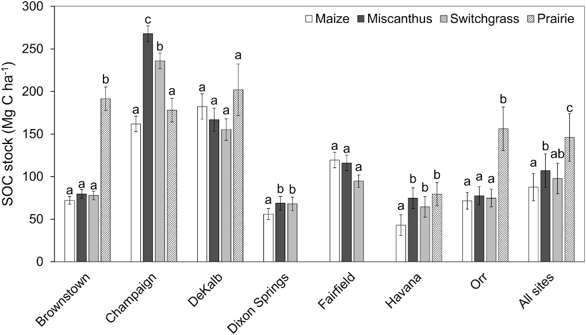
Fig. 1. Comparison of SOC stock on equivalent soil mass basis (Mg C ha⁻¹) between cropping systems (maize, miscanthus, switchgrass, and prairie) across all sites and within each site. Values reported are estimated marginal means
obtained from the linear mixed effect model, with land use and cropping sys-tems as fixed effect and age (number of years since establishment of bioenergy crops) nested within site (for across all sites) or age (within each site) as random effects, fitted to observations from both 2008 and 2013 sampling dates. Error
bars represent ± standard error of the mean and lower-case letters represent differences among crop types (p < 0.05) within each site or across all sites.
lower than miscanthus by 27.2% at 10 – 30 cm depth but was higher than switchgrass by 33.6% at 50 – 100 cm depth.
In contrast to Brownstown and Orr, SOC stock on an ESM basis at Champaign was lower under prairie than miscanthus and switchgrass, though the relative difference was less pronounced. Specifically, SOC stock under prairie (178.0 Mg C ha⁻¹) was lower by 33.6% than mis-
canthus and by 24.6% than switchgrass. SOC content at Champaign was
higher under perennial bioenergy crops than prairie primarily in the subsurface, by 34.3 – 51.4% at 10 – 30 cm depth and by 66.9 – 115.8% at 30 – 50 cm depth. Within cropping systems, SOC stock on an ESM basis
was highest under miscanthus (267.9 Mg C ha⁻¹), followed by switch-grass (236.0 Mg C ha⁻¹), and maize (162.0 Mg C ha⁻¹). Soil organic C
content was consistently lower under maize than perennial bioenergy crops at 0 – 50 cm depth, and more so (1.8 to 2.1-fold) at 0–10 cm depth. Within perennial crops, SOC content was higher under miscanthus than switchgrass by 12.7% at 10 – 30 cm depth and by 29.3% at 30 – 50 cm depth.
Limited differences in SOC stock between prairie, miscanthus, and switchgrass cropping systems were detected at Dekalb and Havana. At DeKalb, SOC stock on an ESM basis varied (155.2 – 201.9 Mg C ha⁻¹) but
was similar across prairie and perennial crops. At 0 – 10 cm depth, SOC
content was 28.5% higher under prairie than maize. At Havana, SOC stock varied among crops from 43.1 – 79.4 Mg C ha⁻¹ and was lower under maize than miscanthus by 42.3%, switchgrass by 33.2%, and
prairie by 45.7%. Soil organic C content under prairie was higher than maize (101%) and switchgrass (53.2%) at 0 – 10 cm depth and all
cropping systems (83.0 – 183%) at 10 – 30 cm depth. Within cropping systems, SOC content under maize was consistently lower than mis-canthus across 0 – 100 cm depth by 36.4 – 53.9%. Similarly, SOC content was lower under maize than switchgrass but only at 10 – 30 cm depth by 35.2% and at 50 – 100 cm depth by 49.2%.
The two sites without a paired prairie, Dixon Springs and Fairfield, also exhibited limited differences in SOC stock between cropping sys-tems. At Fairfield, SOC stocks on an ESM basis varied from 94.6 to 119.5 Mg C ha⁻¹, and SOC content at each depth were similar across cropping
systems. At Dixon Springs, SOC stock on an ESM basis under maize (56.1
Mg C ha⁻¹) was 18.5% lower than miscanthus and 17.5% lower than switchgrass. There was no apparent relationship between differences in SOC among crops and variation in climate among sites.

  - SOC change in 5 years under bioenergy crops within each site

Despite the relatively short interval, an increase in SOC stock from 2008 to 2013 was detected (p < 0.05) under switchgrass at three out of seven sites, with changes in SOC content detected primarily at subsoil
depths (Fig. 3). Under miscanthus an increase in SOC stock could only be detected at Dixon Springs, by 48.9% from 56.6 to 84.3 Mg C ha⁻¹. When compared within each sampling depth, SOC content increased under
miscanthus, from 8.4 to 13.5 Mg C ha⁻¹ at 30 – 50 cm depth and 14.9 to
36.6 Mg C ha⁻¹ at 50 – 100 cm depth (Fig. S1). Under switchgrass, SOC
stock increased at DeKalb, Fairfield, and Orr, but by a smaller magnitude compared to miscanthus (Fig. S2). At DeKalb, SOC stock increased by
14.3% from 146.7 to 167.7 Mg C ha⁻¹ with an increase from 25.9 to
31.4 Mg C ha⁻¹ detected at 30 – 50 cm depth. Though total SOC stock increased by 18.3% from 87.5 to 103.5 Mg C ha⁻¹ over five years at Fairfield, no change in SOC content at a given depth was detected. At Orr, SOC stock increased by 25.7% from 67.6 to 85.0 Mg C ha⁻¹ with an increase from 12.0 to 17.4 Mg C ha⁻¹ at 30 – 50 cm depth (Fig. 3). SOC
did not change significantly between 2008 and 2013 at Champaign with the establishment of perennial crops; however, this site was an anomaly as SOC was higher under perennial crops than prairie, and prairie was not significantly different from maize. The Champaign perennial site was higher in SOC than all other sites at initial sampling.

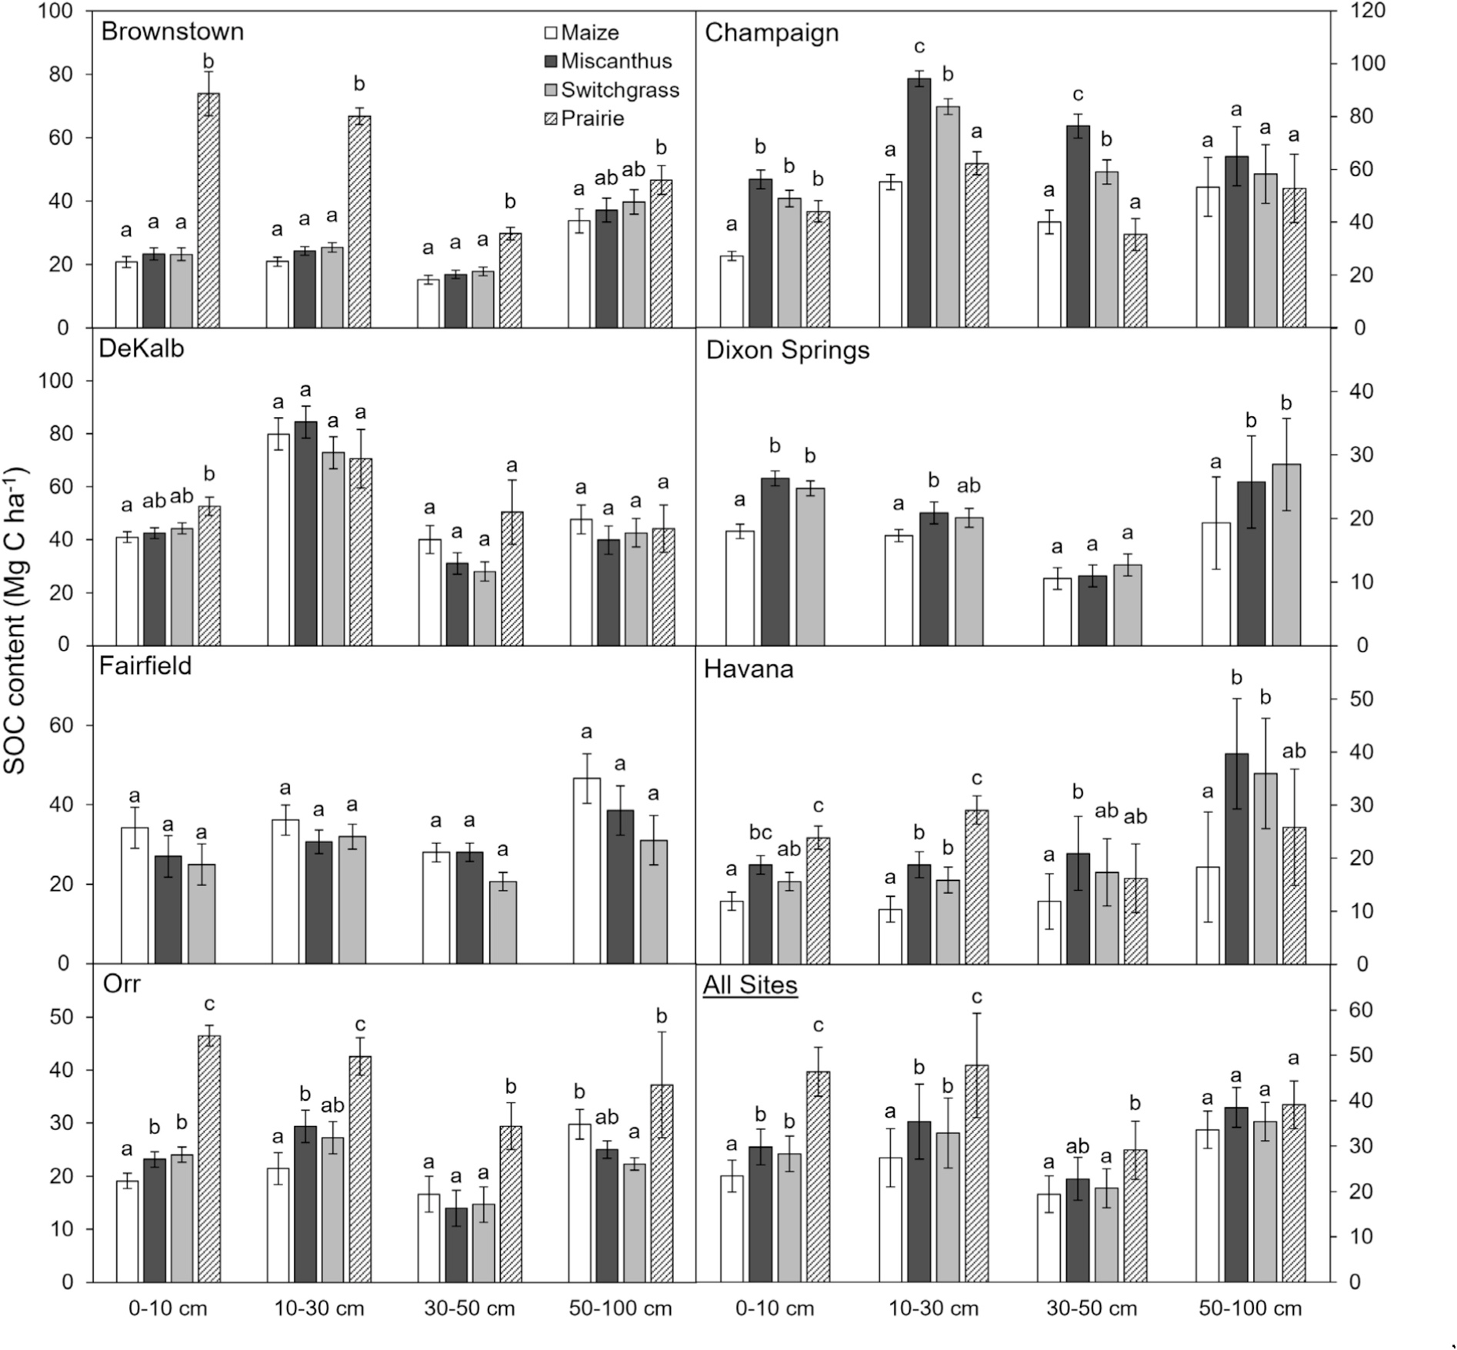
Fig. 2. Comparison of SOC stocks content (Mg C ha⁻¹) by depth intervals (0 – 10 cm, 10 – 30 cm, 30 – 50 cm, 50 – 100 cm) between cropping systems (maize, miscanthus, switchgrass, prairie) across all sites and within each site. Values reported are estimated marginal means obtained from the linear mixed effect model, with land use and cropping systems as fixed effect and age (number of years since establishment of bioenergy crops) nested within site (for across all sites) or age
(within each site) as random effects, fitted to observations from both 2008 and 2013 sampling dates. Error bars represent ± standard error of the mean and lower-case letters represent differences among crop types (p < 0.05) at each depth within each site or across all sites.

  - Soil carbon isotopic signature

Regardless of establishment year, δ¹³C of SOC in surface soils (0 – 30 cm) increased (became less negative) between 2008 and 2013, indi-cating incorporation of new C₄-C into the soil (Table 2, Fig. 4). At Champaign and Dixon Springs, pre-establishment soils were sampled in 2002, prior to planting miscanthus and switchgrass. All other locations were planted in 2002 or 2004 and evaluated between 2008 and 2013. Using a mixing model, we calculated that 21% of the SOC at Dixon Springs was derived from miscanthus within six years (by 2008), and 32% after eleven years (by 2013). At Dixon Springs, 13% of the SOC was derived from switchgrass within six years (by 2008) and 19% within eleven years (by 2013). Similarly, in Champaign 14% of the SOC was derived from switchgrass by six years (2008), and the amount of switchgrass-derived SOC nearly doubled in the following five years to 33% by 2013. For miscanthus plots at Champaign, however, the per-centage of SOC derived from C₄ plant tissue was only 2% in 2008, and in this case, there was no significant difference in the current δ¹³C relative to the establishment year. In 2013, the contribution of C₄ tissue had
increased to 22%.
Perennial bioenergy cropping systems were established at DeKalb in 2002, and in 2004 for Havana, Orr, Brownstown, and Fairfield. Sites planted in 2004 were significantly less δ¹³ depleted (p < 0.05) at the
2008 sampling than sites planted in 2002. All sites shifted toward the C₄-
derived SOC (i.e., increasing; less negative δ¹³C), and the shift was statistically significant for miscanthus at all sites except Havana, and for switchgrass at all sites except Havana and Brownstown (p < 0.05).
Havana and Brownstown had the least negative C₄ signature prior to
switchgrass planting. C₄-C accumulation under perennial crops ranged from 16 to 30% in miscanthus and 12 to 27% in switchgrass (Table 2). Average accumulation of C₄ carbon was greater in miscanthus (24% increase in C₄-derived SOC) than in switchgrass (16% increase in C₄-derived SOC), though the amount of accumulation was not significantly different between plots established in 2002 and those established in 2004. The five-year accumulation of C₄-derived SOC was highest at Havana and Orr, both established in 2004, but there was much greater variability in C₄-derived SOC at Havana. Havana had the strongest C₄ signal in both the miscanthus and switchgrass plots at initial

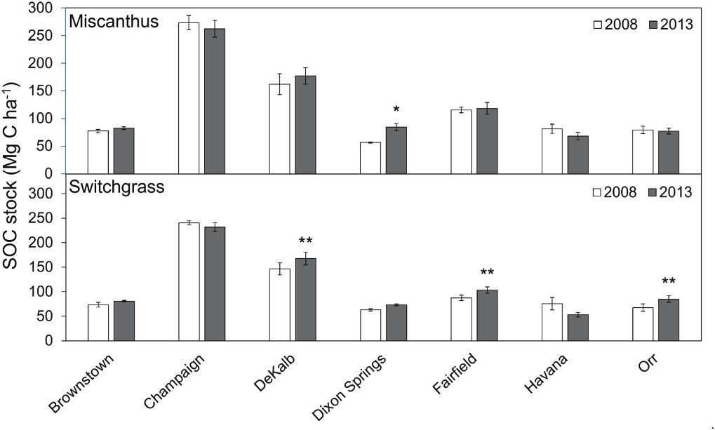
Fig. 3. Change in SOC stock (Mg C ha⁻¹) under miscanthus (top) and switch-grass (bottom) from 2008 to 2013 within each site. Error bars represent ± standard error of the mean and significant changes between the two years are marked with asterisks (** p < 0.01; * for p < 0.05).

measurement in 2008, while initial δ¹³C at Orr was similar to the across-site average. The magnitude of C₄-C accumulation was not associated with soil classification. Furthermore, no correlation was detected (p >
0.2) between aboveground yield and carbon stock or between C₄ carbon
accumulation and carbon stocks at the 2002-established sites of DeKalb, Champaign, and Dixon Springs (Supplemental Table 1).

Discussion

  - Differences in SOC stocks under native prairie relative to cropping systems

Prairie generally exhibited higher SOC stocks than annual or perennial cropping systems, and the difference was largest for sites with lower total SOC (as measured in maize sites), suggesting that decadal bioenergy perennial cropping did not fully recover SOC stocks relative to the native prairie following the 150–200-year legacy of agriculture in
this region. Maize-based cropping is estimated to be at least 150 years old in central-north sites on Mollisols and likely 200 years in the southern Alfisols (Bogue, 2011; Cunningham, 1905). Relative deficits of SOC (i.e., % loss) incurred by agriculture in the US Midwest are on par with much older grain belts of the world (Sanderman et al., 2017), which in part reflects the establishment of a new and lower SOC equi-librium under agricultural land use, wherein SOC loss has slowed and the smaller SOC stock is maintained by current agricultural practices. By sampling native remnant prairie and adjacent agricultural cropping systems across multiple sites, we empirically demonstrate a large, but edapho-climatically-variable, SOC deficit in this region under maize-based cropping relative to native vegetation that has to-date been hy-pothesized and modeled (Sanderman et al., 2017), which supports high regional potential for soil C sequestration. We make the assumptions that SOC has been maintained at equilibria under remnant native prai-rie. The remnant prairies we sampled were carefully selected for mini-mal disturbance, including no prior tillage, though grazing may have occurred (Bogue, 2011) and fire intensity and frequency altered by the late 1800s (Li et al., 2023). Additionally, assessments of SOC at “surface” depths under long-term maize cropping experiments established in the late 1800s suggests that an annual agriculture equilibrium has been nearly reached (Huggins et al., 1998). However, native remnant prairies are scarce and our ability to match prairie soils to agricultural sites was limited by the sampled locations. At DeKalb and Champaign, the soil textural classes of the remnant prairies did not match those of the agricultural sites. Particularly at the Champaign site, the higher SOC under the perennial cropping systems compared to prairie suggests that soils at the prairie (Clarence) and agricultural sites (Flanagan) were not sufficiently compatible for within-site comparisons (Table 1), though their variability is representative of the US Midwest as a whole.
Greater SOC stocks under prairie relative to cropping systems is
consistent with our hypothesis, but that these differences were driven largely by surface depth differences is in contrast to claims that greater rooting depth of prairie entails greater subsurface stock differences by land uses in the central USA. By 50-cm depth, we find no difference in SOC stocks between native prairie and agricultural land use based on across-site evaluation. This could reflect slower loss of prairie-derived

Table 2
Mean stable carbon isotope composition (δ¹³C ± standard error) of soil components in the mixing model and resulting proportion of C in soil derived from perennial bioenergy crops for time periods 2002–2008 (A) and 2008–2013 (B). An asterisk denotes soil δ¹³C values that were significantly different (p < 0.05) for the time period shown.
A.
Species | δ13Cbioenergy | Location | δ13C2002 | δ13C2013 | Fraction of C derived from C₄
Miscanthus | -12.6 ± 0.13 | Champaignª | -18.8 ± 0.10 | -17.4 ± 0.40* | 0.220
 |  | Dixon Springsª | –23.3 ± 0.17 | -19.7 ± 0.40* | 0.332
Switchgrass | -12.7 ± 0.08 | Champaign | -19.7 ± 0.42 | -17.4 ± 0.17* | 0.322
 |  | Dixon Springs | –23.3 ± 0.17 | -21.3 ± 0.17* | 0.186
B.
Species | δ13Cbioenergy | Location | δ13C2008 | δ13C2013 | Fraction of C derived from C₄
Miscanthus | -12.6 ± 0.13 | DeKalbª | -18.6 ± 0.31 | -17.2 ± 0.29* | 0.229
 |  | Havana^{b} | -17.2 ± 0.66 | -15.8 ± 0.23* | 0.297
 |  | Champaignª | -18.5 ± 0.32 | -17.4 ± 0.42* | 0.182
 |  | Orr^{b} | -18.9 ± 0.40 | -17.1 ± 0.34* | 0.285
 |  | Brownstown^{b} | -18.6 ± 0.18 | -17.3 ± 0.21* | 0.210
 |  | Fairfield^{b} | -19.5 ± 0.45 | -18.1 ± 0.48* | 0.205
 |  | Dixon Springsª | -21.0 ± 0.19 | -19.7 ± 0.60* | 0.157
Switchgrass | -12.7 ± 0.08 | DeKalb | -18.6 ± 0.17 | -17.4 ± 0.24* | 0.229
 |  | Havana | -16.9 ± 1.02 | -16.3 ± 0.33 | 0.141
 |  | Champaign | -18.7 ± 0.13 | -17.4 ± 0.21* | 0.217
 |  | Orr | -18.8 ± 0.49 | -17.2 ± 0.32* | 0.268
 |  | Brownstown | -17.5 ± 0.76 | -17.0 ± 0.51 | 0.119
 |  | Fairfield | -18.4 ± 0.39 | -17.6 ± 0.21* | 0.138
 |  | Dixon Springs | -21.9 ± 0.15 | -21.3 ± 0.18* | 0.064
ªsites established in 2002.
^{b}sites established in 2004.

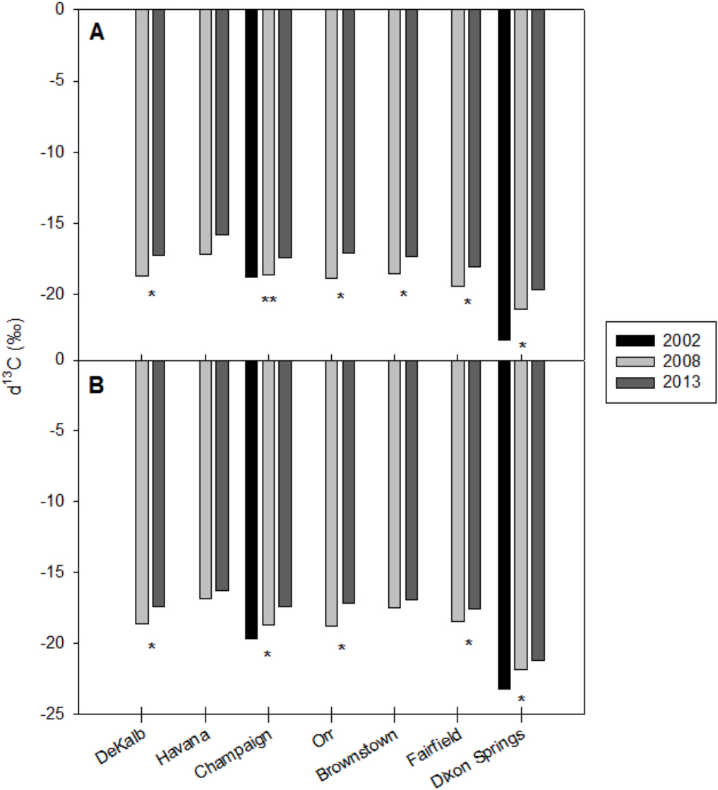

Fig. 4. Carbon stable isotope (δ¹³C) shift over time for all sites for miscanthus
(A) and switchgrass (B) to 30-cm depth. For two sites established in 2002, Champaign and Dixon Springs, pre-planting samples were available (black bars), with 2008 values in light gray and 2013 values in dark gray. A single asterisk identifies a significant change in δ¹³C between 2008 and 2013, while two asterisks show a significant shift between 2002 and 2013. For Dixon Springs, the shift between 2002 and 2008 was significant, as was the shift be-tween 2008 and 2013.

SOC at depth than at surface, both due to attenuated microbial activity in subsoils and greater surface disturbance by tillage in surface soils. Additionally, maize may contribute proportionally more to subsurface than surface SOC stocks than prairie (Dietzel et al., 2017), in part because of greater proportional of belowground biomass in fine roots of rapid turnover as well as subsurface incorporation of crop residue-derived C due to tillage (Souza et al., 2023). Measured SOC stocks at 0–30 cm depth under remnant prairies were similar or higher than
stocks estimated under native prairie for Illinois in 1845 (≥ 90 Mg C ha⁻¹) in central-north Illinois using limited observations from the
broader central US region on SOC in remnant prairie as well as legacy pedon data (Li et al., 2023). Notably, the degree of underestimation of SOC stock modeled was greater for southern locations on Alfisols, which could reflect relative lack of legacy measurements of native prairie in this subregion (Li et al., 2023).

  - Changes in SOC under perennial bioenergy crops

Three lines of evidence supported our hypothesis that SOC accu-mulates over time with perennial bioenergy crops. First, SOC under miscanthus or switchgrass increased on average from 2008 to 2013 (Fig. 3) at four of the seven study sites. Second, SOC accumulation under bioenergy crops was greater over the 5-year sampling period (2008–2013) in 2002-established sites than in 2004-established sites, indicating long-term accumulation potential of these crops. Third, the soil δ¹³C enrichment under miscanthus and switchgrass crops indicated that the accumulation of SOC resulted at least in part from C₄-derived biomass (Table 2, Fig. 4). These results are broadly consistent with partial offset of SOC loss incurred in the disturbance of native vegetation systems (Ascenzi et al., 2025), with perennial bioenergy crops
mimicking some of the ecosystem services provided by native grassland. While full recuperation of SOC stocks under prairie is unlikely under biofuel perennials, the timescales of majority restoration of SOC are likely to extend, non-linearly (Hernandez et al., 2013), beyond the decadal period evaluated here.
The accumulation of SOC under perennial crops is likely due to a combination of vegetation characteristics and management practices. Perennial grasses produce larger belowground biomass than maize or soybean and extend the rhizosphere both deeper and wider (Neukirchen et al., 1999; Ma et al., 2000; Heaton et al., 2008; Anderson-Teixeira et al., 2013, Kantola et al., 2022). The cessation of tillage, combined with increased soil aggregation due to organic inputs, protects the increased organic matter inputs (Jastrow, 1996; Six et al., 1998; Ontl et al., 2015; Tiemann and Grandy, 2015; Kantola et al., 2017).
The ability of perennial bioenergy crops to restore SOC differed by location across the latitudinal and soil gradients of Illinois; this variation was evident even among sites with crops that were established on the same soil texture. Carbon loss or accumulation was unrelated to yields of perennial crops, as sites with contrasting initial concentrations of SOC yielded similar amounts of miscanthus and switchgrass harvestable biomass (Arundale et al., 2014). Soil organic C under perennial bio-energy crops at Dixon Springs was 68% lower than the same crops at Champaign in 2013 despite being the same age. Miscanthus cropping increased SOC stock at Dixon Springs but not Champaign, despite similar aboveground biomass at the two sites (Table S1, Heaton et al., 2008; Arundale et al., 2014). This may reflect the lower SOC stocks at Dixon Springs than Champaign, and thus a greater relative increase that is more detectable and/or greater SOC deficit (Breure et al., 2025). Additionally, the southernmost site of Dixon Springs is situated on a well-drained Alfisol, with warm and moist conditions that likely entailed higher decomposition rates under annual row crop agriculture relative to the cooler and more poorly drained soils at Champaign. For soils across our study sites in Illinois and similar conditions in the greater central USA, the accumulation of SOC following conversion from annual row crops to perennial bioenergy feedstocks may be more strongly affected by decomposition rates than plant productivity.
Mean annual precipitation (Illinois State Water Survey) was 27 cm greater and mean annual temperature was 6 ◦C warmer (Table 1) in the southernmost site (~37.45◦N latitude) than the northernmost site (~41.84◦N latitude). Differences in SOC among sites did not appear to be associated with the north–south gradient in climate, but likely were
controlled by an interaction between climate and soil characteristics, including drainage. The mid-latitude sites, which experienced neither the coldest winters nor hottest summers, had the greatest SOC storage in perennial bioenergy crops over the 5-year evaluation period. This may reflect conditions favoring greater crop biomass production but also greater organic matter decomposition relative to colder or drier condi-tions across the latitudinal gradient.
Increases in soil δ¹³C indicated that C from miscanthus and switch-grass was rapidly incorporated in SOC (Table 2). At Dixon Springs, the southernmost site, 19 and 32% of soil C originated from switchgrass and miscanthus, respectively, by 2013. This increase in C4-derived carbon under miscanthus was consistent with the rapid increase in SOC stock for this crop (Fig. 3). At some of the miscanthus sites (Orr, Fairfield), this occurred despite little change in SOC stocks, indicating that organic carbon input from miscanthus was offset by a loss of old C. Hansen et al. (2004) also reported an increase in miscanthus-derived SOC (13–31% at 0–20 cm depth) without a corresponding change in SOC stock.
In 2013, δ¹³C in miscanthus soils was enriched by a C₄ contribution of 23% at Champaign, the site with greater SOC than other crops (Table 2). Marked increases in C₄-SOC within five years indicates ad-ditions of new carbon exceeded losses from mineralization. It is notable that miscanthus has greater lignin content than other grass species (Foereid et al., 2004) and, despite the stability of lignin in soil, portions of lignin have been shown to turnover more quickly than bulk SOC in grasslands and agricultural soils (Heim and Schmidt, 2007).

Without a baseline isotopic signature of the soils at the five addi-tional sites prior to the establishment of perennial crops, the total enrichment of δ¹³C due to perennial grass establishment cannot be determined. However, using 2008 as the starting point for the five sites, the incremental increase in C₄-SOC over 5 years can be calculated from the stable isotope signature of SOC. Accumulation rates of C₄-SOC varied by site, and were not correlated with initial δ¹³C signature or soil series. Each site, though similar in soil type and identical in species planted, offers a unique combination of soil texture, temperature, and precipi-tation representative of the ecotones of the former tallgrass prairie biome of the central USA (Huggins et al., 1998). Average accumulation of C₄-SOC between 2008 and 2013 was greater in the younger (2002 establishment) sites than in the 2004-established sites for both crops (Table 2). However, this accumulation rate contrasts with the observa-tions at Champaign between 2002 and 2008, which was smaller in both miscanthus and switchgrass at Champaign than in in the period from 2008 to 2013. Accumulation at Dixon Springs was larger from 2002 to 2008 than 2008–2013, but smaller than the 2008–2013 average of the other sites. This indicates that the accumulation rate of C₄-SOC was not driven entirely by the age of the perennial crops, but by the balance of C₄-SOC gain and loss of existing SOC over time.
Soil organic C under maize-based cropping might be restored to the
levels of native prairies if miscanthus or switchgrass crops were planted and harvested annually, though the rate of SOC restoration would likely vary regionally and with the current degree of carbon saturation. The average rate of SOC accumulation across sites from 2008 to 2013 (Fig. 3)
was 0.7 MgC ha⁻¹ y⁻¹ and 1.2 MgC ha⁻¹ y⁻¹ for miscanthus and
switchgrass, respectively (Table S2). These values are consistent with the increases reported by Kantola et al. (2025) for miscanthus (2.0 Mg ha⁻¹ y⁻¹) and switchgrass (1.75 MgC ha⁻¹ y⁻¹) measured at the same
site 8 years after conversion from maize/soybean, and within the wide
range (5–25 Mg C ha⁻¹) predicted by Mishra et al. (2012) for miscanthus over 30 years. However, values for the rate of SOC accumulation pre-sented here are higher than estimates in previous literature that project
an addition of 20–30 Mg C ha⁻¹ over 30 years with switchgrass (e.g. Andress, 2002; McLaughlin et al., 2002). Mean differences in SOC
accumulation among crops change with time after planting because crops mature at different rates and accumulation of SOC can decline as soil aggregates stabilize (Gulde et al., 2008). Temporal and spatial variation must be considered for accurate estimates of SOC gains and thus net C sequestration by bioenergy crops.
In conclusion, side by side comparisons revealed that intensive row-crop agriculture reduced SOC compared to native prairie remnants by 40%, and planting the perennial crops, miscanthus and switchgrass, rebuilt some but not all this SOC deficit. Despite the deep rooting habit of prairie, miscanthus, and switchgrass, most of the loss and rebuilding of SOC happened in surface soils, less than 50-cm depth. The ability of miscanthus and switchgrass to rebuild SOC was highly variable along a latitudinal gradient with variation in precipitation, temperature, and soil properties, and was not correlated with variation in aboveground productivity. Rates of decomposition were not measured but may have contributed to latitudinal variation in SOC restoration by perennial bioenergy crops. Planting perennial crops for bioenergy production will rebuild some of the SOC deficit caused by the intensive cultivation of maize and soybean.

CRediT authorship contribution statement

Ilsa B. Kantola: Writing – original draft, Methodology, Data cura-tion, Conceptualization. Yuhei Nakayama: Writing – review & editing, Writing – original draft, Visualization, Methodology, Data curation. Ezra Moses: Writing – original draft, Formal analysis. Elena Blanc-Betes: Writing – original draft, Formal analysis, Data curation. Sarah C. Davis: Writing – review & editing, Writing – original draft, Formal analysis, Data curation, Conceptualization. Michael D. Masters: Writing – review & editing, Writing – original draft, Methodology,
Formal analysis, Conceptualization. Robert G. Darmody: Methodology, Investigation. Andrew J. Margenot: Writing – review & editing, Writing – original draft, Formal analysis, Data curation. Evan H. DeLucia: Writing – review & editing, Writing – original draft, Re-sources, Methodology, Investigation, Formal analysis, Conceptualization.

Declaration of competing interest

The authors declare the following financial interests/personal re-lationships which may be considered as potential competing interests: Evan DeLucia reports financial support was provided by US Department of Energy. Evan DeLucia reports financial support was provided by En-ergy Biosciences Institute, University of California, Berkeley, and Uni-versity of Illinois, Urbana-Champaign, IL USA. Evan DeLucia reports financial support was provided by DOE Center for Advanced Bioenergy and Bioproducts Innovation (U.S. Department of Energy, Office of Sci-ence, Office of Biological and Environmental Research under award number DE-SC0018420). If there are other authors, they declare that they have no known competing financial interests or personal re-lationships that could have appeared to influence the work reported in this paper.

Acknowledgements

We thank the Illinois Nature Preserve Commission and the Grand Prairie Friends of Illinois for access to prairie remnants, and we thank Emily Heaton for providing the 2002 soil samples. This research was supported by funding from the North Central Regional Sun Grant Center at South Dakota State University through a grant provided by the US Department of Energy Office of Biomass Programs (award # DE-FG36-08GO88073), the Energy Biosciences Institute, University of California, Berkeley, and University of Illinois, Urbana-Champaign, IL USA, and the DOE Center for Advanced Bioenergy and Bioproducts Innovation (U.S. Department of Energy, Office of Science, Office of Biological and Envi-ronmental Research under award number DE-SC0018420). Any opin-ions, findings, and conclusions or recommendations expressed in this publication are those of the authors and should not be constructed to represent any official U.S Department of Energy, U.S. Department of Agriculture or U.S. Government determination or policy.

Appendix A. Supplementary data

Supplementary data to this article can be found online at https://doi. org/10.1016/j.geoderma.2026.117830.

Data availability

Data will be made available on request.

References

Adler, P.R., Del Grosso, S.J., Parton, W.J., 2007. Life-cycle assessment of net greenhouse-gas flux for bioenergy cropping systems. Ecol. Appl. 17, 675–691.
Adu Fosu, S., Davis, S.C., 2024. Decadal change in soil carbon and nitrogen with a Miscanthus x giganteus crop on abandoned agricultural land in southeast Ohio. GCB Bioenergy 16, e137171. https://doi.org/10.1111/gcbb.13171.
Ampleman, M.D., Crawford, K.M., Fike, D.A., 2014. Differential soil organic carbon storage at forb- and grass-dominated plant communities, 33 years after tallgrass prairie restoration. Plant and Soil 374, 899–913.
Anderson-Teixeira, K.J., Davis, S.C., Masters, M.D., DeLucia, E.H., 2009. Changes in soil organic carbon under biofuel crops. Glob. Chang. Biol. Bioenergy 1, 75–96.
Anderson-Teixeira, K.J., Masters, M.D., Black, C.K., Zeri, M., Hussain, M.Z., Bernacchi, C. J., DeLucia, E.H., 2013. Altered belowground carbon cycling following land-use change to perennial bioenergy crops. Ecosystems 16, 508–520. https://doi.org/ 10.1007/s10021-012-9628-x.
Andress, D., 2002. Soil carbon changes for bioenergy crops. Argonne National Laboratory, US Department of Energy, Argonne, IL.

Arundale, R.A., Dohleman, F.G., Heaton, E.A., McGrath, J.M., Voigt;, T.B., Long, S.P., 2014. Yields of Miscanthus x giganteus and Panicum virgatum decline with stand ate in the Midwestern USA. Glob. Chang. Biol. Bioenergy 6, 1–13.
Ascenzi, I., Hilbers, J.P., van Katwijk, M.M., Huijbregts, M.A., Hanssen, S.V., 2025. Increased but not pristine soil organic carbon stocks restored in ecosystems. Nat. Commun. 16, 637. https://doi.org/10.1038/s41467-025-55980-1.
Blanc-Betes, E., Gomez-Casanovas, N., Yang, W.Y.H., Chandrasoma, J., Clark, T.J., DeLucia, E.H., Hyde, C.A., Kent, A.D., Pett-Ridge, J., Rabinowitz, J., Raglin, S.S., Schwender, J., Shen, Y.H., Van Allen, R., von Haden, A.C., 2023a. Accelerating the development of a sustainable bioenergy portfolio through stable isotopes. GCB Bioenergy 15, 84–866.
Blanc-Betes, E., Gomez-Casanovas, N., Hartman, M.D., Hudiburg, T.W., Madhu, K., Parton, W.J., DeLucia, E.H., 2023b. Climate vs energy security: quantifying the trade-offs of BECCS deployment and overcoming opportunity costs on set-aside land. Environ. Sci. Technol. 57, 19732–19748. https://doi.org/10.1021/acs.est.3c05240.
United States Department of Agriculture, Natural Resources Conservation Service. https://www.nrcs.usda.gov/conservation-basics/natural-resource-concerns/soil/ citing-our-databases.
Bogue, A.G., 2011. From Prairie to Corn Belt: farming on the Illinois and Iowa Prairies in the Nineteenth Century, Second Edition. Ivan R. Dee, New York. 328 pages.
Breure, T.S., De Rosa, D., Panagos, P., Cotrufo, M.F., Jones, A., Lugato, E., 2025.
Revisitng the soil carbon saturation concept to inform a risk index in European agricultural soils. Nat. Commun. 16, 2538. https://doi.org/10.1038/s41467-025-57355-y.
Cadoux, S., Ferchaud, F., Demay, C., Boizard, H., Machet, J.-M., Fourdinier, E., Preudhomme, M., Chabbert, B., Gosse, G., Mary, B., 2014. Implications of productivity and nutrient requirements on greenhouse gas balance of annual and perennial bioenergy crops. GCB Bioenergy 6, 425–438.
Cunningham, J.O., 1905. Champaign, IL: The History of Champaign County. Higginson Book Company. 435 pages.
David, M.B., McIsaac, G.F., Darmody, R.G., Omonode, R.A., 2009. Long-term changes in Mollisol organic carbon and nitrogen. J. Environ. Qual. 38, 200–211.
Davis, S.C., Anderson-Teixeira, K.J., DeLucia, E.H., 2009. Life-cycle analysis and the ecology of biofuels. Trends Plant Sci. 14, 140–146.
Davis, S.C., Parton, W.J., Del Grosso, S.J., Keogh, C., Marx, E., Adler, P., DeLucia, E.H., 2012. Impacts of second-generation biofuel agriculture on greenhouse gas emissions in the corn-growing regions of the US. Front. Ecol. Environ. 10, 69–74. https://doi. org/10.1890/110003.
Dietzel, R., Liebman, M., Archontoiulis, S., 2017. A deeper look at the relationship between root carbon pools and the vertical distribution of the soil carbon pool. Soil 3, 139–152. https://doi.org/10.5194/soil-3-139-2017.
Don, A., Osborne, B., Hastings, A., Skiba, U., Carter, M.S., Drewere, J., Flessa, H., Freibauer, A., Hyvo¨nen, N., Jones, M.B., Lanigan, G.J., Mander, U., Monti, A., Njakou Kjomo, S., Valentine, J., Walter, K., Zegada-Lizarazu, W., Zenone, T., 2012. Land-use change to bioenergy production in Europe: implications for greenhouse gas balance and soil carbon. GCB Bioenergy 4, 372–391.
Ehlringer, J.R., Cerling T.E., 2002. Stable isotopes, in Mooney, H.A., and J.G. Canadell: The Earth System: Biological and Ecological Dimensions of Global Environmental Change. Wiley and Sons, Chichester, pp. 544-550.
Fehrenbacher, J.B., Alexander, J.D., Jansen, I.J., Darmody, R.G., Pope, R.A., Flock, M.A., Voss, E.E., Scott, J.W., Andrews, W.F., Bushue, L.J., 1984. Soils of Illinois. Bulletin 778, University of Illinois at Urbana-Champaign, College of Agriculture Experiment Station in Cooperation with the Soil Conservation Service, U.S. Department of Agriculture. 104 pp.
Ferchaud, F., Chlebowski, F., Mary, B., 2023. SimpleESM: R script to calculate soil organic carbon and nitrogen stocks at Equivalent Soil Mass. Institut National de Recherche pour l'Agriculture, l'Alimentation et l'Environnement (INRAE).
Ferchaud, F., Vitte, G., Mary, B., 2015. Changes in soil carbon stocks under perennial and annual bioenergy crops. GCB Bioenergy 8, 290–306. https://doi.org/10.1111/ gcbb.12249.
Foereid, B., de Neergaard, A., Hogh-Jensen, H., 2004. Turnover of organic matter in a Miscanthus field: effect of time in Miscanthus cultivation and inorganic nitrogen supply. Soil Biol. Biochem. 36, 1075–1085.
Garten, C.T., Wullschleger, S.D., 2000. Soil carbon dynamics beneath switchgrass as indicated by stable isotope analysis. J. Environ. Qual. 29, 645–653.
Garten Jr., C.T., Smith, J.L., Tyler, D.D., Amonette, J.E., Bailey, V.L., Brice, D.J., Castro, H.F., Graham, R.L., Gunderson, C.A., Izaurralde, R.C., Jardine, P.M., Jastrow, J.D., Kerley, M.K., Matamala, R., Mayes, M.A., Metting, F.B., Miller, R.M.,
Moran, K.K., Post III, W.M., Sands, R.D., Schadt, C.W., Phillips, J.R., Thomson, A.M., Vugteveen, T., West, T.O., Wullschleger, S.D., 2010. Intra-annual changes in biomass, carbon, and nitrogen dynamics at 4-year old switchgrass field trials in west Tennessee USA. Agr. Ecosyst. Environ. 136, 177–184.
Gleason, H.A., 1913. The Relationship of forest distribution and prairie fires in the Middle West. Torreya 13, 173–181.
Gulde, S., Chung, H., Amelung, W., Chang, C., Six, J., 2008. Soil carbon saturation controls labile and stable carbon pool dynamics. Soil Sci. Soc. Am. J. 72, 605–612.
Hansen, E.M., Christensen, B.T., Jensen, L.S., Kristensen, K., 2004. Carbon sequestration in soil beneath long-term Miscanthus plantations as determined by ¹³C abundance. Biomass Bioenerg. 26, 97–105.
Harris, D., Horwath, W.R., van Kessel, C., 2001. Acid fumigation of soils to remove carbonates prior to total organic carbon or carbon-13 isotopic analysis. Soil Sci. Soc. Am. J. 65, 1853–1856.
Heaton, E.A., Dohleman, F.G., Long, S.P., 2008. Meeting US biofuel goals with less land: the potential of Miscanthus. Glob. Chang. Biol. 14, 2000–2014.
Heim, A., Schmidt, M.W.I., 2007. Lignin turnover in arable soil and grassland analysed with two different labelling approaches. Eur. J. Soil Sci. 58, 599–608.
Hernandez, D.L., Esch, E.H., Alster, C.J., McKone, M.J., Camil, P., 2013. Rapid accumulation of soil carbon and nitrogen in a prairie restoration chronosequence. Soil Biol. Biochem. 77, 2029–2038. https://doi.org/10.2136/sssaj2012.0403.
Hothorn, T., Bretz, F., Westfall, P., 2008. Simultaneous inference in general parametric models. Biometrical J. 50 (3), 346–363.
Hudiburg, T., Davis, S.C., Parton, W.J., DeLucia, E.H., 2015. Bioenergy crop greenhouse gas mitigation potential under a range of management practices. GCB Bioenergy 7, 366–374. https://doi.org/10.1111/gcbb.12152.
Huggins, D.R., Buyanovsky, G.A., Wagner, G.H., Brown, J.R., Peck, T.R., Lesoing, G.W., Vanotti, M.B., Bundy, L.G., 1998. Soil organic C in the tallgrass prairie-drived region of the Corn Belt: effects of long-term crop management. Soil Till. Res. 47, 219–234. https://doi.org/10.1016/S0167-1987(98)00108-1.
Jastrow, J.D., 1996. Soil aggregate formation and the accrual of particulate and mineral-associated organic matter. Soil Biol. Biochem. 28, 665–676.
Joo, E., Zeri, M., Hussain, M.Z., DeLucia, E.H., Bernacchi, C.J., 2017. Enhanced evapotranspiration was observed during extreme drought from Miscanthus, opposite of other crops. GCB Bioenergy 9, 1306–1319. https://doi.org/10.1111/gcbb.12448.
Kahle, P., Beuch, S., Boelcke, B., Leinweber, P., Schulten, H., 2001. Cropping of Miscanthus in Central Europe: biomass production and influence on nutrients and soil organic matter. Eur. J. Agron. 15, 171–184.
Kaiser, C.M., Sacks, E.J., 2015. Cold-tolerance of Miscanthus seedlings and effects of spring and autumn frosts on mature clonally replicated cultivars. Crop Sci. 55, 2401–2416. https://doi.org/10.2135/cropsci2014.10.0679.
Kantola, I.B., Masters, M.D., DeLucia, E.H., 2017. Soil particulate organic matter increases under perennial bioenergy crop agriculture. Soil Biol. Biochem. 113, 184–191.
Kantola, I.B., Masters, M.D., Blanc-Betes, E., Gomez-Casanovas, N., DeLucia, E.H., 2023. Long-term yields in annual and perennial bioenergy crops in the Midwestern United States. GCB Bioenergy 14, 694–706. https://doi.org/10.1111/gcbb.12940.
Kantola, I.B., Blanc-Betes, E., von Haden, A., Masters, M.D., Blakely, B., Bernacchi, C.J., DeLucia, E.H., 2025. Soil organic matter increases under long-term perennial bioenergy crop production. GCB Bioenergy 17, e70080, 10.111/gcbb.70080.
Kuznetsova, A., Brockhoff, P.B., Christensen, R.H.B., 2017. lmerTest package: tests in linear mixed effects models. J. Stat. Softw. 82 (13), 1–26. https://doi.org/10.18637/ jss.v082.i13.
Lenth, R., 2024. _emmeans: estimated marginal means, aka least-squares means_. R Package Version 1 (10), 5. https://CRAN.R-project.org/package=emmeans.
Li, N., Zhou, S., Margenot, A.J., 2023. From prairie to crop: spatiotemporal dynamics of surface soil organic carbon stocks over 167 years in Illinois, U.S.A. Sci. Total Environ. 857. https://doi.org/10.1016/j.scitotenv.2022.159038.
Liebig, M.A., Johnson, H.A., Hanson, J.D., Frank, A.B., 2005. Soil carbon under switchgrass stands and cultivated cropland. Biomass Bioenerg. 28, 347–354.
Lüdecke, D., Ben-Shachar, M.S., Patil, E., Waggoner, P., Makowski, D., 2021. performance: an R package for assessment, comparison and testing of statistical models. J. Open Source Softw. 6 (60), 3139. https://doi.org/10.21105/joss.03139.
Ma, Z., Wood, C.W., Bransby, D.I., 2000. Impacts of soil management on root characteristics of switchgrass. Biomass Bioenerg. 18, 105–112.
McLaughlin, S.B., de la Torre Ugarte, D.G., Garten, C.T., Lynd, L.R., Sanderson, M.A., Tolbert, V.R., Wolf, D.D., 2002. High-value renewable energy from prairie grasses. Environ. Sci. Tech. 36, 2122–2129.
Mishra, U., Torn, M.S., Fingerman, K., 2012. Miscanthus biomass productivity within US croplands and its potential impact on soil organic carbon. GCB Bioenergy 5,
391–399.
Moran, K.K., Jastrow, J.D., 2010. Elevated carbon dioxide does not offset loss of soil carbon from a corn-soybean agroecosystem. Environ. Pollut. 158, 1088–1094.
Neukirchen, D., Himken, M., Lammel, J., Czypionka-Krause, U., Olfs, H.-W., 1999.
Spatial and temporal distribution of the root system and root nutrient content of an established Miscanthus crop. Eur. J. Agron. 11, 301–309.
Olchin, G.P., Ogle, S., Frey, S.D., Filley, T.R., Paustian, K., Six, J., 2008. Residue carbon stabilization in soil aggregates of no-till and tillage management of dryland cropping systems. Soil Sci. Soc. Am. J. 72, 507–513.
Omonode, R.A., Vyn, T.J., 2006. Vertical distribution of soil organic carbon and nitrogen under warm-season native grasses relative to croplands in west-central Indiana USA. Agric. Ecosyst. Environ. 117, 159–170.
Ontl, T.A., Cambardella, C.A., Schulte, L.A., Kolka, R.K., 2015. Factors influencing soil aggregation and particulate organic matter responses to bioenergy crops across a topographic gradient. Geoderma 255, 1–11.
Peralta, A.L., Wander, M.M., 2008. Soil organic matter dynamics under soybean exposed to elevated [CO₂]. Plant and Soil 303, 69–81.
Posit team, 2024. RStudio: Integrated Development Environment for R. Posit Software, PBC, Boston, MA. URL http://www.posit.co/.
R Core Team, 2024. R: A Language and Environment for Statistical Computing.
Foundation for Statistical Computing, Vienna, Austria.
Robertson, G.P., Paul, E.A., Harwood, R.R., 2000. Greenhouse gases in intensive agriculture: contributions of individual gases to the radiative forcing of the atmosphere. Science 289, 1922–1925.
Sanderman, J., Hengl, T., Fiske, G.J., 2017. Soil carbon debt of 12,000 years of human land use. Proc. Nat. Acad. of Sci. 114, 9575–9580. https://doi.org/10.1073/ pnas.1706103114.
Schneckenberger, K., Kuzyakov, Y., 2007. Carbon sequestration under Miscanthus in sandy and loamy soils estimated by natural ¹³C abundance. J. Plant Nutr. Soil Sci. 170, 538–542.
Six, J., Elliott, E.T., Paustian, K., Doran, J.W., 1998. Aggregation and soil organic matter accumulation in cultivated and native grassland soils. Soil Sci. Soc. Am. J. 62, 1367–1377.

Strullu, L., Cadoux, S., Preudhomme, M., Jeuffroy, M.-H., Beaudoin, N., 2011. Biomass production and nitrogen accumulation and remobilization by Miscanthus x giganteus as influenced by nitrogen stocks in belowground organs. Field Crops Res. 121, 381–391.
Souza, L.F.T., Hirmas, D.R., Sullivan, P.L., Reuman, D.C., Kirk, M.F., Ajami, H., Wen, H.,
Sarto, M.V.M., Loeck, T.D., Rudick, A.K., Rice, C.W., Billings, S.A., 2023. Root distribution, precipitation, and soil organic carbon depth distributions. Geoderma
437. https://doi.org/10.1016/j.geoderma.2023.116569.
Tiemann, L.K., Grandy, A.S., 2015. Mechanisms of soil carbon accrual and storage in bioenergy cropping systems. GCB Bioenergy 7, 161–174.
Tolbert, V.R., Todd, D.E., Mann, L.K., Jawdy, C.M., Mays, D.A., Malik, R., Bandaranayake, W., Houston, A., Tyler, D., Pettry, D.E., 2002. Changes in soil quality and below-ground carbon storage with conversion of traditional agricultural crop lands to bioenergy crop production. Environ. Pollut. 116, S97–S106.
Venables, W.N., Ripley, B.D., 2002. Modern applied statistics with S, Fourth Edition.
Springer, New York.
von Haden, A.C., Yang, W.H., DeLucia, E.H., 2020. Soils' dirty little secret: depth-based comparisons can be inadequate for quantifying changes in soil organic carbon and other mineral soil properties. Glob. Chang. Biol. 26, 3759–3770. https://doi.org/ 10.1111/gcb.15124.
Wang, H., Stumpf, A.J., Kumar, P., 2018. Radiocarbon and stable carbon isotopes of labile and inert organic carbon in the critical zone observatory in Illinois, USA. Radiocarbon 60, 989–999.
Warntz, W., 1957. An historical consideration of the terms “Corn” and “Corn Belt” in the United States. Agr. Hist. 31, 40–45.
Wendt, J.W., Hauser, S., 2013. An equivalent soil mass procedure for monitoring soil organic carbon in multiple soil layers. Euro. J. Soil Sci. 64, 58–65. https://doi.org/ 10.1111/ejss.12002.

